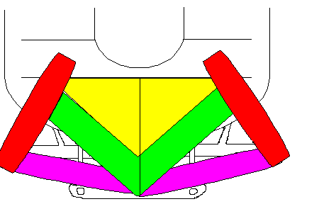

* **Suboccipital Triangle contains: Suboccipital nerve and vertebral artery**
* **Rectus Capitis Posterior Minor**
* **Rectus Capitis Posterior Major**
* **Obliquus Capitis Superior**
* **Obliquus Capitis Inferior**

Superior Nuchal Line

Inferior Nuchal Line

EOR