DCYH CONCESSION STAND OPERATIONAL HANDBOOK FOR DIBS VOLUNTEERS
1.0 General Information
The concession stand is one of our biggest fundraisers for DCYH. It’s ran solely by volunteers. DCYH receives the profit but we do have to pay a percentage of our sales to the Four Seasons Arena.
The concession stand is open for the following reasons:
- Termite practice
- Supermite practice/games
- Squirts/10U games
- Peewee/12U games
- Bantam games
- High School Boy games
- High School Girl games
- Home Tournaments
- Special occasions
We have tested being open for the following but it has not generated enough sales to warrant the time and the risk of losing aging unsold inventory:
- Learn to Skate sessions
- Return of the Robin Hockey Tournament
- Dodge County Fair rink events

2.0 Concessions Season
The concessions stand is operational from August until March
- August
  - Report for DCYH Board meeting
  - Pre-season event: HS girls 4x4 on Sundays – contact Jeremy Gunderson (HS Coach)
  - Pre-season DIBs schedules (load Aug-Oct)
  - Pre-season inventory (cleaning supplies, paper goods and inventory)
  - Pre-season deep cleaning (2-3 people 1.5 hours)
  - Concessions setup
  - Cash register setup
  - Pre-season cash
  - Establish cleaning schedule for upcoming season
  - Seek volunteers to support concessions responsibilities for season
- September
  - Report for DCYH Board meeting
  - Pre-season event: HS girls 4x4 on Sundays
  - Pre-season bi-weekly cleaning
  - Pre-season inventory (inventory other as needed)
  - Pre-season DIBs schedule
  - Pre-season cash
- October
  - Report for DCYH Board meeting
  - Pre-season event: HS girls 4x4 on Sundays
  - DIBs schedule (load Nov in early Oct)
  - DIBs schedule (load full Termite and Supermite schedule)
  - Pre-season bi-weekly cleaning
  - Pre-season inventory (inventory other as needed)
  - Pre-season DIBs schedule
  - Pre-season cash
- November
  - Report for DCYH Board meeting
  - Youth Hockey and HS Hockey games – SEASON RAMP UP
  - DIBs schedule (load Dec schedule in early Nov)
  - Weekly cleaning
  - Full inventory (inventory other as needed)
  - Full season cash management
- December
  - Report for DCYH Board meeting
  - Youth Hockey and HS Hockey games – PEAK SEASON
  - DIBs schedule (load Jan schedule in early Dec)
  - Weekly cleaning
  - Full inventory (inventory other as needed)
  - Full season cash management
- January
  - Report for DCYH Board meeting
  - Youth Hockey and HS Hockey games – PEAK SEASON
  - DIBs schedule (load Feb schedule in early Jan)
  - Weekly cleaning
  - Full inventory (inventory other as needed)
  - Full season cash management
- February
  - Report for DCYH Board meeting
  - Youth Hockey and HS Hockey games – RAMP DOWN
  - DIBs schedule (load special Feb needs and March events)
  - Weekly cleaning
  - Limit inventory purchases (inventory other as needed)
  - Full season cash management
- March
  - Report for DCYH Board meeting
  - Youth Hockey post season play – CLOSEOUT
  - Weekly cleaning until end of scheduled events
  - End of season deep cleaning (2-3 people 1.5 hours)
  - Inventory selloff
  - End of year account out

3.0 Concession Responsibilities
There are a number of responsibilities that go into running the concession stand effectively. Below outlines responsibilities that need to be covered.
- Concessions Manager – This is an individual responsible for the overall management of the concessions from pre-season planning, seasons full operations, post season cleanup, communication with the DCYH Board of Directors (https://www.dcyh.org/board) - Essentially everything outlined in this document and other needs for business operations. In addition to general oversight, the Concessions Manager takes on responsibility of at least one of the following while supporting as needed on all others.
  - Concession Housekeeping – Daily cleaning is the responsibility of each DIBs worker that volunteers to take a shift in the concessions. There is a dialy checklist for cleaning just to maintain the fundamental cleanliness according to health standards. See Reference Document – Concessions Signs.doc
  - Weekly Concessions Cleaning – There is weekly deeper cleaning of all of the equipment. This has for the past 3 years been divided between two dedicated association members. See Reference Document - DCYH Concessions Stand Cleaning and Support.doc
  - Finance Management – There is responsibility to manage cash availability for the days of operations, basic financial reconciliation, and banking withdraws and deposits. See Reference Document – DCYH Concessions Money.doc
  - Inventory Management – Responsible for maintaining adequate levels of inventory to support the monthly events while minimizing excess product inventory. See reference document – DCYH Concessions Inventory.doc
  - Dibs Management – This role is responsible for ensuring there are volunteer sessions listed in our DIBs tool to cover the scheduled hours of operations for the concessions stand. This traditionally has been managed by someone other than the Concessions but recently (2018-20) it has been managed through concessions for simplicity of coordination. Concessions manager is responsible for determining number of workers per event.

4.0 Concessions Cleaning
The concessions stand is inspected by the MN State Health Department and requires adherence to their defined health standards. There is an annual unannounced health inspection where the rink manager will let them in to inspect during off hours. Upon completion of the inspection, they will email the concessions manager their findings. It is the concessions manager to remediate the findings. If there are extensive expenses required as part of the remediation, this should be taken to the board for awareness. The treasurer will need to pay for the licensing fee. A certificate of inspection will be mailed to the DCYH mailing address. This certificate must be visibly displayed in the concessions stand.
Pre-season deep cleaning is an extensive cleaning of shelves, cupboards, freezers, fridges, equipment, etc. Pre-season cleaning can easily be coordinated with initial stocking of inventory because it goes pretty quick.
During the season, the concessions needs to be cleaned on a regular weekly basis. Cleaning supplies should be available for use. These are typically stored in the cabinets above the sink. The following should regularly be part of the cleaning todo list:
- Counters
- Inside cupboards and drawers
- Faces of doors and drawers and their handles
- Popcorn drawer needs to be wiped down from the oil
- Popcorn machine
- Slushie Machine
- Cappuccino Machine (flushing water through machine)
- Coffee Machine (flushing water through machine)
- Microwaves
- Fridge fronts and door handles
- Outside of all other machines (do not forget the top of the machines)
- Mopping the floor
Post-season deep cleaning is removing inventory, freezing product, consolidating products, straightening pantry and extensive cleaning of shelves, cupboards, freezers, fridges, equipment, etc.
Cleaning Supplies should be stocked at the beginning of the season and replenished throughout the season as needed. There is usually supply left from previous season so check inventory before stocking.
- Mop
- Rags (usually get pack of microfiber rags at Home Depot)
- Dish soap
- Sanitary tablets (from Cisco)
- Hand soap
- Nail Brush
- Floor cleaner (multipurpose cleaner)
- Food safe degreaser (from Cisco?)
- Magic erasers (for cabinet fronts as needed)

5.0 Concessions Cleaning Volunteers
There are approximately 36 hours of cleaning for a hockey season. Each scheduled session is approximately 1 hour to earn 1 DIBs hour of credit. Having consistent cleaning divided between two people works best. Some things do not need a deep cleaning weekly (ie popcorn machine) and some like certain jobs more than others so the pairs that have worked previously did a good job dividing tasks BUT ensuring the concessions was well maintained.
At the beginning of a season, a Google doc can be constructed that lists out all of the weeks. This document can be shared and the designated cleaners can sign up for the weeks that best fit their schedules. The following link is an example of what has been used in previous years.
https://docs.google.com/document/d/18_3tFCy0M49cnrwuvZH2curi1zu_XZCP2Lo6EVoaKto/edit?usp=sharing
Cleaning to be done on a weekly basis. Cleaning to be performed one time per week during off hours preferably sometime between Sun-Wed of each week. Each session equals 1 Hour DIBS credit unless stated. These will automatically be credited to your account at the end of the season.

Other areas that cleaners assist with: Restocking as needed, washing the rags, exchanging money, filling in if needed/available, Sam’s pickups, etc. These all help to round out the required hours for the season.

6.0 Square Point-of-Sale System
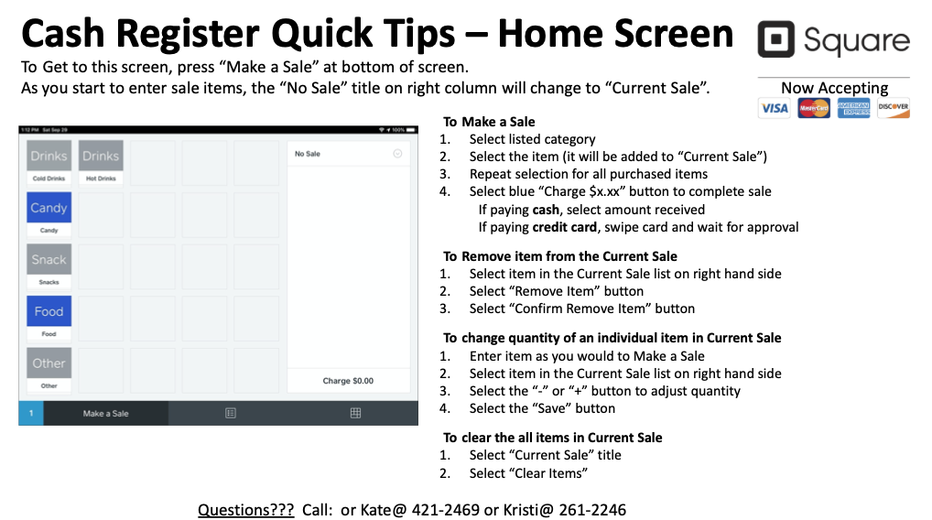

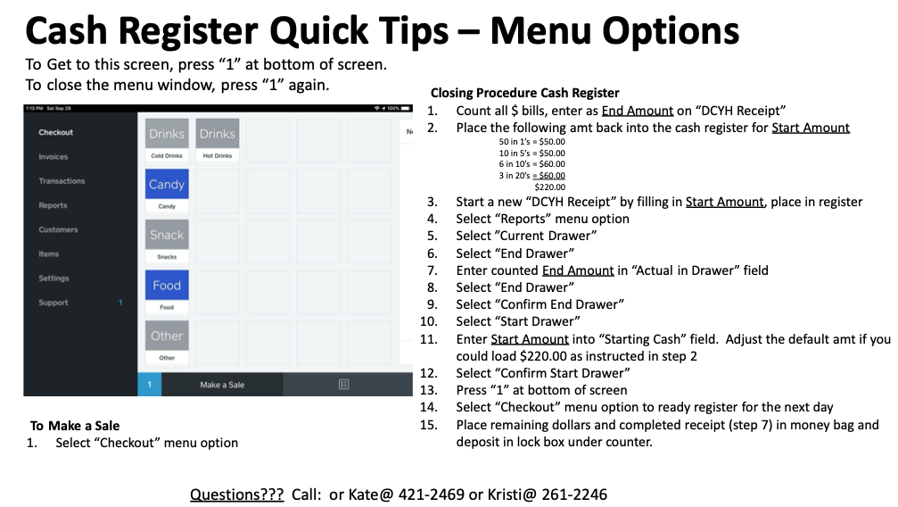
7.0 DIBs Management
DIBs hours are credited to each volunteer that supports concessions responsibilities. It is the Concession Managers responsibility to ensure the volunteers are fulfilling the hours and the expected responsibilities.
- Allocation of hours
  - Concessions Manager – Receive FULL credit for family DIBs requirement
  - Concessions Cleaner x 2 – 18 Dibs hours for each cleaner
  - Finance Manager – 18 Dibs hours
DIBs hours are loaded for every hour the concessions stand is to be operational. The number of people assigned on each DIBs opportunity is important to balance the demand of hours against supply of hours volunteers will contribute. If there are no volunteers or a cancellation for a DIBs session the following can be used:
- Post demand to Facebook requesting assistance
- Send an association wide email requesting assistance
- Send a request to the DCYH Board of Directors
- Personally recruit someone to cover (must be 16 years of age)
- Utilize the concessions staff members (cleaners, managers)
- Staff the shift yourself
- Close the concessions stand (this is permissible on a youth game, not on a HS game)
Because the concessions is under surveillance we can have single individuals operating it during low traffic events. It is important to express to new association members that have never worked in concessions before, they take a shift where more than one person is on shift to learn how the concessions operates before they attempt to manage a session independently. Saturdays full of youth hockey games back to back all day can add supplemental support around meal times. To open for the day, scheduled hours should be 15 minutes before a DCYH event, 30 hour before a High School event. This may be shifted to meet anticipated rink traffic.
Recommended DIBs session hours to properly staff the concessions stand (adjust as necessary). There has been a declining volunteer participation to fill DIBs hours so managing conservatively will be required to ensure there are enough volunteers to cover hours when nearing end of season..
- Termite practice - 1 person
- Supermite practice/games – 1 person
- Squirts/10U games – 1 person
- Peewee/12U games – 1 person
- Bantam games – 1 person
- High School Boy games – JV 3 people, Varsity 4-5 people
- High School Girl games – JV 2-3 people, Varsity 4 people
- Home Tournaments – 2 people
- Special occasions – TBD
The following are durations typically allocated and staggered per level game throughout a day:
 | Volunteers shift according to start time
Level | 1 | 2 | 3 | 4 | Duration
Mites | -15 mins |  |  |  | +15 mins past scheduled duration
Squirt  10U | -15 mins |  |  |  | 1.25 hours
PeeWee  12U  Bnatam | -15 mins |  |  |  | 1.5 hours
JV | -30 mins | -15 mins | -15 mins |  | 2.0 hours
V Boys | -30 mins | -30 mins | -15 mins | Game time | 2.5 hours
V Girls | -30 mins | -30 mins | -15 mins | Game time | 2.5 hours
Reading the table:
- Mites have one volunteer. The start time is 15 minutes before event start and booked 15 mins past event time for cleanup.
- JV games have two volunteers. The start and end times are staggered with one starting 30 mins before event start, the second 15 mins before event start. Both will be scheduled for 2 hours in duration. (end times will also be staggered so there is never a time where all staffing is switching at once, this allows for smoother shift transitions)
The concessions manager will work with the DIBs manager to ensure the necessary hours are loaded for concessions. The concessions schedule is driven from the rink MASTER schedule specifically for games. Any other event will require special coordination to ensure there are DIBs hours, ready inventory and money in the cash register.

8.0 Concessions Signs
Signs are posted around the concessions stand to guide the DIBs volunteers. These will be refreshed as needed on a yearly basis. It is management goal to ensure the instructions are relevant and easy references for operating all stations in the concessions stand. There are contact and emergency numbers posted in multiple locations to be used as necessary.

9.0 Daily Operations
To open for the day, come in about 15-30 minutes before an event according to the DIBs schedule.
WASH YOUR HANDS UPON ENTRY!!!
The goal of everyone working concessions is to serve our patrons as quickly as possible. When multiple people are working, dividing into stations and managing the station responsibilities is most efficient and reduces congestion throughout the concession stand.
You must log all sales in the cash register with one exception. Exception case: during Varsity games the lines can get very long. If someone working is capable of manually adding prices, do so and just make the appropriate change. This is possible if someone is very familiar with the pricing list.
There are cheat sheets
- Operating the cash register
- Price List
- Closing Procedures
There are checklists posted in the concessions stand to guide processes throughout the day:
- See Opening Procedure Checklist
- See Closing Procedure Checklist
During the events:
High school games are the busiest. Busy times are before the game, between periods, and at the end of the game. You need to have food ready to sell between periods. Busy times require approximately 3-4 concessions workers.
Volunteers should remain at a station for the duration of their shift or at least agreed time periods during the shift (ie between periods). A volunteer working a station should focus on preparation and distribution of the station product to move it as quickly as possible. Managing stations also reduces traffic congestion in the concessions stand.
- During HS events, it is good to have at least the following prepared and ready to go heading into an intermission. Estimate needs on demand leading up to the intermission. (NOTE: Intermission prior to 3rd period will be slower, main food items will move slower and may not require as much food preparation)
  - 4 cookies
  - 4 pizzas in the warmer unit
4 pretzels in the warmer unit
  - Pre-boxed popcorn (about 10)
  - 2 pots of coffee
- During Youth Hockey events you should plan according to demand. If busy and covering during meal times of the day, you can plan for the following. If you are nearing the end of the days rink activities, prepare food on demand. Many times if slow, you should make upon demand to avoid excess waste.
  - Cookies on demand
  - 1-2 pizzas in the warmer unit
1-2 pretzels in the warmer unit
  - Pre-boxed popcorn (about 4)
  - 1-2 pots of coffee

10.0 Opening for the day
To open for the day, come in about 15-30 minutes before an event (according to DIBs scheduling). There are detailed opening instructions in this manual. It takes about 15 minutes or more to get ready before you can open the stand. The concession stand should be open at least 15 minutes prior to game start for the High School. The North window is the door we use to sell. Detailed instructions are by each machine.
WASH YOUR HANDS UPON ENTRY!!!

10.1 Opening Procedure Checklist – 15 minute startup!

Concessions DIBs schedules start 15-30 minutes before an event according to DIBs schedule. Concessions window should open at least 15 minutes before event start.

- Get the front office person to let you in. Click the lock button to keep the door unlocked. (Remember the door auto locks so don’t lock yourself out)
- Check the register to ensure the iPad is operational and there is cash in the drawer
- Turn on the machines in the following order to be ready to serve customers as quickly as possible. Each machine has directions right by it.
  - Load and turn on Nacho Cheese machine
  - Make 2 pots of coffee
  - Make 2 batches of popcorn (if after 10 am)
  - Turn on pizza warmer and pizza ovens
  - Make pizzas – approx. 2-3 (if after 10:30 am)
  - Make pretzels – approx.. 2-3 (if after 10 am)
- Open the concession north stand window – it works like a garage door. If you keep it a quarter closed it will stay warmer.
- Put out napkins, stir sticks, sugars and creamers on window ledge
- Double check Cappuccino machine is full
- Double check stock of pop and water in cooler
-Stock pop behind to move oldest forward
- Double check snack and candy stock
-Stock chips behind to move oldest forward
-Leave candy in boxes

Leave everything on until close (even if there is an hour between events).

10.2 NACHOS

To turn on the Nacho Cheese machine, press the button on top of the Belkin outlet plug located behind the popcorn machine. When the machine is “ON”, a green light on the plug will be illuminated.

You will need to remove cheese from the fridge and load into machine.

Periodically check the “GREEN LIGHT”. This is on a three hour timer and will automatically turn off the Nacho Cheese Machine.

If light is off, press the button on top of the Belkin outlet plug to reset.

At Closing
- Take out cheese container and place in bottom of pop cooler
- Wipe down the Nacho machine.
- Machine will turn off automatically.

10.3 COFFEE

1 Packets of coffee grounds per pot of coffee.Change filter with each pot of coffee made.

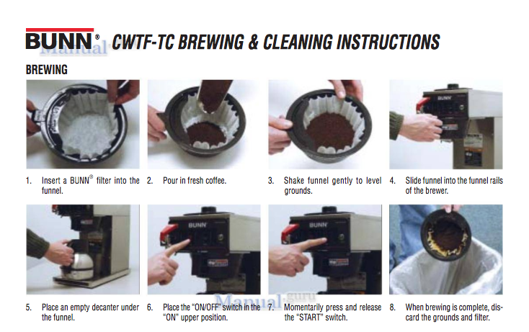

DO NOT ADD WATER!
This is an automatic coffee maker. There is a waterline directly attached. No water needs to be added to the machine.

At Closing

- Turn the Coffee maker “OFF” (switches on front of machine)
- Wash the coffee pots
- Wipe down the coffee machine

10.4 POPCORN
- Turn all switched “ON”
- For the first batch only, let the kettle heat about 4 minutes
- Add the following to the kettle:
  - ¼ Cup ButterIt oil
  - 1 tsp salt
  - 1 Cup popcorn kernels
- Dump the popcorn kettle when popping is about 99% complete (popping sound slows to 1 a second)
- Turn off all kettle switches except the light

WARNING: Keep the kettle switches “OFF” when not popping. Failure to do so will cause overheating, machine smoking, fire alarms to sound

At Closing

- Unplug this unit before cleaning
- Clean out all the popcorn
- Dump the kernel trap
- Remove all metal pieces and wash (excluding kettle)
- Wipe inside windows with paper towels

NOTE: DO NOT clean this machine with Windex or other ammonia cleaners. It will damage the finish and doors. Clean only with soap and water.
10.5 PRETZELS/PIZZAS/COOKIES
- Preheat the pizza oven.
- Bake product according to instructions above oven

At Closing
- Turn off the pizza oven (Do Not Unplug)
- Clean the outside of the oven
- Wipe off the inside grill (do not scrub with anything)
- Turn off the warmer and wipe down (Do Not Unplug)

10.6 SMOOTHIES

- Serve Smoothies in clear plastic cups with dome lids
- Top with whipped cream and sprinkles if desired (and time permitting)

Refilling Machine
- Pour 1 bottle of fruit juice into machine
- Fill the fruit juice bottle with cold water from faucet and add to machine – do this twice
(1 bottle fruit juice + 2 bottles of water)

At Closing

- Wash the overflow trays
- Wipe down the smoothie machine
- Leave machines running

11.0 Closing for the day
There are detailed closing instructions in this manual. If there is food left over at close, please try to sell at 1⁄2 price or 2 for 1 to aid in lowering our loss.
Closing preparation can start before the concessions window has closed. Be sure to maintain a watch on the window to ensure customers do not have to wait as you are cleaning. The window can officially close with 3-5 minutes left in the final game of the day.

11.1 Closing Procedure Checklist

- Restock supplies?
- Cappuccino machine full? Do NOT turn off!
- Pop and Water in refrigerator (stock new behind the old)
- Candy and Chips
- Ramen Noodles and Mac n Cheese
- Napkins, Straws, Coffee sweeteners
- Turn off Coffee machine (switches on FRONT of machine ONLY)?
(Do NOT turn off cappuccino machine)
(Nacho Cheese machine automatically turns off)
- Turn off Pizza/Pretzel oven?
- Turn off Pizza/Pretzel warmer?
- Turn off Popcorn machine?
- Ensure freezer doors are closed tight?
- Clean everything you need to?
- Wash dishes
- Wipe down Nacho machine
- Wipe down Coffee machine
- Wash Coffee pots
- Wipe down Cappuccino machine
- Wash Cappaccino trays
- Wipe down Pizza/Pretzel oven (outside)
- Wipe down Microwave (inside and outside)
- Wipe down Pizza/Pretzel warmer (inside and outside)
- Wipe down Popcorn machine (inside and outside)
- Wipe Fridge handles
- Wipe down counters
- Put away pickles, ketchup, mustard, napkins, stir sticks (counter stuff)?
- Closed the concession window and locked it?
- Reload cash register?
- Deposit excess money into lock box below counter?
- GARBAGE out to the arena dumpster – new bags in the garbage cans?
- SWEEP the floor?
- MOP the floor?
- Turn the LIGHTS OFF and LOCK THE DOOR?

11.2 Closing Procedure Cash Register

- Count all $ bills, enter as End Amount on “DCYH Receipt”
- Place the following amt back into the cash register for Start Amount
50 in 1’s = $50.00
10 in 5’s = $50.00
6 in 10’s = $60.00
3 in 20’s = $60.00
$220.00
- Start a new “DCYH Receipt” by filling in Start Amount, place in register
- Select “Reports” menu option
- Select ”Current Drawer”
- Select “End Drawer”
- Enter counted End Amount in “Actual in Drawer” field
- Select “End Drawer”
- Select “Confirm End Drawer”
- Select “Start Drawer”
- Enter Start Amount into “Starting Cash” field. Adjust the default amt if you could load $220.00 as instructed in step 2
- Select “Confirm Start Drawer”
- Press “1” at bottom of screen
- Select “Checkout” menu option to ready register for the next day
- Place remaining dollars and completed receipt (step 7) in money bag and deposit in lock box under counter

Dodge County Youth Hockey
wants to THANK YOU for your help!
It’s people like you that keep our association going!

