Get your t-shirt for the first home football game on Sept. 6
Trojans remember 9-11 and are helping our own
Hero Bryan Powell make it to the 2016 Paralympic Games in Rio.
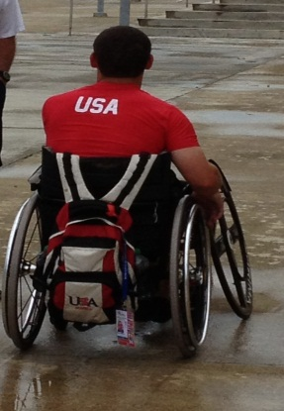
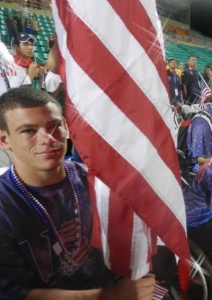

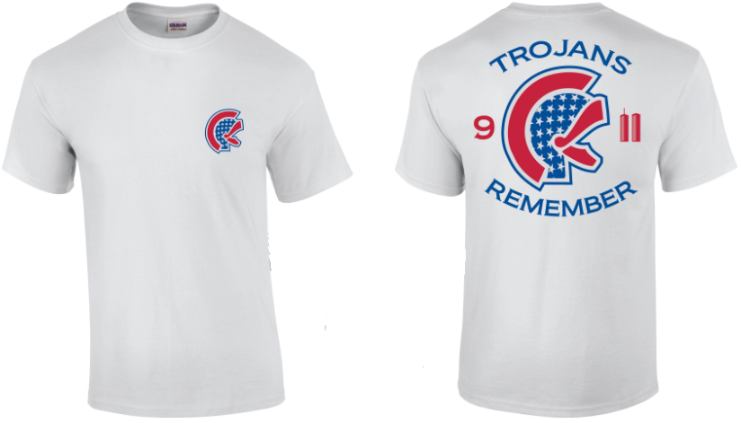
$10.00 $10.00

Cash or Check made payable to Lassiter
T-shirts will be sold in skylight before school and during all lunch periods
starting Wednesday, September 4.

Sponsored by Lassiter FBLA and the Sports Information Department
Contact Information: carol.pizza@cobbk12.org OR lindsey.taylor@cobbk12.org

