Activities

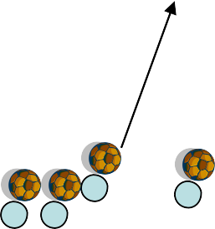Across the water

Set Up and Rules
- Area 30x20 yards square
- Each player has 1 ball
- 1 shark in the middle
- On coaches call Players have to get from one side of the pond to the other. If the shark kicks the ball out of the field They also become a shark
- Sharks can’t go out of square

Variations

Coach calls out two or more players at a time either by numbers or by colors that they are wearing

Progressions

- Start with Shark only moving on all 4’s (crab walking)
- Sharks can only walk
- Sharks have no restrictions

The pyramid game

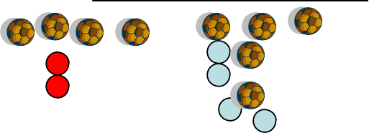


Pyramid is five balls with One Sitting on top

Area – Two lines 20 yards apart 2 teams of 4

Players dribble their ball in a relay race style To the opposite line. When they return they
Tag the next player and they take their ball across.

Once the team has all of their balls on the
Opposite line they can make a pyramid with one ball on top

Variations

Have one team going North/South and another going East/West

Progressions

  - Start the players carrying their ball across
  - Players can dribble their ball across
  - Add in a coned gate that they must dribble through

Cowboys and Indians Area 20x15 with as many balls as possible

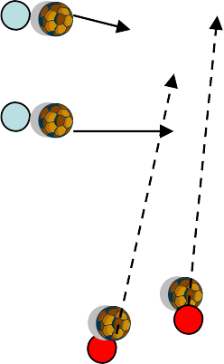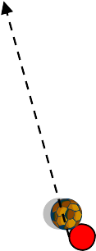Two teams Cowboys and Indians
The Cowboys have to run with their horse (soccer ball) from one end of the valley to the other. The Indians must fire their arrows from outside the Valley and hit the cowboys horse (soccer ball). If a cowboy’s horse gets hit they become an Indian. The winning player is the last to get caught

Progression 1

Have the Cowboys get progressively slower when their
ball gets hit
    - Run across the valley
    - Hop
    - Crawl across the Valley

Progression 2

Have the Indians run across the Valley

Get the Duck

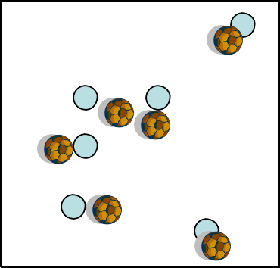Area 15x15 yard square

Each player has a soccer ball and the coach is the duck On the call “get the duck” the players try to kick their ball and hit the duck

Progression 2
Change the duck

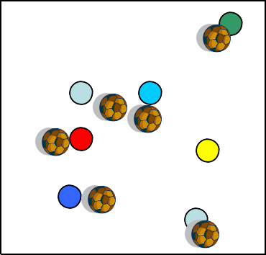Progression 3
Have the players pick different animals and the coach can choose which animal to get

Progression 4
Make some safe houses for the animals to take shelter
during their season

