Team Building

Game 1 Tag Area 15x25
Players run around and try to tag as many players as possible
•Players try to tag as many as possible without getting tagged
•Same activity but with a ball
•Have one tagger and play freeze tag

Game 2 Ameba Tag Area 15x25 All players with a ball each
One player is the tagger
When players get tagged they join the Ameba
Can they beat their previous score

Ameba’s must tag / kick the ball

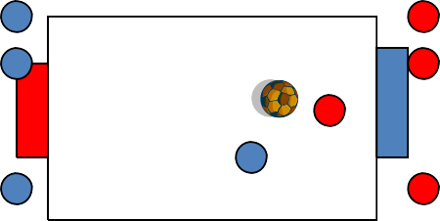Game 3 Back to the coach Area 15x25
Players have a ball each and must get it to the coach as many
c times as possible
- With different surfaces/ head/ feet
- Coach should slowly eliminate what they cat use
2. In pairs- joined together or combining

Using two different surfaces (one knee and one elbow
Game 5 The zoo- Area 15x25 with a 10 yard coned goal
Two teams each with a Lion, horse, elephant, Monkey, try to
get the food (Ball) Into their Zoo (Goal) which is opposite The coach calls out 1 animal at a time
Progress to letting the remaining animals guard the zoo on
the condition that they are joined together
Coach moves around to promote awareness

Praise Combination play

Team Building

C
Back to Goal

Area 30x40 with one 5 yard goal
Players have 1 ball each and must get the ball into the goal as many times as possible. On scoring the coach throws the ball into space
C

Progression –have player work in pairs linking arms or
holding hands to try and get the ball back to the goal.
Progression- Have one player face one direction and
the other face the opposite way
Progression- Have groups of 3 building up to two equal teams
Progression -finish with a an entire team Joined up and add balls for repetition and another goal to score in so they have to work together

To promote kids working together and solving problems without adult intervention

