Passing

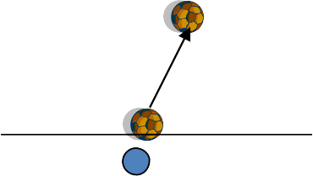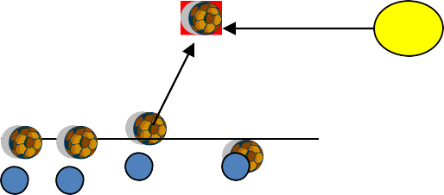Bowling

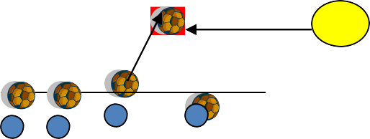20 yards

In pairs with 1 ball each Player 1 kicks their ball
Player 2 tries to hit it when it stops With his ball.
Player 2 gets 1 point if he hits the ball
Players switch roles each time
C

Progression 1
The coach now passes a ball and all the players have 1 attempt to get their ball the closest. Players can knock away the other balls with their ball

Progression 2
C Divide the players up into two teams and put them all 10 yards away from the ball The team with the closest amount of balls wins

