3rd Annual CFPO Holiday Bowl  Player Registration Form  League Website: www.cfpo-palyouthsports.com  Tournament Director: Adrian Almendarez  Email: adrianalmendarez@yahoo.com  Phone: 210-473-1963 | 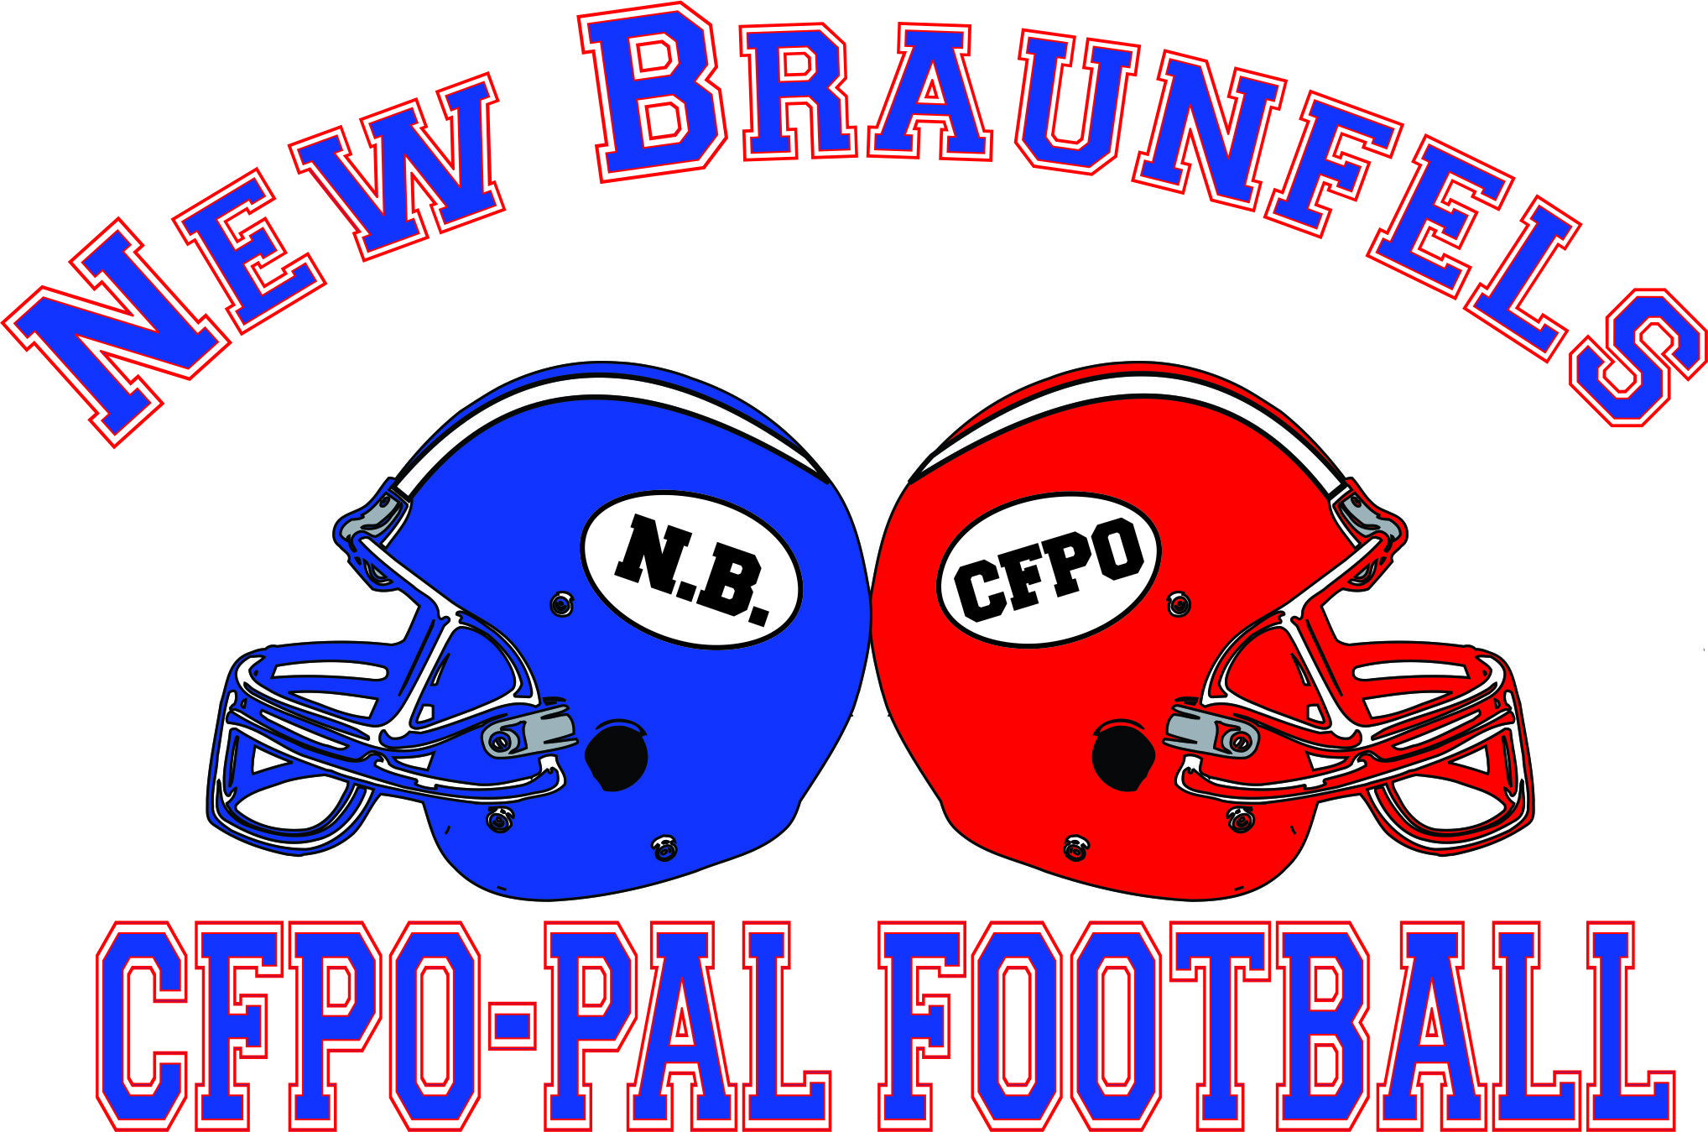
Please check appropriate box(s):
Official Use Only
City | Age | Team Name
PeeWees (7-8 yrs old) Juniors (9-10 yrs old)
Seniors (11-12 yrs old) Majors (13-14 yrs old)as of Aug 1, 2013
IMPORTANT: Please attach a copy of the birth certificate & current photo.

Please print or type legibly
Last Name | First Name | Birth Date | Weight | School | Grade
 |  | / /
Address |  |  |  | City | Zip Code

Parent/Guardian First and Last Name |  | Relationship
Home Phone | Work Phone | Cell or Pager
( ) - | ( ) - | ( ) -
Email Address

Parent/Guardian First and Last Name |  | Relationship
Home Phone | Work Phone | Cell or Pager
( ) - | ( ) - | ( ) -
Email Address
Is this child covered by insurance? Yes No (If not, please check insurance waiver below)

Insurance Waiver: I, Guardian of this child, do not have my own Health/Injury insurance coverage. I assume all risks and hazards incidental to such participation without health/injury insurance coverage and do hereby waive, release, absolve, indemnity and agree to hold harmless the CFPO, the host organization, the teams, the sponsors, directors, supervisors, participants, volunteers and any other persons involved in the CFPO.

I, the Guardian of the above named child, hereby give my approval to his/her participation in any and all CFPO Football/Cheer activities during the tournament. I understand that football as well as cheerleading is a dangerous sport that may result I serious injury or even death. I assume the risks and hazards incidental to such participation including transportation to and from such activities, and I do hereby waive, release, absolve, indemnity and agree to hold harmless the CFPO, the Host Organization, the teams, the sponsors, directors, supervisors, participants, volunteers and persons transporting my child to and from activities for any claim arising out of injury to my child.

Physical Examination: I, the Guardian of this child, believe to the best of my knowledge that he/she can withstand the rigors of a football & cheerleading season. I, the Parent/Guardian, believe there is nothing physically/mentally wrong with my child. I, the Parent/Guardian, hereby give my approval to my child to participate in the upcoming tournament without a physical examination which is recommended by the CFPO. I assume all risks and hazards incidental to such participation without a physical and do hereby waive, release, absolve, indemnity and agree to hold harmless, the CFPO, the host organization, the teams, the sponsors, directors, supervisors, participants, volunteers and any other persons involved in the CFPO.

Emergency Medical Authorization: I, the Guardian of this child, hereby give my authorization for any emergency medical treatment of the participant for any injury resulting from any activity of the CFPO. It is understood that efforts shall be made to contact the undersigned prior to rendering treatment to the injured participant. This authorization will expire on 12/31/13.

Equipment Liability: I understand that players also should provide their own shoes, which should be all-purpose football shoes with molded sole rubber cleats. Metal cleats are not permitted.

Age Verification: I, the undersigned give the CFPO and its agents the right to verify my child’s age with his/her school if my child’s age comes into question or is challenged by a CFPO organization.

Yes No – My child’s picture or likeness may be displayed on the CFPO/host organization web sites.

I have read, understand, and agree to the above information:
Parent/Guardian signature: |  | Date:

