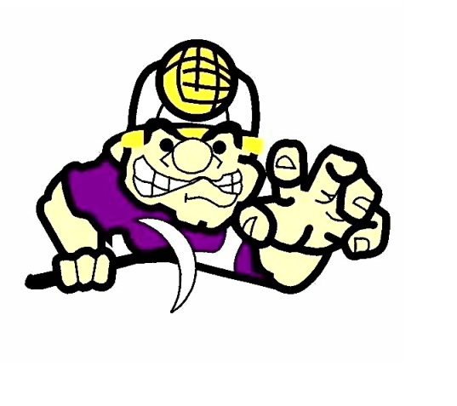
MINT HILL MIDDLE SCHOOL
Athletic Booster Club

Athletic Fundraising Guidelines

Mint Hill Middle School athletes, teams, and clubs are encouraged to develop and implement ideas to generate funds to help their respective sport. The following guidelines are in place to provide order and direction over fundraising activities and to prevent activities from becoming too numerous and demanding on employees, students, and the general public. These guidelines cover all fundraising activities related to MHMS athletics, including activities at athletic events in the community.

•Fundraising activities must be pre-approved in writing by the appropriate person within the Charlotte Mecklenburg School system. It will be the responsibility of either the athletic booster club board and/or the athletic director to ensure that such an approval has been obtained.
•A coach or employee of the school must be designated as a primary contact person for the fundraiser.
•There must be proper controls in place for the collection of money. The booster club may be used as a collection and disbursement point in this regard, if desired.
•Sales efforts must be tasteful and take into account the overall experience of the fans.
•Solicitations may not be made within the stands during an event.
•All fundraising activities must comply with the law.
•Fundraising organizers are responsible for the setup and removal of all tables, chairs, etc. used.
Adopted: October 30, 2012

