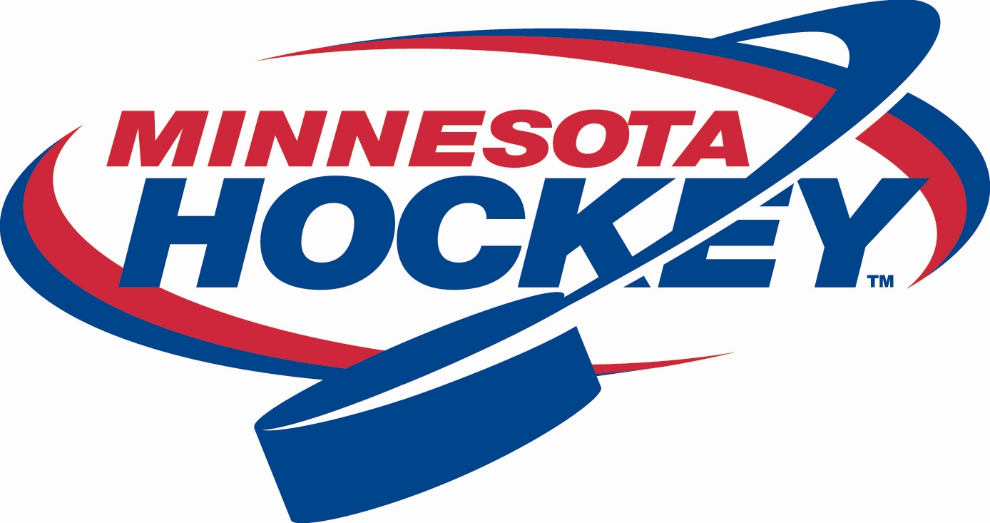
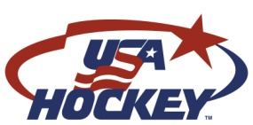
Minnesota Hockey
Membership Development Report
January 25-26, 2014

The Minnesota Hockey Membership Development Committee continues to make a significant and effective effort to increase the awareness of and participation in hockey through the utilization of available Minnesota Hockey and USA Hockey growth programs.

Mission and Goals

With a new Committee Chair in place, our committee met in December to further define our committee charter and start developing our mission, strategies and goals.

Mission: The Membership Development Committee provides leadership, program and grant opportunities and marketing and communication assistance to our community association leaders in a cooperative effort to grow the game of hockey.

Strategy: The primary role of our group is to facilitate communication between Minnesota Hockey, USA Hockey and our community based associations. To do that, we need to further establish a robust network of membership development contacts at the association and district levels. While developing that network, committee members will work to identify associations that are struggling to attract new families and provide support to that area.

Goals:
- Grow the 8U level by 10%
- Initiate monthly communication with each association in Minnesota
- Work to integrate a growth program in coordination with Hockey Day Minnesota 2015
- Clarify and update our grant programs for the 2014-15 season
- Create a Minnesota Growth Calendar of Events
- Develop a Minnesota Wild Learn to Play program for the late summer and fall of 2014

Nov. 2nd Try Hockey For Free Results

On Nov. 2nd, there were 74 sites in Minnesota that hosted Try Hockey For Free Day and a total of 1,863 participants were reported. Both of these numbers were not only records for Minnesota but set the bar for any state in the US. See the table below for a breakdown by age group.

Age Breakdown | # of Participants*
6 & Under | 1,037
7 & 8 | 429
9 – 12 | 282
The membership discount provided by USA Hockey was also a success. Minnesota had 139* players redeem the discount which was the highest in the U.S. and meant 19.5% of THFF participants ages 7-12 registered to play more hockey this season.

*All THFF statistics were as of Dec. 13.

March 1st – Try Hockey For Free

On March 1st, USA Hockey is hosting the second Try Hockey For Free day of the season in conjunction with Hockey Weekend Across America. The event is positioned capitalize on the excitement revolving around the Olympics, which will be furthered by NBC’s free promotion throughout the Winter Games. As of January 23rd, Minnesota has a total of 54 associations hosting events at 52 sites. Here is a summary of the participating associations by district:
District 11
Two Harbors
Woodland (Duluth)

District 12
Ely
Hibbing

District 15
Alexandria
Fergus Falls
Long Prairie

District 16
Bemidji
Crookston
District 9
Albert Lea
Austin
Mankato
Northfield
Red Wing
Rochester
Waseca

District 10
Andover
Cambridge-Isanti*
Champlin Park
Coon Rapids
Mora
North Branch
Princeton
St. Francis

District 5
Becker/Big Lake
River Lakes
Sartell
St. Michael Albertville
Willmar

District 6
Bloom. Kennedy
Burnsville
Chaska Chanhassen
Eden Prairie
Prior Lake
Richfield
Shakopee

District 8
Apple Valley
Eagan
Inver Grove Heights
Sibley
South St. Paul

District 1
City of Lakes
Edgcumbe

District 2
Forest Lake
Highland/Central
Roseville
Tartan

District 3
Delano
Hopkins
North Metro
Orono
Osseo/Maple Grove
St. Louis Park

District 4
New Ulm/Sleepy Eye

Current Action Items

Growth Workshops - We are currently working on planning our second year of growth workshops. As of now, we are looking at conducting two open workshops in the metro area and coordinating the outstate workshops with each district, in hopes of better attendance in those areas. The metro area workshops will once again be held in April.

Growth Award - The committee has had initial discussions on the subject of awarding a statewide growth award at the annual banquet in recognition of an association or individual making a special effort to grow the game in their community. A decision will be made in the near future on whether to start the award this season or wait for another year.

Online Community - We are looking at developing an online community where association leaders can communicate quickly and easily with Minnesota Hockey and membership development contacts at other associations. The original plan is to use our current website platform which has some capabilities that may allow this type of cooperation and collaboration. If ready, this platform would be introduced to the associations during this spring’s growth workshops.

