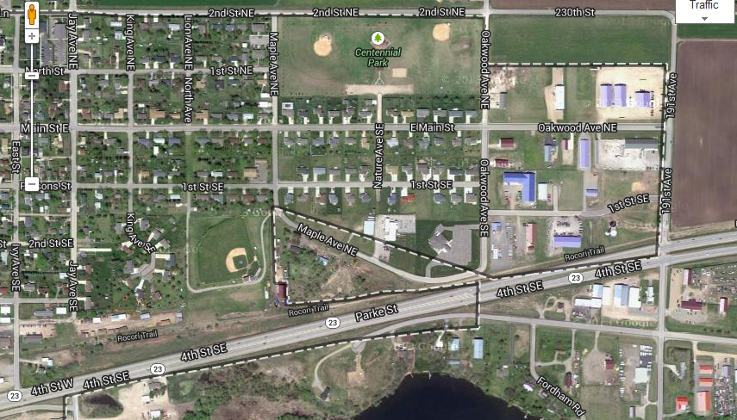
Richmond Field
From St. Cloud, take MN23 West to Richmond
Turn right on 191st Ave
Turn left on 1st Str SE
Turn left on Oakwood Ave SE (it turns into Maple Ave NE)
Field is on your left

