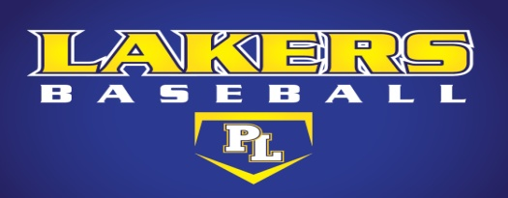
PRIOR LAKE BASEBALL PROGRAM
SKILL & DRILL FOCUS: WARM-UP

1. TEAM CARDIO WARM-UP
-Team starts from 1st/3rd base coaching box
-Team jogs down foul line to fence – along warning track to opposite foul line and back
-Team lines up on foul line

2. TEAM STRETCHES
-Walk out stretches to 2B
-Knee Pulls (pull knee to armpit)
-Frankenstein kicks /Toe Pulls (arm reaches down and grabs opposite foot)
-Walking Lunge (hip turn to side after each lunge)
-Sideways Lunge (switch lead leg half way)
- Power Skips (drive the arms)
- High Knees/Butt Kicks (switch half way)
-Team lays down for SLEEPER STRETCH
-Team pairs up for PARTNER AIRPLANCE STRETCH

3. TEAM SPRINTS
-Team jog to 2B
-Team jog back to foul line – half way team sprint to foul line
-Team sprint to 2B
-Team sprint to foul line

4. SHOULDER EXERCISES
-Arms straight above head – Slight bend in elbow
-Karate Chops (20) -Swimmers (20)
-Small Circles (20) -Reverse Small Circles (20)
-Arms straight out at side – T position
-Power Claps (20) -Pronated Power Claps (20)

5. BAND WORKOUT (OPTIONAL FOR NON P)
-12-15 Row (Set at EYE level)
-12-15 Reverse Fly (Set at EYE level)
-12-15 Punch Plus (Set at EYE level)
-12-15 90/90 (Set at KNEE level)
-12-15 Scaption (Set at KNEE level)
-12-15 Incline Plus (Set at KNEE level)
-12-15 Victory (Set at KNEE level)

PRIOR LAKE BASEBALL PROGRAM
SKILL & DRILL FOCUS: WARM-UP

THROWING PROGRESSION
-Shoulder exercises, shoulder stretches, and band work already completed before throwing
1. Arm slot wrist flips
2. Direction – Extension (feet apart in athletic stance)
3. Figure 8 – Direction – Extension
4. Lead foot throwing
5. Lead foot into crow hop long toss
6. Work back in and progress into INF: Burn Out
OF: FB/GB transfers into crow hops
P: Mini bullpens
C: Transfers

Teaching Points: 1. Throw with purpose 2. Focus on target 3. Loose arm action
4. Start with lead foot 5. Track ball in 6. Move feet to ball

