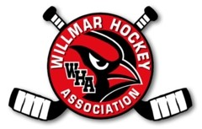
March 3, 2014
Civic Center
Meeting called to order 6:10 PM

Members Present – Kip O, Kent D, Priscilla W, Rolf F, Matt D, Kraig D, Melissa H, Karen S, Justin B

Secretary’s Report – not available
Treasurer’s Report – Motion to approve by Kraig D, 2nd by Melissa H – Approved
D5 – Brenda B was unable to attend tonight
Try Hockey for Free: Great turnout. Approximately 33 skaters and several helpers.
Fundraisers – A motion was made by Rolf F to eliminate the raffle for next year. 2nd by Priscilla W. Approved

Discussed moving Smith Open to a Friday.

Next meeting January 6, 2014 at 6 PM in the Civic Center.

