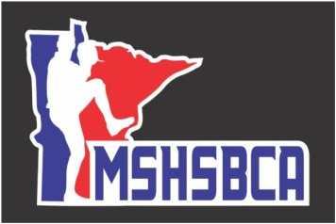
SCHEDULE for 2014 MSHSBCA COACHES CLINIC

Friday – October 24th:
4:45 pm Registration/Visit Exhibitors

5:30-6:15 pm George Tsamis, St. Paul Saints Manager – Have a plan/How to throw a Bull Pen

6:35-7:20 pm Rich Maloney-Head Baseball Coach, Ball State University—“Practice Organization”

7:45-8:30 pm Bob Rients, Head Baseball Coach, University of Minnesota- Duluth— Outfield Drills

8:30pm -???? Coaches Mixer

Saturday – October 25th:
7:30 am Registration/Visit Exhibitors

8-9:15 am MSHSBCA Meeting

9:30-10:15 am George Tsamis, St. Paul Saints Manager – PFP’s & How to Practice Them/Holding Runners

10:35-11:25 am Rich Maloney-Head Baseball Coach, Ball State University—“Double Plays for MIF’ers”

11:45-12:30 pm Jeff Albert-Hitting Coordinator for the Houston Astros-Hitting I

12:30-2 pm Lunch Break(on your own)

2:-2:45 Nate Damman, Bullpen Catcher for Minnesota Twins – “Catching….The Anchor of Any Team’s Success”.

3:05-3:50 pm Jeff Albert-Hitting Coordinator for the Houston Astros-Hitting II

4:10-4:55 pm Rich Maloney-Head Baseball Coach, Ball State University—“Infield Situational Defensive Play”

7-9 pm Hall of Fame/Awards Dinner

Sunday – October 26th:
7:30-8:45 am FCA Breakfast

9-9:45 am Jeff Albert-Hitting Coordinator for the Houston Astros-Hitting III

10:05-10:50 am George Tsamis, St. Paul Saints Manager – Pitch Grips & Mechanics

10:50-11:40am Matt Parrington-Head Baseball Coach Macalester College—
“Bunting—part of the Game Left Behind”

