Roll Call: Ryan Laferriere, Adam Welch, Joe Kuhn, Brooks Savage, Chuck Schiller, Randy Kruse, Travis Steele, KC Erredge, Jim Zgoda, Josh Colvin, Jeff Plank, Terry Johnson , Lisa Foster, Joe Kuhn, Matt Zaruba, Shannon Callahan, Ryan Stoffel, Brain Dooley
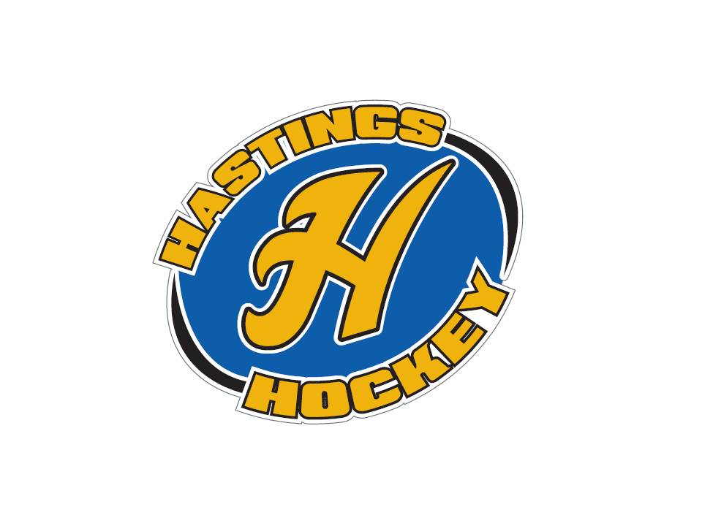

Not in attendance – Jesse Viall,
Approval of Agenda - motion made by Brooks, seconded by Ryan, motion passed
Approval of Minutes – motion made by KC, seconded by Brooks, motion passed

Coordinator Reports
Referee – Jesse Viall/John Klimek
Registrar – Shannon Callahan
Technology – Jay Stark/Randy Kruse
- Cleaning the website out, creating new email addresses out for next year. Wifi is down for the ice arena
Tournament Director – Jim Foster
Sponsorships – Terry Johnson
District 8 – Brian Dooley
- nothing new
- coaches had to go to meetings for misconduct, player went for kicking
Goalie – Josh Colvin
- things went well with equipment, might need a few things for next year
- talked to Adam about trying to improve coaching – software available to help??? Hockey boosters willing to purchase?? GoPro camera behind the net – someone with ipad etc can link in and download it. Josh is able to connect without actually being at the games. Seems under $1000
- Josh is wanting equipment back if goalies aren’t using it this Spring.
- Joe H still thinks we need to have goalie coaches at each level.
Secretary – Bernadette Schaffer - no updates

Officer Reports:
President – Joe Harris
- Asking retiring board members to come back next month to receive their “hardware”.
- Gave compliments to Chuck about how he ran the bantams the last 2 years.
- Jim Zgoda – great leaderships, transition years, good job even with the controversy over how we have changed the program. Asset to the board as he sees the long run, and how important this level was. Did a great job helping out with a minor injury this weekend at the tournament. Also thanks to him for stepping up to the B peewee level.
- Ryan L. – Stepped up to the plate with not having a ton of prior knowledge in hockey. Did a great job keeping things organized, stringing nets etc. Thanks for being willing to help out! Wrote about a grant to get equipment with the help of KC.
- Lisa – able to run a $500,000 machine with 100% volunteers. Able to figure out numbers so that we can run a smooth program. Everything in the program runs through Lisa, so her 4 years of service have been greatly appreciated.
- Jay Stark – he has been on the board for 15 years – able to explain just about everything that goes on in the board. He is able to fight for the rights of each level.
- Talked about the importance of our facebook page, please get others to “like” it to keep informed.
- 6 Teams still playing – PeeWee C teams still playing, Girls , Bantam C
- Reiterated that coaches are on a year to year approvals. Recommends that all coaching positions will be advertised for the 2015-2016 season. Harris talked about why he thought this was a good idea Coaches need to be held accountable for player development, support of program policies, professionalism, integrity, etc. Coaching in the Hastings Hockey Program is a privilege.
- Russ Welch , Hastings High School boys head varsity coach announced his retirement. Joe will reach out to Tom Johnson, activities director to learn about the recruitment process. He mentioned the importance of Hastings hockey being part of the vetting process.

Vice President – Brooks Savage
- ice scheduling – east rink is done tomorrow. Lots of last minute changes over the last month due to regions etc. Getting the latest ice bill this last month.
- Teams trying to give back ice time, do we have a policy on this??
- If changes are needed for next year, please let Brooks know. Please let Brooks know how many teams you will have for next year.
- Getting boards for next year for the mites program?? A net divider as like Wakota.
- Schedule is starting to be roughed in in April.
- Joe asked to look into River Blades and seeing if we can change her time frames as we are the biggest tenants, or see if she can partner up with us.

Treasurer – K.C. Erredge
- Shared the financials for the month of January -
Net income was (11868), current checking balance $187,273, Approx 66,000 in checks outstanding. Zgoda made motion, Brooks seconded and motion was passed.
- February financials will be ready in the next meeting
- Joe will ask for a net/loss for the 4 tournaments
- Districts will be $3,000 positive –
- River Rumble , Big Chill, Sugar Spice – positive about $15,000

Director Reports:
Volunteers – Lisa Foster
- Waiting for this last weekends tournament but thinking it is about 12 checks being cashed this year
Director of Hockey – Adam Welch
- Doing exit interviews this month
- Coaches with high school staff time for next year??
Operations – Ryan LaFerriere
- Waiting to get equipment back??? Might be keeping stuff for Spring??
- meeting with Matt to get him started for next year
Ter-Mites – Josh Colvin
- 90% showed up to get medals – Able to get ahold of many kids to see why they weren’t showing up and got them to come back
- Looking for a replacement for the future

- Looking at numbers for the next few years to see what we will need in the next few years, have 30 sets already so we shouldn’t need to purchase a ton more.
- Possibility of getting bags in the future? We do have 20 bags???
- 98 kids ended the season -Colvin has a large number of jerseys left over if kids need practice jerseys – would like kids to keep turning the jerseys in each year as they do that in the other years
- There was a discussion of whether or not they need to inventory the equipment for spring skating
- Joe H would like to give kids jerseys each year
Mighty and Super Mites – Jim Zgoda
- finished the season today – thanks to all the coaches
- Supers, U8 – changed a bit in the beginning of the season, tried the Squirt models and went to 4 teams on Sundays. Helped with kids who maybe weren’t as skilled to be able to touch the puck more. He feels as though this helped. Thanks to Adam and his wife who helped with scrimmages etc
- Need to rewrite evaluations ???

Girls – Jay Stark
- U12 finished season – battled hard
- U14 finished the season in regions
- U10 is setting up for districts next weekend in Farmington
- District checks - KC needs an address. She will get them sent
Squirts – Ryan Stoffel
- Wrapped up the season tonight, went well – another successful season
- model is right, working well. The point differential was within 2 points from the first place team and the last place team
Peewees – Joe Kuhn
- AA took fourth in districts, went to regions and lost against Rosemount by 1 goal. Lost to Stillwater – great game
- B teams did well but didn’t go to regions
- both C teams are still going!!
Bantams – Chuck Schiller
- A – VFW game is Tuesday
- B – done
- C – district starts on Sunday
Team size was discussed
Jr. Gold – Jeff Plank
- The team was set up last minute, didn’t have success, many disciplinary actions taken, no leadership
- Season wrapped up , assistant coach was here – John
- U16 team, rumor coming up???
- There were a lot of questions regarding district??
- Issues with locker room

Old Business -

New Business:
Raffle Survey – K.C. Erredge
- 74 responses
72% thought it was effective to keep costs down
majority liked the raffle as it is; although they feel it needs better explanation during the registration process; some wanted a few more, and larger prizes
calendar raffle – 58% said no
termites – discussion was held last year about whether to offer raffle tickets to termite families; was decided to keep program entirely free to them. However, just over 50% would like the option to purchase tickets.
84% would like to keep the raffle if removing it was going to increase costs
Discussion was held about whether there should be any changes made to the raffle; decisions will be made soon.

Business Promotion Programs – Terry Johnson
- Landscape businesses want to advertise and kick back a portion to the association.
Offer it to our sponsors first??
- We will talk to Rosemount and see how thy do it, is it worth it??

Team Distractions/Outside Influences – Joe Harris
- Parent reached out to Joe about an issue on the JR Gold team. She came to discuss how this could be handled in the future.

2015 Election Results – Election Officers
- Motion to approve the results – Jeff Plank, seconded by Brooks motion was passed.
- Introduced Terry Johnson as the new volunteer position
- Introduced Travis Steele, and Matt Zaruba to the board, Donny new to Bantams

Board Comment –
Membership Comment - Adam Hoffman - chatted about U8 - 28 players for traveling program – paid for by the parents.

Adjournment and Notice of Next Meeting: TBD (April 5th is Easter Sunday)

meeting adjourned at 10:03 motion made by KC, seconded by Brooks.

