Team Minnesota 2015
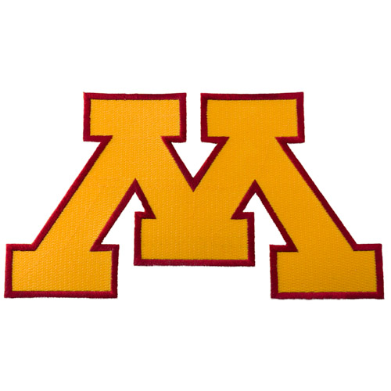

Name # Position HIghschool College Attending
Julia Luciano 22 3B Eastview North Dakota State Univ
Kennedy Haney 11 P Maple Lake Saint Catherine Univ
Kelsey McAllister 23 P Centennial Bemidji State Univ
Shannon Petersen 30 P Edina Augustana College
Bhrett Zahnle 5 2B Hayfield Luther College
Makaela Egan 7 OF East Ridge Univ of Alabama
McKenzie Paap 8 OF Minnetonka Minnesota State Mankato
Lauren Reimers 2 SS Morris Area North Dakota State Univ
Kylie Olson 15 C Maple River Central College
Anna Gimmestad 3 SS Wayzata Bucknell Univ
Kerrigan Hoshaw 32 P Eastview Univ of Sioux Falls
Moira Carlson 9 1B Jackson Co Central Univ St. Thomas

Coaches
Laura Olson Maple River
Dawn Engebritson Rockford
Kim Bowen Big Lake

Director
Shelly Hotzler Jackson Co Central

