10 Things to Know As A Softball Player
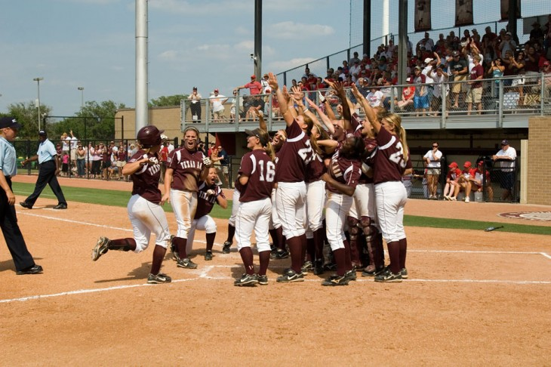
From one softball player to another, I wanted to give you a few things to do and know that can help you become the best softball player you can be. Here are 10 things to know as a softball player (no matter your age or level).
1.Take Care of Your Glove.
Your glove should not look like a pancake. Pay attention to how you care for your glove. Keep a ball in it. When you set it down on the ground, set it down with the palm down. It should not look flat. This doesn’t change no matter how old you are or the level you play at. The way you take care of your glove is representative of how much you take pride in small details of this game. Small details of this game are VITAL for success.
2. Train explosiveness.
Think about it – our game is nothing but quick, explosive movements. Running to first base as quick as you can. One explosive pitch. 10 steps to run down a fly ball as an outfielder. One step to snag a line drive as an infielder. It does no good to run 4 miles. It’s better to do agilities or sprints. It’s better to do movements that are explosive – squat jumps, box jumps, broad jumps, etc. Those types of movements will help create the habit over time to be more explosive in every softball movement you do. Running long distance is great if you are trying to shed a few pounds, but that is not how our sport is played. Our sport is quick and fast. And that’s how you should train.
3. Listen to your parents, they can help you.
A lot of times your parents have the answers to help you make corrections. I know it’s hard to hear, but it’s true. Listen to them. Respect them. Build a relationship with them by communicating with how you would like to be given corrections, how often you would like to hear them or if YOU are going to be the one to go up to them and ask for their help. If they’ve been to lessons, practice and games with you, more times than not they have information that can help you, so develop a plan WITH your parents in how that information will be relayed and shared. They need to be able to listen to you, too, as you coach them on how to coach you where you can HEAR what they are telling you.
4. It’s cool to work hard.
You will come across teammates who don’t want to work hard for one reason or another. They will come up with excuses to get out of practice with the team, practice on their own, and games. No matter what anyone else is doing, know it’s super awesome to work your hardest at anything you are doing. Limit excuses and go out and play.
5. You are not defined as a person based on how “good” you are at softball.
Remember there is more to life than softball. 20 years after you are done playing, your friends will not remember how many strikeouts you had or how many homeruns you hit. They will remember if you were a good teammate, a good friend, and if you set a good example for younger players. Those things are more important than being labeled a “good” softball player. The awards you win or do not win as a softball player is NOT a direct reflection of the type of friend, daughter, sister or person you are. When your softball career is over, you don’t’ want someone saying, “Yeah she was a really good short stop, but I would not trust her as far as I could throw her.” Be loyal. Be trustworthy. Don’t gossip. Stay humble. Be appreciative.
6. Being a pitcher is not about striking everyone out.
Even if you are NOT a pitcher, this is an important one. Defenders – your pitchers are not going to strike everyone out. Get used to it. Make plays behind her. Pitchers – get it in your head that you are not going to strike everyone out, and don’t TRY to. Usually when you TRY to strike someone out, it doesn’t quite pan out how you want it to. Know your pitching strengths and how you get outs. The defense should be aware of your strengths such as best pitch, which side of the plate you throw to and if you generally get more ground ball outs or pop ups.
7. There’s always something to do in a game.
If you are at the ball field on a team, you have a job to do whether you are in the starting 9 or on the bench waiting for your chance. Even if you are injured and are not going to play, you can still contribute. Pick pitches or signs, notice pitching tendencies, pick up your teammates who are down, chart pitches for YOUR pitcher, chart pitches of the opposing pitcher. Get creative with how you are finding a way to still help your team, because in the end, if you are on a team, you are wanting to WIN even if you are not the one starting at your position.
8. It’s good to play multiple sports.
Playing multiple sports makes you a more diverse athlete. Every sport is going to work different muscles and different athletic skills, so the more sports you play, the better athlete you become. Don’t live your life in fear of getting hurt – that can happen anywhere. Be ATHLETIC. It’s one of the biggest things coaches look for when you get older, and you can develop a more diverse athletic skills profile by tackling different sports.
9. With every rep you take, you are either getting a little better or getting a little worse.
If you are going to practice, make that time worth it. The most valuable thing we have is time. So if you are using your time to take reps, take those reps and get BETTER. If you are not paying attention to your reps and just going through the motions, you might even be getting a little worse. Every time you go out to practice, remember that day you are either getting a little better or a little worse.
10. You will not be perfect – accept it.
You chose to play softball. Understand that this choice comes along with the fact you will NOT be perfect. Find a way to balance trying to be perfect with the acceptance that it is not going to happen. The longer you hang on to being up set that you were not perfect in a game, at practice or for a certain rep, the longer it takes to recover and get better/grow. Learn from your mistakes more than you hang on to them. It’s ok not to be perfect. Every person you play with, against, or who you have watched played before and may even look up to, has not been perfect at this sport. You are not alone. Trying to be perfect and the inability to work through NOT being perfect is one of the biggest limiting factors your game can come up against.

