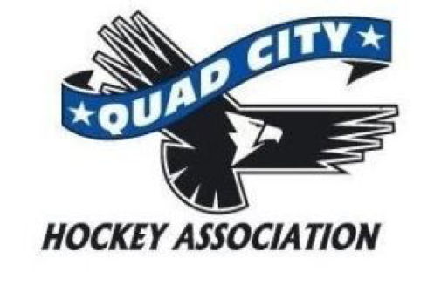

Meeting Minutes
Monday, December 1, 2014
6:00 pm The River’s Edge

Call to Order 6:05

Present: Mike Hurd, Anne Gannon, Cory Nelson, Jay Freiburger, Marv Wise, Allen Arndt, Mel Muskopf, Lori Sturtzer

Excused Absence: Todd Larsen, Bill Shink, Elliott Little. Anne made motion to approve, Cory second - All approved.

Approval of Minutes – November Minutes. Cory made motion to approve. Anne second. All approved.

New Business:
- A request was made to ask the City of Davenport to repair the sinks in the Women’s restroom. Mike Hurd will communicate this request.

Old Business:
- A deposit policy for travel hockey will be drafted by Anne Gannon.
- According to MWHA, no alcohol will be served during the Blues games. Mike Hurd will verify with the city regarding sale times.

Director reports:
President – Mike Hurd
- Try Hockey for Free – 47 participants. Following future Try Hockey for Free – need to promote One Goal.
Vice President – Elliott Little
- Patrik Levesque has asked for cross-promotion with dek hockey and ice hockey. Patrik will be invited to attend the January board meeting.
Treasurer – Anne Gannon
- Review of 990 Form. Submitted November 20, 2014. Anne made motion to approve. Cory second. All approved.
- Financial update was sent to all board members to day.
- Recent donation from John Deere of $2000. This is done through employee matching program.
- The city has billed the association through August 2014.
- Working on house budget. Needs enrollment by each level times the number of ice times per month.
Secretary – Lori Sturtzer
Coaching – Ed Odegard
High School – Marv Wise
- Marv has resigned form this position. Recommends Jay Carr as Interim Director. He will fill this position until the upcoming election, Spring 2015.
- Mike proposed motion 1-month interim for Jay Carr. Anne second. All approved.
Travel – Bill Shink
House – Jay Freiburger
- Schedule ready this week. Jay will have Chris update the website accordingly.

One Goal –
- Cory brought forms to order equipment for One Goal. Will do exterior banners to promote this program.
At Large – Volunteerism – Allen Arndt
At Large – Asset Management – Cory Nelson
- Reviewed One Goal equipment order form. 16 sets small; 16 sets large; 24 sticks.
- Anne made motion to spend no more than $4000; as sized deemed necessary by One Goal Director. Allen second the motion. All approved.
At Large – Mel Muskopf
- Update of Player/Team Photos – good turnout at all levels.
- Need to refine the process for One Goal and LTP; names to communicate with parents.
- All photos will be mailed.

Committee Reports:
- Spirit Wear and coaches gifts have been shipped. Will arrive shortly.

Adjournment: Anne made motion 7:20 to adjourn the meeting. Allen second. All approved

Next Meeting: Monday, February 2, 2015, 6pm at The Rivers Edge

