Import Events to the Calendar (Games & Practices)

Over view:
The process consists of completing a spreadsheet with the relevant information and using the site to upload the information. Some basic information is needed to generate the events. The events appear on calendars depending on their tags. Events can multiple tags. For example, for a standard practice where we have teams on the ice, only 1 event needs to be created and have multiple tags associated to the event.

Access Admin Control Panel – Schedule Upload
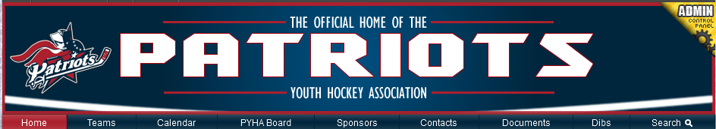
- Once Logged in, Click the yellow Triangle in the upper right of the Banner (Admin Control Banner)
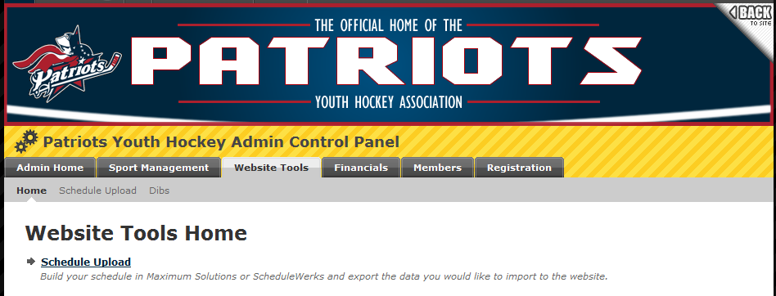
- Click the Website Tools tab
- Click Schedule Upload Link

Viewing Mapping Codes
- Mapping codes are the Abbreviations\variable that the system has created when assigning tags to the event
- Click Mapping Codes
- Select Non-League Teams
- Mapping Code equals the TAG entry
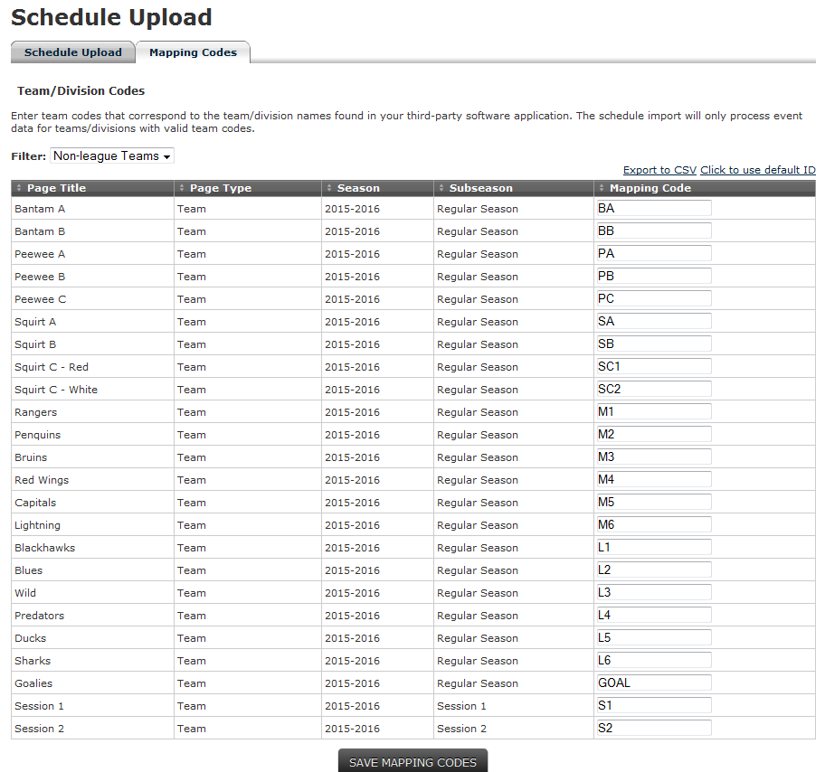

Completing the Spreadsheet
- Download the Event Import template
  - Home > Coaches > Managers > Event Import Template
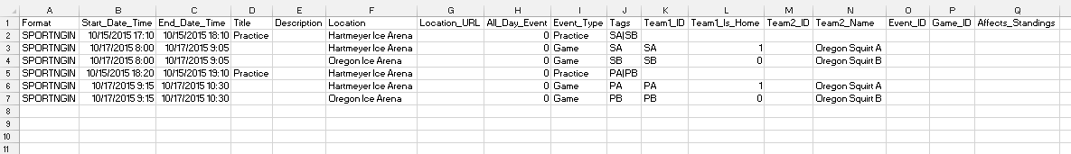
- Complete the form
  - Format = SPORTNGIN
  - START DATE = mm/dd/yyyy HH:MM (Military Time)
  - END DATE = mm/dd/yyyy HH:MM (Military Time)
  - LOCATION = Name of the Ice Arena (Sport Ngin is working on a Arena/Facility Node)
  - EVENT TYPE = Practice or Game
  - TAGS = Abbreviation for team(s)
    - Teams are separated with a Pipe ( | )
      - Mite Practice = M1|M2|M3|M4|M5|M6
      - Level 2 Practice = L1|L2|L3|L4|L5|L6
      - Bantam A & B Practice = BA|BB
    - Abbreviation are found on the site Under the Mapping Codes (See above)
  - If it is a game
    - Enter the TAG for the team for team 1
    - Team_1_is_home = (1= Yes, 0 = No)
    - Team 2 Name is the team name that we are facing
- Save the Spreadsheet
  - It needs to be saved as a CSV file not an XLSX

Importing the CSV File
- Click the Schedule Upload Tab on the Schedule Upload Page
- Click Browse and locate the file
- Make sure Sport Ngin File Format is checked
- Replace all previously uploaded events not Checked
- Click Upload & Process File
  - System will chug and finally display if you had an errors
