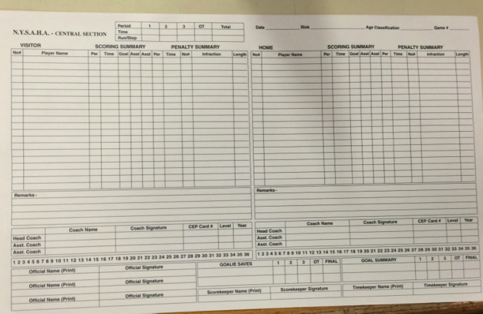

Here is a picture of the whole scoresheet. At the top right corner of the form, please indicate the date, rink (Morrisville Iceplex), Age Classification (12U), and game number, which you can get from Rod.
When you look at the score sheet in it’s entirety, you will notice there is a large section for the Visiting Team on the left and a section for our team (Home) on the right. All player names and numbers should be filled in prior to the game. (Once our side is all filled in, find someone from the visiting team who can lead you to the individual who fills their sheet in.) Stickers are not recommended but if a team uses them, they need to be on all three copies.
Underneath each of those rosters, the coaches should print and sign their names before the game as well. Most of the time these items will already be filled in when you are handed the sheet.
At this point, I need to encourage you to tell the refs before the game starts that you are a new person filling in the score sheet. They will help you if they know this. :)

Examples: | Clock Reads | Subtract from period time | Time to record on sheet
Penalty Occurs | 12:42 | 15:00 | 2:18
 | 10:17 | 15:00 | 4:43
 | 9:36 | 15:00 | 5:24
 | 6:17 | 15:00 | 8:43
 | 3:22 | 15:00 | 11:38
 | 0:35 | 15:00 | 14:25
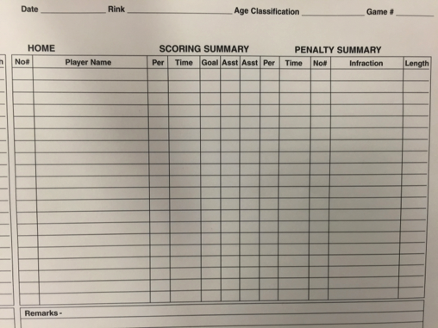

Next to the player rosters you will see “Scoring Summary” and Penalty Summary”. This is where you will write in all goals and penalties. Please note....the goal or penalty does not have to go NEXT TO the name of the player on the roster who it belongs to.....They are actually listed separately from the roster . Just write them down in the order they occur.
When a player scores, UNDER SCORING SUMMARY you must write in the Period, Time in the period (not time on the clock, so you need to subtract from 15), the number of the player who scored the goal, and the number of the player(s) who assisted the goal. The referee will come over and tell you the player numbers when a goal is scored. Please wait for the ref to give you this info.
When a player gets a penalty, UNDER PENALTY SUMMARY you must indicate the Period, Time in the period (not time on the clock, so you need to subtract from 15), the player’s number, the infraction and the length of the penalty (which is almost always two minutes). The referee will come and tell you the player number and the infraction. Please wait for the ref to give you this info

Examples: | Clock Reads | Subtract from period time | Time to record on sheet
Penalty Occurs | 13:26 | 15:00 | 1:34
 | 11:12 | 15:00 | 3:48
 | 8:43 | 15:00 | 6:17
 | 4:26 | 15:00 | 10:34
 | 2:15 | 15:00 | 12:45
 | 0:05 | 15:00 | 14:55
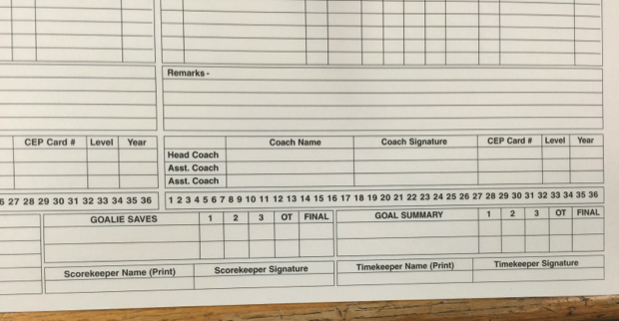

Before the game, please try to get all coaches from both teams to sign the sheet. If you miss someone, you can usually get them when they gather on the bench before the game begins.

You will also notice a row of numbers under the Visitors side, and one under the Home side of the sheet. (Right under the coaches signatures) You will use this list to indicate home many shots on goal each team gets. If a shot would have been a goal if the goalie didn’t stop it, it’s a shot on goal. The first time the team gets a shot, put a slash through the number one....and just keep going from there. (Typically you and the person running the clock keep each other in check on this number!) If the shot ends up being a goal, circle it instead of slashing it. And to help you calculate at the end of the game.....Go ahead and put a thick line between the numbers at the end of each period, dividing the shots on goal into three sections. This will help when you......

Count up goals and saves for the summaries at the bottom of the sheet. As you can see in the picture, you need to write in each team and list their “Goalie Saves” and “Goalie Summary” for each period.

Then at the end of the game, you, the Timekeeper (Clock) and the refs will all sign the sheet.

Please remember that the Timekeeper and the refs will help you!

Include picture of a completed one here

