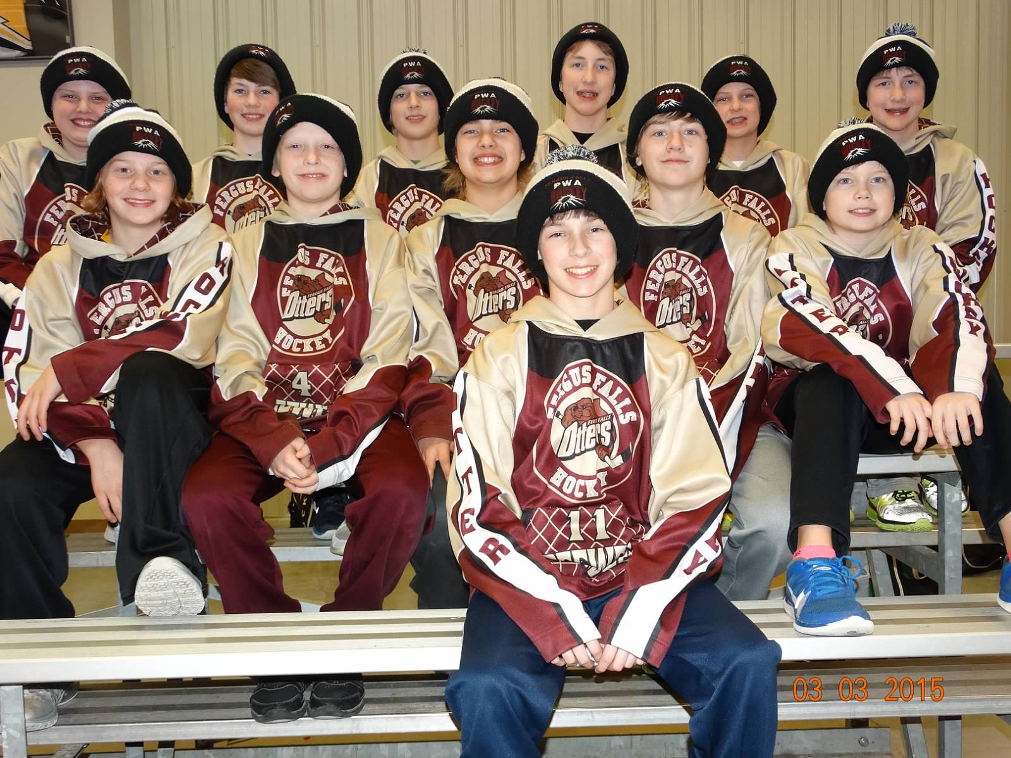
Pee Wee A’s Season Ending Results

The Zero Variance Pee Wee A Team matched up against Detroit Lakes for the first game in District Play. The Fergus Team held the Lakers scoreless for the first eleven minutes in the first period. Then, Detroit Lakes responded with four unanswered goals. Fergus Falls held the Lakers to one goal in the second period but they were unable to generate any goals. The Lakers cruised to a 7 to 0 win. Goaltender Scott VanVoorhis saw 44 shots on goal. Next, the Fergus Fall’s Pee Wee Team took on Brainerd. Both goalies were solid in a fast-paced back and forth defensive game. Brainerd managed to put in three goals. Fergus continued to scramble in front of the Brainerd net. Blayne Schuetzle knocked one in with the assist credited to Kaden Peterson. Brainerd took a 3 to 1 lead into the third period. With back to back questionable penalties called against Fergus, the team fought off high pressured power plays by the Brainerd Team. The game remained tight with Fergus Falls peppering the Brainerd goalie until the end. Brainerd skated away with the 3 to 1 win. The Pee Wee A Team had one last battle in a dual against the parents and family members of their team. Injured team members Blake Schuetzle and Campbell Cichosz took on the role of coaches for the Pee Wee A Team. The battle was on as the Pee Wee Team matched up against siblings and parents. Declan Young was a surprise weapon for the Parent/Sibling Team when he took on the task of goaltending. He faced multiple shots from the aggressive Pee Wee Team. Drew Luhning filled the goalie spot for the Pee Wee Team as VanVoorhis was out ill. Luhning kept the Pee Wee Team in the game as he was continuously peppered by the Parent/Sibling Team. This high scoring game did not lack in entertainment and intensity. Despite being pulled off the ice and into the parent’s bench, Ethan Danner continued to fight for his Pee Wee Team. In retaliation of the previous episode, Pat Shol was pulled off the ice to face the whole Pee Wee Team Bench. A few of the other highlights include: Robin Andrews representing on behalf of all the mothers; Varsity players Peter Johnson and Kyler Peterson helping the parents look good; and “Best scorekeeper” honor bestowed on Jason Schuetzle during tournament play. The Pee Wee A Zero Variance Team was coached by Marc Bye, Brandon Crowser, and CJ Muxfeldt. An upcoming Team Banquet will close out the Pee Wee A Season. Thanks again to Team Sponsor Zero Variance!

