3rd Grade Drills/Emphasis
Warm-up (3 minutes)
- Lines – Run, jog, high knees, lunge, etc. their way to the half court line and other baseline. If you want, have them go sideline to sideline to change it up.

Stationary Ball Handling (2 Minutes)

- Around the World – Rotate ball around their heads, waist, both knees, individual knees, ankles
Stationary Dribbling (L/R) (5 Minutes)
- Single Hand dribbling – Feel the basketball with their hands, keep fingers wide apart, dribbling waist high, maintain control. Emphasis keeping their head up, ask them how many fingers you’re holding up
- Cross Over dribbling – Maintain control, work on pushing side to side, not straight down dribbling.
- Two Hand dribbling – Dribble two balls in each hand at once, dribble in one spot on the floor, control!
Dribbling While Walking (5 Minutes)
- Dribble Relay - Half court and back relay – Stress control. Regardless how fast they walk, always under control. Begin working on heads up, how many fingers are you holding up
- Two Hand Dribble Relay - Half court and back relay – Stress control. Regardless how fast they walk, always under control.
- Obstacle Course – Using cones or chairs, have them dribble between the cones/chairs, switching hands using the cones/chairs as defenders. Keep none dribbling hand up to keep ball away from defender
- Stop Light - Green Light (Go), Red Light (stop, but keep dribbling), Yellow Light (back up dribbling)
- Traveling - Show/discuss what traveling is and why we don’t want to travel
- Double Dribbling - Show/discuss what double dribbling is and why we don’t want to double dribble
Shooting (10 Minutes)
- B.E.E.F - Shooting Form (2 minutes)
  - Balance – footwork, toes to the target, knees bent
  - Elbow – Keep the elbow in, not out wide (does not have to be straight up and down)
  - Eyes – Eyes on the target, pick a target on the rim or backboard
  - Follow Through – Hand/arm should look like a Fish Hook/Goose neck. Ask them to freeze their follow through so they can show you their follow through and you can help instruct them.
- Around the World Shooting – Five spots around the basket, 5-15 feet from the basket, working on shooting up with proper form (2 minutes) Coach stand in front with hands up to get them to shoot up and help with their form
- Miken Drill – Starting the right or left block, each player shots the ball using the backboard, catching their own rebound they quickly move to the other block and shoot with their other hand. Right block, right hand, left block, left hand. This can be a timed drill, focus on using the proper hand to shoot.
- Lay-ups – Stationary – String attached to the same side knee and elbow. Work on it multiple times; ask them to hold the lay-up position. (6 minutes)
  - High Five - Start at elbow and have the kids take few steps and high five you with the proper hand and leg in the air like a lay-up
  - Two Line Lay-ups - Give them a ball and start them on lay-ups from each free line elbow. One line dribbles in for the lay-up, the other rebounds the ball. Later start the ball in one line and have them pass the ball to the opposite line as they are going to the basket for the lay-up.
Passing/Catching (5 - 8 minutes) – Hands always ready to catch a pass
- Partner Passing Moving – Back and forth the lane width apart and start moving going to half court and back while passing the ball back and forth to each other. Focus on moving and heads up, seeing the ball.
- Triangle Passing – Stationary – Work on passing and receiving but now incorporating pivoting them to the person they are passing to.
- 3 Person Weave - 3 person weave without a basketball – Half Court and back. Once they understand the concept, introduce the basketball into the weave without dribbling though.
- Star Passing – Create a circle with 5 players, one player starts with the ball, each player will pass the ball two players to their right. As they pass, they yell the player’s name they are passing to.
Triple Threat Position (Pass, Dribble, Shoot) (1 Minutes)
- Explain what it is, Pass, Dribble or Shoot
- Knees bent, ball on hip, swing through to the other side
- Tell them that at any point you may stop what they’re doing and say “Triple Threat Position” and they should instantly get into the position.
Defense (No reaching, stealing or hugging) (5-10 Minutes)
- Defensive stance – Knees bent, butt down, hands up, feet more than shoulder width apart. Keep their eyes on the dribblers chest
- Defensive Mirror - You can then dribble a basketball and have them follow you instead of mirroring your movements. They would be “defending” you. Have them between you and the basket and explain why that is important.
Shell Drill – Defensive Positioning (10 minutes)
- 3-5 cones on the three point line. Offense and Defensive player on each cone.
- Pass the ball around from player to player on each cone. Make sure they make good passes and go into Triple Threat position once they receive the ball. The Defense must move and adjust with each pass.
- The defensive players are not to steal or intercept the ball, since this is drill designed to emphasize proper positioning on the floor. The defensive players must work on proper positioning in relationship to the offensive player they are guarding. Below is a diagram of what the proper positioning should look like.
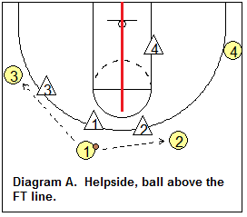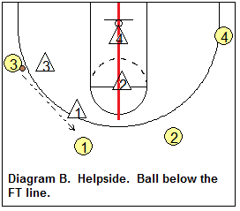
- The Offense can now move with the basketball using V-cuts, backdoors, pass/cut/replace and screening action to help simulate game like movements for the defenders. The offense should not try to score, only focusing on passing, catching, dribbling and correct movement/spacing for offense.

Read and React Basics (10 minutes) Use a similar cone positioning as the Shell Drill above.
- V-Cut - Introduce V cut to get open - Start with three spots on the three point line, one player or coach at the top of the key and two players on each wing. Wing players run down to each block and pop back out. Player 1 or coach passes to players 2/3 when they pop back out. Focus on hard cuts, good passes, catching to a triple threat position. See the diagram below for an example:
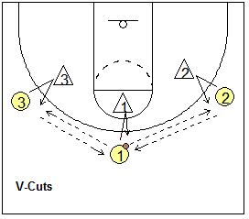
- Backdoor Cut - Introduce back cut (backdoor) – Same set up as V cut, but Player 1 will dribble at Player 2. Player 2 will cut hard to the basket, player 1 will bounce pass the ball to Player 2 and Player 2 will shoot a lay-up. Player 3 replaces Player 1. You can flip the side of the court, player 3 back cuts and player 2 replaces. Focus on hard cuts, good passes, dribble under control
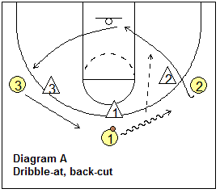
- Pass, Cut, Replace - Introduce Pass and cut – Start with three spots (you do not need 4 an d 5 as seen in the diagram below), player on each wing (2 & 3) and Player 1 at the top of the three point line. Player 1 start with the ball and passes it to either Player 2 or 3. Player 1 then cuts through the lane, Player 3 in the diagram below fills the spot player 1 just had, while player 1 will fill where player 3 was on the wing. Repeat over and over, working on passing, strong cuts, proper footwork.
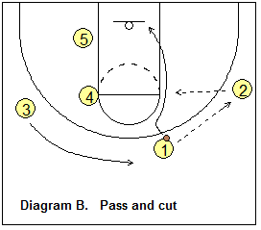
- Screening – Do not run into the defender (No tackling), Arms tuck to your chest or waist, Be strong with feet shoulder width apart, proper angle or position of the screen, get set quickly
- Down Screens – Start without a defender. You could have two offensive players. One player on the wing, another player on the block. A coach or third player could have the ball on top of the key. The player on the wing sets a down screen, the other player rubs off the screen, catches the ball, pivots, and shoots. Now repeat over and over. Your players are working on screens (part of your offense), pivoting footwork and shooting (skills). Focus on screen positioning and the other player not moving until the screener is set. No moving screens. See below diagram
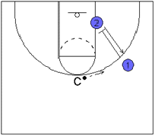
- Back Screen – Start without a defender – You could have two offensive players. One player on the wing, another player on the block. A coach or third player could have the ball on top of the key. The player on the block sets a back screen, the other player rubs off the screen, catches the ball and shoots a lay-up. Now repeat over and over. Your players are working on screens (part of your offense), footwork and shooting (skills). Focus on screen positioning and the other player not moving until the screener is set. No moving screens. See below diagram
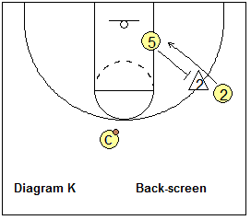
Ball Screen – Start without a defender – Player 1 has the ball and waits for player 2 to set a screen. Once Player 2 is set, Player 1 then can dribble the ball around Player 2 and drive towards the basket for a lay-up. See diagrams below.
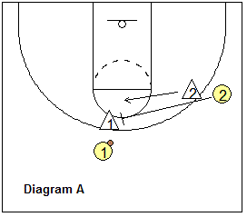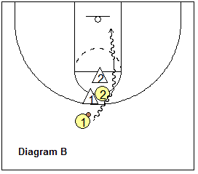

Introduction of Plays (Examples)
- Line or Stack – Side out of Bounds or underneath the basket out of bounds play. See below for the movement. You can also have player 3 screen for player 4 who then cuts down to the basket for an easy layup.
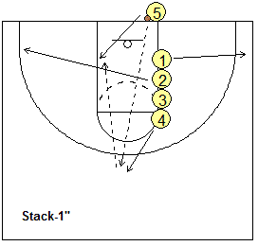
- 1-4 High – Introduce High 1-4 set, multiple plays can be run from this set.
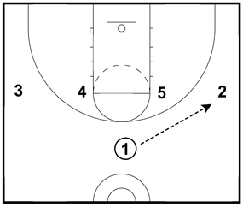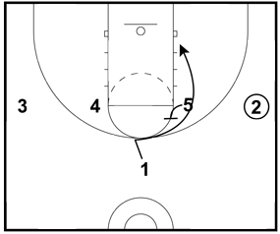
- In the above diagrams, player 1 passes to player 2, player 5 sets a screen for player 1 to cut to the basket and receive a pass from player 2 for a lay-up.
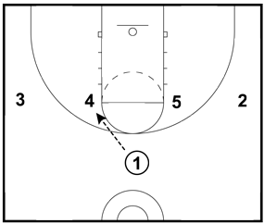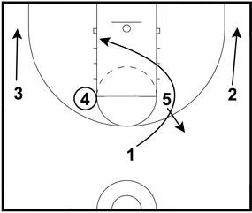
- In the above diagrams, player 1 passes to player 4. Player 1 cuts to the basket by going around player 5. Player 1 receives a pass from player 4 for a lay-up.

Scrimmaging
- Focus on drills you worked in practice. (Passing, dribbling, defensive positioning, proper cuts, etc..)
- Use a whistle - Blow the whistle to instruct. Remember to keep it positive so blow the whistle to point out positives as well as teaching moments
- Practice how you want your kids to play. Don’t just let them run up and down the court.
- But also let them have FUN!

- End practice with a recap (1 minute)
  - Who remembers a drill we did today?
  - What was the best part of practice?
  - What line is at the end of the court? (Base line)
  - Assign skills to work on at home with any kind of ball. Shooting form, dribbling, ball handling
Below is a Half Court diagram with key spots on the court to help the kids understand different locations on the court.