GOALIE SIZING GUIDE

Goalie Leg Pad Sizing
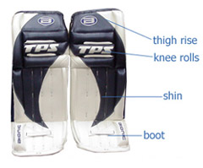 | To measure for goalie leg pads, you will need three measurements.  - Your skate size  - Measure from inside ankle bone up to the center of the knee cap with the leg bent slightly forward  - Measure from the center of the kneecap up to the desired height on your thigh. This will typically run between 6 and 9 inches  Add these three values together for your recommended goal pad size. Ideally, the player's knee will fit into the middle knee roll.

Goalie Blocker and Catcher Sizing
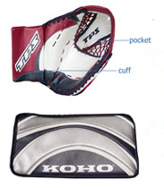 | Gloves are a personal preference but should fit loose. Arm pads should be able to move freely and fit comfortably in the cuff of the glove. The ideal fit for a glove should be something comfortable yet protective.

Goalie Chest & Arm Protector Sizing
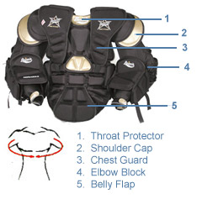 | A good chest pad will provide protection in all areas including the collarbone, ribs, sternum, and biceps. A good fitting pad is essential for both the prevention of injury and the most responsive performance.

