2015
Waukesha West Boys Volleyball
Bowl-A-Thon
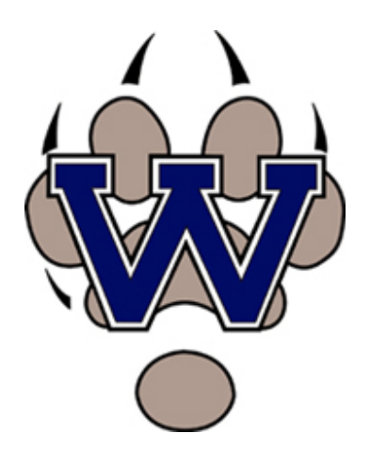
Monday, October 19th
3:30-6:00 pm
At Sunset Bowl

Skip selling overpriced frozen pizza and cookie dough. Rather, in an effort to raise funds for BVB, we will be running a Bowl-A-Thon! Details: Athletes have until October 18th to request family/friend support; donations will be due October 23rd. Two ways to support: flat pledge or pledge/pin. Players will bowl three games; cost per player is $6 (to cover Sunset Bowl’s fee). Questions- contact Coach Clementi at tgclementi@gmail.com or 262.719.7202. Thank you in advance for your support!

