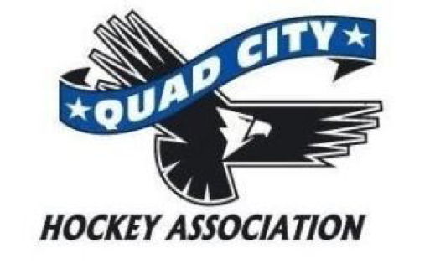

Meeting Minutes
Monday, November 2, 2015
6:00 pm The River’s Edge

Call to Order: meeting was called to order at 6:07
Present: Mike Hurd, Elliott little, Zach Honert, Todd Mahoney, Jen boatman, Jim Barnes, Alex Lambert, Allen Arndt, Lori Sturtzer, Cory Nelson, Mel Muskopf,
Excused Absence:
Approval of Minutes – Mike made motion. Zach second all approved.

New Business:

Old Business:
- Electronic vote was taken on 10/14/15 and 10/15/15 to approve the appointment of Drew Otten as the Mite Select Head Coach and Scott Amo as the Squirt Select Head Coach. All approved.

Director reports:
President – Mike Hurd
- Joe Lambert was introduced as Director of Sled Hockey program in the Quad Cities. Every Sunday this program is held at the rivers edge. 4:30 until 6:15. It is targeted for people with physical or mental challenges. Very wide range of age. This program has been here for 17 years and 30 participants have signed up. This time is open for other skaters also.

Vice President – Elliott Little
- Assignments of bylaw review was distributed to each responsible position
- During the next month, review your assigned article and be prepared at next meeting in Dec to make recommendations/suggestions.
- Safe sport and concussion policy
- Safe sport training must be taken on an annual basis - for all involved with or have access to players. Evaluate time clock attendants, score keepers, penalty box attendants
- Concussion - we should have a link on the website that gives concussion symptoms and QCHA policy regarding this.
- A consistent form that will be used across the organization to be completed - awareness and consistency

Treasurer – Todd Mahoney
- 2014/15 tax return will need to be filed; since we are not for profit, we don't owe taxes.
- The board members on the return are those officers June 30, 2015;
- We will send an email blast that the tax return for the organization is available to see.
- Todd made motion to file. Mike second. All approved.
- Plans to close the budget gap
  - 2 sheets- one is budget approved and one is spent to date
- For the month of Sept. realized a profit; October/Nov. payment will be less
- For house league we projected 206 participants - we are 45 off our goal. This realizes to a deficit;
- A few cost reduction thoughts - 5 bantam select tourneys - move dates; high school ice times - modify ice times, possibly remove several sessions to break even; half hour for squirt on Saturdays; year end tourney is $5800 - can we scale back expense of ref and ice - restructure this schedule
- Can we formulate a committee recommendation that can evaluate the tournament schedule to be fiscally responsible?
- We have a 45 day window to evaluate this
- Have his finalized by Dec 15 - if you have submitted budgets, take a look to see where we can verify; budget committee is treasurer and 2 other board members - volunteer coordinator and Allen; numbers; master schedule and verify ice times

Secretary – Lori Sturtzer
- Have board members sign the QCHA Board of Directors Code of Conduct Agreement

Coaching – Ed Odegard
- Coaching modules will need to be completed by Dec 31 for those who need to

High School – Alex Lambert
- No updates from coaches; youth players can go to blue games for free if they wear their jerseys

Travel – Jim Barnes
Has open hours that have been designated for travel teams - will verify with teams
Consideration of developing or approving:
- RE Schedule (to-date)
- Home Game Event/Team Management Guidelines
- Documents to review for board members; will send out and ask for input/recommendations; first aid kits will need to be outdated/and replaced
  - Home Game Injury/Emergency Action Plan and Guidelines
  - Away Game/Tournament Travel and Team Guidelines
  - Away Game First Aid Kits and Injury/Emergency Guidelines
  - Mandatory Emergency Contact Lists

House – Zach Honert
- House League Evaluations - developed a rubric to be used; will be some modifications with parameters for select team;
- House League Budget – the budget will be reviewed and all commitments evaluated.
- Middle School Playoff/Bantam Select Tournament Conflict - bantam select has tourney scheduled for first week of house playoff; March 4-6; this included extensive discussion. An evaluation needs to be made in light of budget issues, on schedule and ice time. The Bantam select will be participating in the out of town tournament in March. They have already made the deposit (which is non-refundable)
- Skill Clinics - Payment - online option available? Do we bump the price to cover fees; to make sure we cover the costs; can we do advanced payment; then higher walk in fee? 12/15. Will touch base with Michelle Arndt regarding set up

One Goal – Allen Arndt
- 55 registered; 750/800 spent on equipment
- Try hockey for free - order 15 sets of one goal equipment for next session;

At Large – Volunteerism – Jen Boatman
- Schwann’s care - not good participation -
- Signup for birdies for charity
- Try hockey for free participation

At Large – Asset Management – Cory Nelson
- House socks are in
- Blank jerseys should be in soon
- One set of travel jerseys out

At Large – Mel Muskopf
- Pictures next week; Mel will contact coach/team managers regarding time and day

Committee reports:
- Lisa Beckwith has talked about girl’s initiative and proposal was distributed. Will be put on agenda in December.

Adjournment: meeting adjourned at 8:37 Allen made motion. Cory second. All approved

Next Meeting: December 7, 2015

