18th ANNUAL FLINT POWERS HOCKEY SCRAMBLE
BEST BALL GOLF SCRAMBLE
AUGUST 19, 2018
1:00P.M. SHOT GUN START
CASH BAR
GET YOUR FOURSOME IN EARLY TO GUARANTEE YOUR SPOT
FEE: $125.00 PER PERSON ($500.00 PER TEAM)
ALL CHECKS PAYABLE TO : FLINT POWERS HOCKEY
STARTING LINE UP INTERMISSION
REGISTRATION OPENS AT 11:30 A.M. FREE DONUTS/BAGELS UPON ARRIVAL
SKINS FREE HOT DOG, CHIPS &POP AT TURN
MULLIGANS FREE BEER ON THE COURSE
RED TEES
FRIDGE FULL OF BEER RAFFLE
50/50 RAFFLE
SILENT AUCTION
WINE BASKET RAFFLE GOAL COURSE OPPORTUNITIES
RESTAURANT RAFFLE BASKET DIXON GOLF PRIZE OPPORTUNITES

SLAP SHOT SPONSORSHIP OPORTUNITIES

$1000.00 SPONSORSHIP PACKAGE 4 GOLFERS,
1 FLAG AND 5 HOLE SIGNS– -ONLY 18 AVAILABLE
$750.00 SPONSORSHIP PACKAGE 4 GOLFERS,
1 HOLE SIGN, 10 CART SIGNS PENALTY BOX
$100.00 GOLF HOLE SIGN UNLIMITED
DINNER AFTER LAST FOURSOME
$25.00 CART SPONSOR UNLIMITED 50/50 TICKET WINNER ANNOUNCED AT 7
SILENT AUCTION TABLE CLOSES AT 6:30
ANY DOOR PRIZE DONATIONS EXCEPTED RAFFLE PRIZES ANNOUNCED
ANY MONETARY DONATIONS EXCEPTED

EVENT LOCATION
FLINT ELKS CLUB
7177 E. MAPLE ROAD
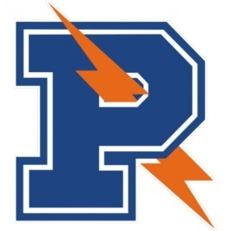
GRAND BLANC, MI 48439

HOCKEY

