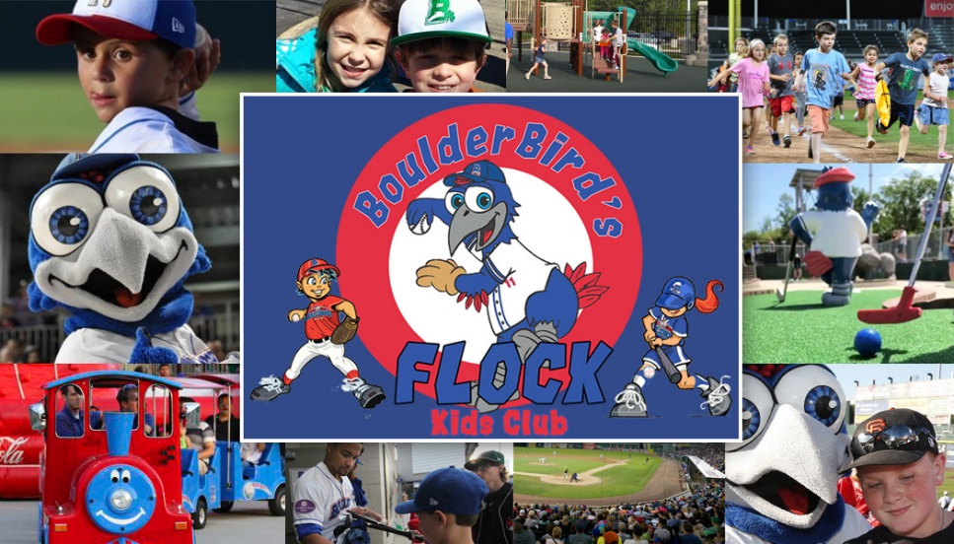
2022 Information
Thank you for signing up for the 2022 Kids Club! Our Kids Club has been completely revamped for the 2022 season. Please see below for details about your membership options. You can pick your items up at the box office!
Free Kids Club Membership Includes: *Certain exclusions may apply
-One (1) Free ticket to Sunday home games & camp days.*
-10% off in the Team Store, birthday party & camps.
-Free mini golf on select dates (TBD)
-Membership Card

$25 Premium Kids Club Membership Includes: *Certain exclusions may apply
-One (1) Free ticket to Sunday home games & camp days.*
-15% off in the Team Store, birthday party & camps.
-One free round of mini golf on Sundays.
-4 Any Time ticket vouchers.
-Fast pass for kids run the bases on Sundays (must be in t-shirt).
-Birthday card
-Membership Card, Premium Kids Club t-shirt, & pencil.
Membership Eligibility
The Kids Club is for children aged 12 and under. Any children over the age of 12 who are signed up will be removed from the email newsletter and all correspondence. Children who are 12 years of age as of Opening Day of 2022 are eligible.

Free Sunday Tickets
Kids Club members will receive one (1) free ticket to Sunday home games- certain restrictions may apply. Show membership card at the box office window to receive ticket. Kids Club ticket will be valid for an infield box seat, based on availability. Additional tickets are available for purchase at standard ticket price. Patrons may upgrade Kids Club ticket, but the difference in price must be paid at time of redemption. Kids Club tickets are only available on the Sunday of promotion. Tickets are valid for date issued only and may not be used for any other game under any circumstance including, but not limited to inclimate weather, game cancellation/postponement, and illness.

10% Off in Team Store on Sundays
Kids Club members can receive a 10% discount on purchases made in the Team Store at Clover Stadium. A valid Kids Club membership card must be shown to the cashier in order for the discount to apply. Discount does not apply to online orders.

Kids Club Newsletter
Parents/guardians of Kids Club members will receive an electronic newsletter with all Kids Club news and updates. A valid email address must be provided. Any email address that has previously opted out of a New York Boulders newsletter is blocked from the email service. In this case, an alternate email address must be provided, or the email address can be opted back in by following this link: http://visitor.r20.constantcontact.com/d.jsp?llr=bpdxqzdab&p=oi&m=1103589248481&sit=q9ow6rifb&f=d4d9459d-1710-4a82-9d49-939cbad6dc5e

Baseball Camp Discount
Kids Club members can receive a discount on baseball camp registration. To claim discount, please call 845-364-0009 to register. Payment in full is required at time of purchase. The Kids Club discount may not be combined with any other discount.

Birthday Party Discount
Kids Club members are eligible for a discount on birthday party packages. The Kids Club child having the birthday may enter free of charge, limited to one Kids Club member per party. Please visit our birthday party web page at https://www.nyboulders.com/page/show/4870045-birthday-parties or call 845-364-0009 with any questions or to book a party.

Membership Card
Kids Club members will receive a membership card. Members must pick up cards at the ballpark at the Kids Club table or in the box office. Redemption may take place any time during a Boulders home game at the designated Kids Club table beginning at the first exhibition game. Membership cards cannot be mailed. If a lost membership card is found, please return to Clover Stadium. Membership card must be presented to receive the full benefits of the Kids Club.

2022 Membership
2021 Kids Club members need not re-register for the 2022 season. Members will remain enrolled until they reach the age of 13. Kids Club members may opt-out at any time without penalty. If the Kids Club program is redesigned at any time in the future, re-enrollment may be required. A new membership card for 2022 may be required.

Additional Benefits and Events
Additional Kids Club benefits and events may be announced throughout the course of the year. All information will be distributed via the Kids Club newsletter. Any questions should be directed to the New York Boulders Front Office at 845-364-0009. Some events may require pre-registration.

