LIVERPOOL FC International Academy America Character, Quality, Tradition est. 2006
CAMP KOP 2016 Let the Tradition Continue
Camp Kop, named for the most spirited, passionate, beloved part of Liverpool's Anfield Stadium, "the Kop," is the first event in Liverpool FC America’s innovative Liverpool Heritage Trilogy Series. The series started in 2012 is designed to teach and truly experience what it means to be a part of Liverpool FC. All Liverpool FC America U-11 teams join together and become immersed into Liverpool Football Club’s culture, history and tradition during a three day, two night camp at the YMCA Adventure Camp in Anna, TX.
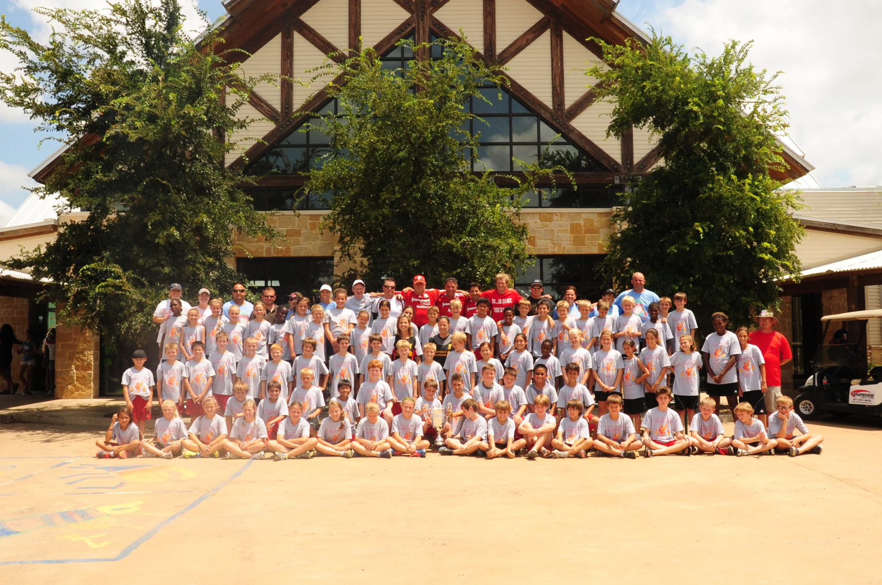
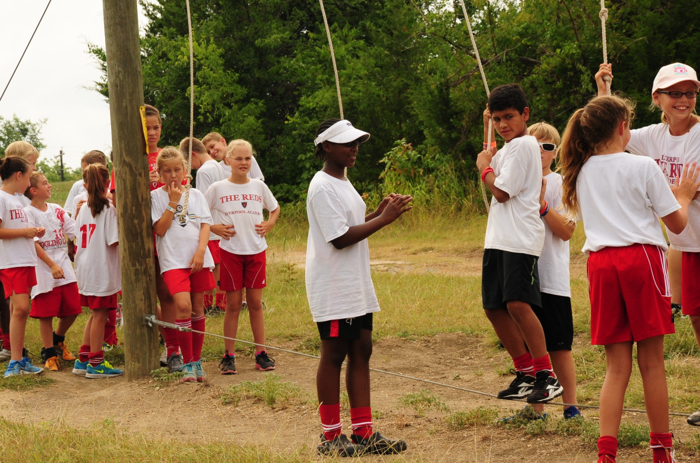
Camp Kop
- Fun
- Team Challenges
- Traditions
- Pride and Understanding
- Bringing to life ‘The Liverpool Way’ in America

The Camp Kop 3-day experience, including three days and two nights, will feature:
- Professional YMCA camp staff to coordinate and run outstanding team bonding opportunities for your teams teamed with our professional coaching staff to guide their experience
- Games, events, and activities including canoeing, fishing, hiking and team skits
- Team challenges that will prepare and equip teams and players to problem solve and deal with adversity
- Terrific training facilities, including grass fields, soccer goals, meeting pavilions, indoor learning center, state of the art cabins with air conditioning and private baths
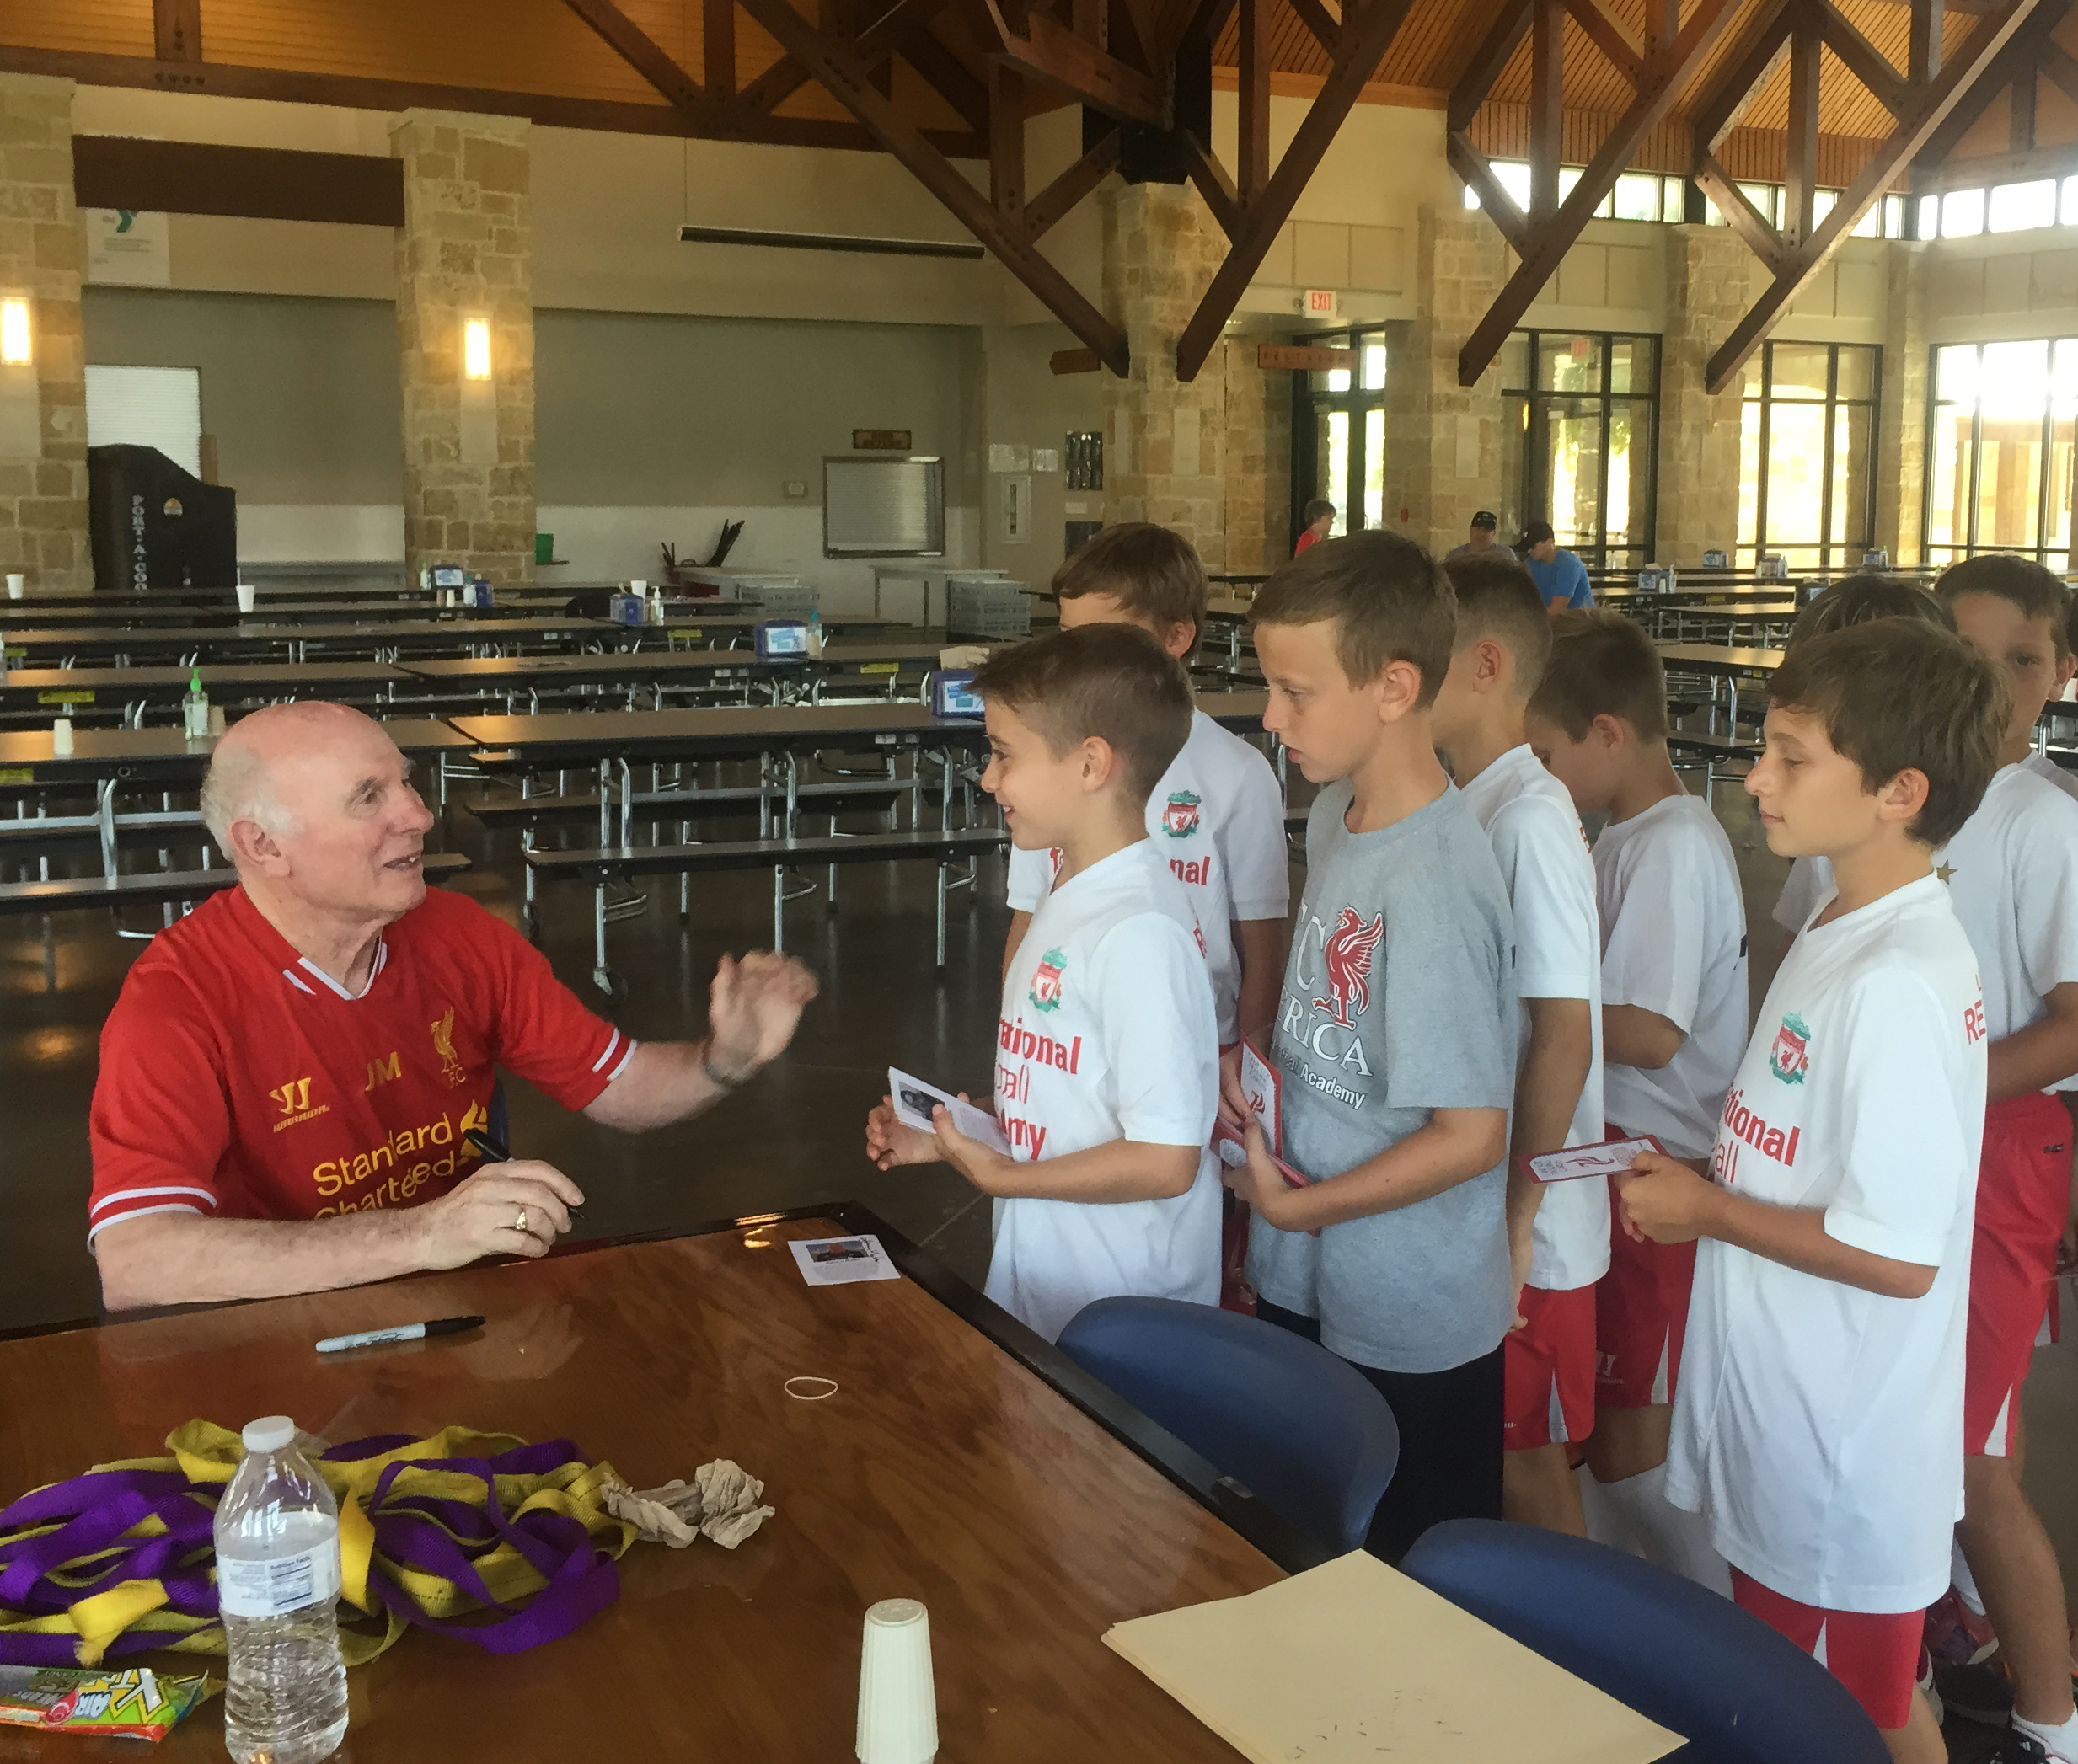
- Team recognition, team competition, spirit honors, and special awards
- Understanding of the history, traditions, and values of Liverpool FC

Your players will absolutely love Camp Kop and will enter the new season with both enthusiasm and motivation for the year ahead. The pride and tradition of LFC comes alive! There is a per player fee that covers each player’s meals! There is also a small admin/ support and reservation fee that goes to the YMCA Camp. Liverpool FC International Academy America supports and invests all costs for the activities, lodging, facilities…etc. We believe that this experience is an important first step to our players knowing and understanding who they represent when they wear the uniform. We want every player to come to Camp Kop with the enthusiasm of players, and leave united with the strength, determination and camaraderie of a team.
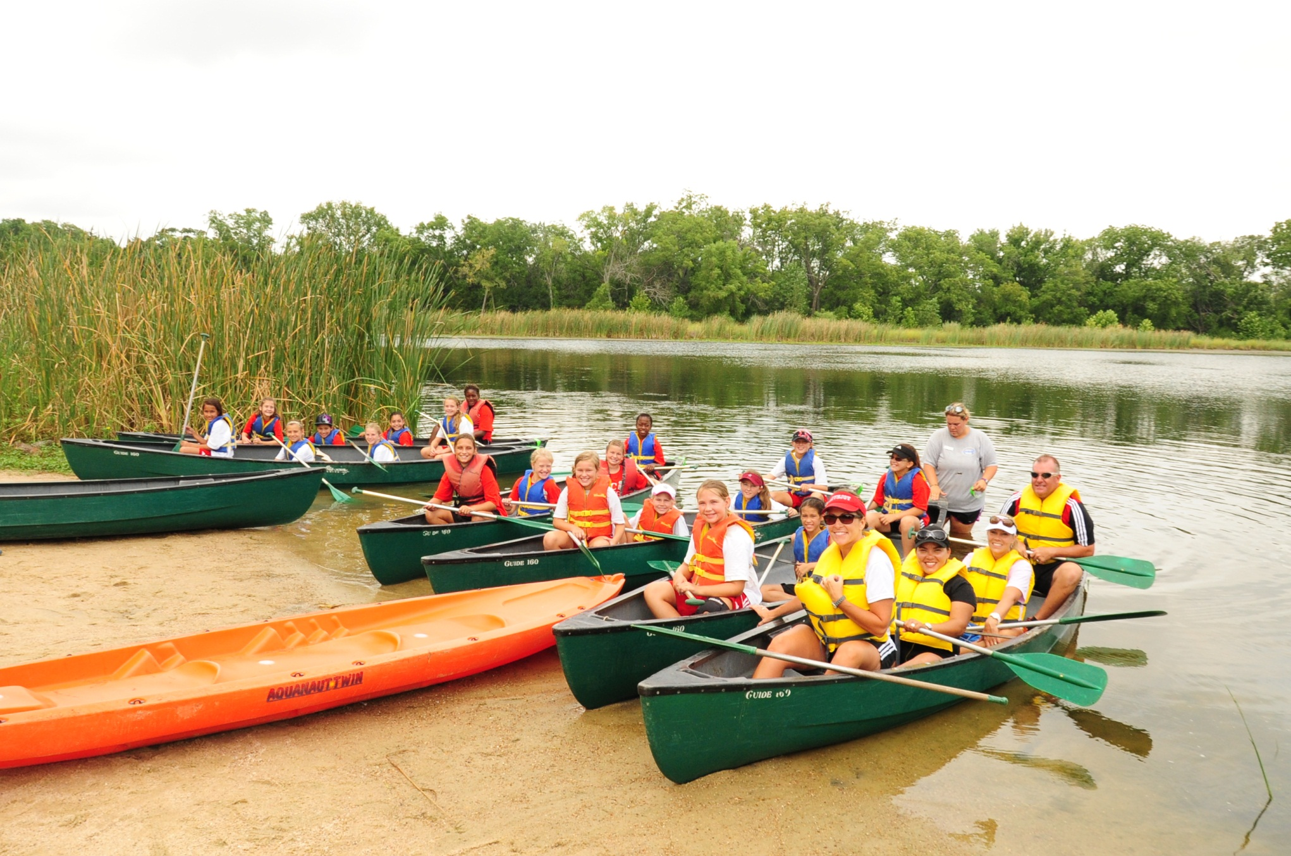

Camp Kop Specifics
Registration: Open online June 15 at www.liverpoolfcamerica.com (click on North Texas, Click on Registration, NTX Club- Camp Kop) (acceptance to Camp Kop does not indicate a contract will be offered for a roster position on July 1st. If a player is not offered a contract, they will be refunded in full for camp registration.)
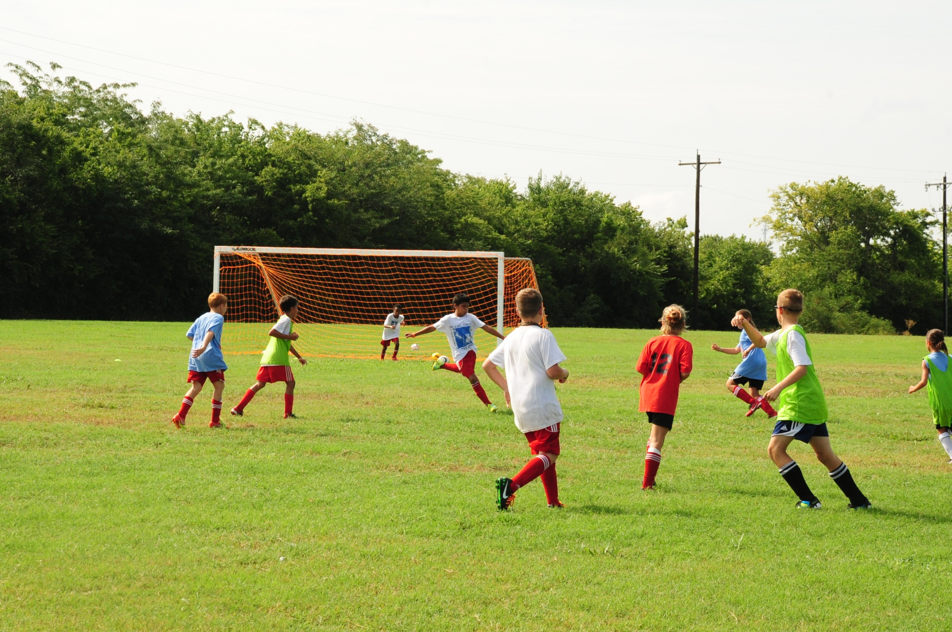

When: July 6-8 or July 11-13 (Please talk to your coach to understand which session your team is registered for- Players must attend as a team)

Where: YMCA Adventure Camp- Anna Texas

Cost: $129.00 paid during registration along with $19.00 admin/support fee

Forms: Online registration asks that you download certain forms and send with the athlete to camp- THESE ARE REQUIRED FORMS. ATHLETES WITHOUT THE FORMS WILL NOT BE ALLOWEDE TO ATTEND CAMP. Please be sure to complete.


Medication: Will be checked in when player arrives at camp by camp director and cabin chaperones
Chaperones: Each team must have two chaperones that are able to sleep in the same cabin as the team and can trek through the camp daily with the team.
Transportation to camp: Parent transportation to camp- Must arrive between 9:00-9:30am at YMCA Camp
Transportation home from camp: Parents should arrive at Camp at 1:30pm for closing ceremony held in Dining Hall

Questions, please contact Camp Director: Nancy Lane- 214-676-2515
nancy.lane@liverpoolfcamerica.com
July 6-8 or 11-13
CAMP KOP 2016
A Great Liverpool Experience for Our Players

