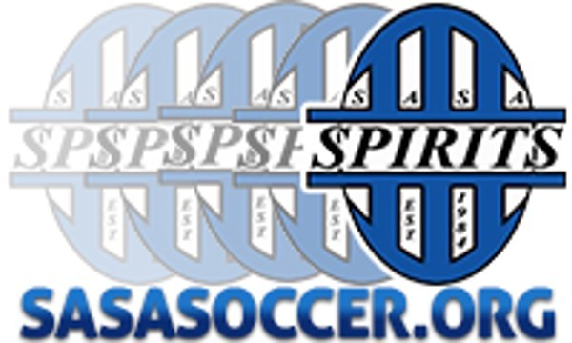
DOC TRAI
NING

August 2016

SASA Newsletter

In this issue:
- DOC nights for SASA Players.
- SASA Field Player
Technical Wheel.
- SASA Goalie Technical Wheel.
- Goalkeeping Training Session nights.
Advantages of DOC Training?
The purpose of a DOC training is to provide specialized technical development to SASA Soccer players from birth years 2009-2004. These technical development sessions will focus on 20 individual skills that every SASA player needs to improve their game on the field. SASA Coaches and Directors will implement the brand new SASA Technical Skills Wheel and provide evaluation of each technical skill by DOC (player has to attend at least 1 evaluation night the last week of each month to get evaluation).

DOC Nights Starting September 7th and Ends in the last week of October.
Director of Coaching: Joe Eck
Boys: 2009-2007 Th. 6:15-7:15 pm
2006-2004 Wed. 6:15-7:15 pm
Director of Coaching: Drew Lenhardt
Girls: 2009-2007 Mon. 6:00-7:00 pm
2006-2004 Mon. 7:15- 8:15 pm
Goalkeeping Training Session Nights
Coach Jack and Colt
Wed. 2009-2006 5:45-6:45 pm Boys and Girls
Wed. 2005-2002 7:00-8:00 pm Boys and Girls



“These specialize nights to focus just on individual skills can do a tremendous amount towards your soccer player achieving its goals on and off the field. SASA brand new Technical wheel will give parents/coaches/players an evaluation tool to improve on the field and a tool that the player can use to train on their own to improve individual skills through the use of video demonstration.”
-Drew Lenhardt
SASA Spirits
Director of Coaching-Girls

