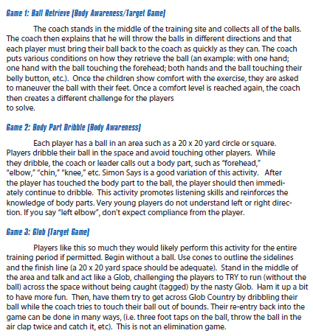
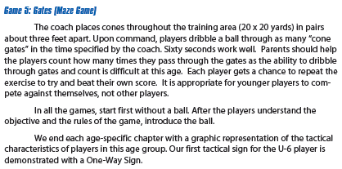
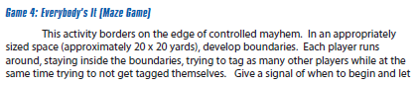
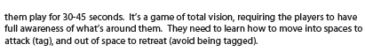
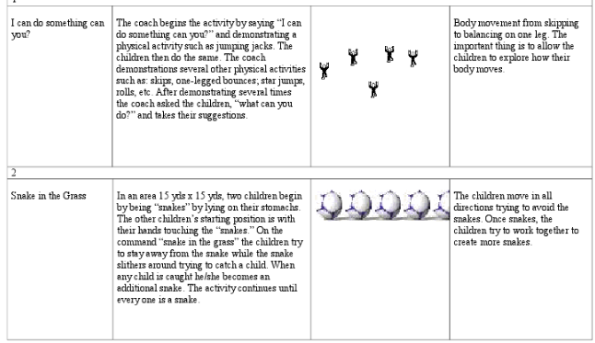
Capital Area Soccer Association
Recreational Coaching Guide
Table of Contents:
- Coaching Hints

- Environment

- What to Expect
- Training Session Ideas
- Training Session Examples
- Rules
- Resource Links
Coaching Hints:

COACHING IS TEACHING…

HOW WOULD YOU TEACH YOUR OWN CHILDEREN?
Teaching soccer is similar to teaching to read, count, color, etc.

HAVE FUN!!
Build a Connection!! Enjoy the Process!!

PLAYERS WANT THE BALL.
Every Player should spend 1/3 of a session with the ball individually!

STOP THE 3 L’s.
No Laps. Lines. Lectures. Practice = Replicate the Game.

PLAYERS WANT THE BALL.
Teaching soccer is similar to teaching to read, count, color, etc.

CONFIDENCE.
Player’s need a sense of belief in the content being delivered.
Environment:
APPROPRIATE CHALLENGES.
Conduct games and activities to the age and ability level that will challenge the team appropriately.
CLEAR AND CORRECT INFORMATION.
Understand the message and skill that is being taught. Too much information and the message is lost. Too little information and players can not complete the exercise.

SIMPLE TO COMPLEX.
Each activity should build and be presented in a way that new challenges are able to build on the message and skills taught previously.

DECISION MAKING.
Are there opportunities for the players to make decisions? These decisions could be where to run or pass, when to pass, how to use technical skill with the ball. Let the players play.

LONG TERM IMPLICATIONS FOR THE GAME.
The game is the best teacher. Coaches should guide the progression of the team of individuals. Limit micromanaging. Provide a safe/fun training session. The Activity will provide the needed structure.
AGE GROUPS & WHAT TO EXPECT:
CHARACTERISTICS of the PLAYER
Constantly in motion, Short-Attention Span, Individually oriented, Easily bruised psychologically, Basic eye-foot coordination, Little concern for team activities, Balance on the dominant foot, No sense of pace; they will run until they drop.

CHARACTERISTICS of the TRAINING SESSION
Give brief directions; repeat when necessary, Various small activities of short duration, Lots of water breaks, Limit training sessions to 45 minutes, Emphasize familiarity and confidence with the ball, Every child must have access to a ball throughout every training session.

TRAINING SESSION STRUCTURE:

WARM-UP (5 Minutes)
Each Player w/a Ball; Simon Says, Ball Manipulation, Motor Skills
Additional Examples Attached

TECHNICAL GAME 1 (10-15 Minutes)
Each Player w/a Ball; Gates, Bulldozer, Tag, Ball Hunter
Additional Examples Attached

TECHNICAL GAME 2 (10-15 Minutes)
Each Player w/a Ball; Gates, Bulldozer, Tag, Ball Hunter
Additional Examples Attached

SCRIMMAGE (10-15 Minutes)
1 BALL, 2 TEAMS, 2 GOALS. No Restrictions. Normal player Minimize Sideline Management Use time to let player play OR teach rules during game play Additional Examples Attached

Cool Down/Debrief (2-5 Minutes)
Coach should stand while players sit with backs to the sun Review/Ask players questions on what was accomplished or played

TRAINING SESSION EXAMPLES
TRAINING SESSION EXAMPLES

TRAINING SESSION EXAMPLES
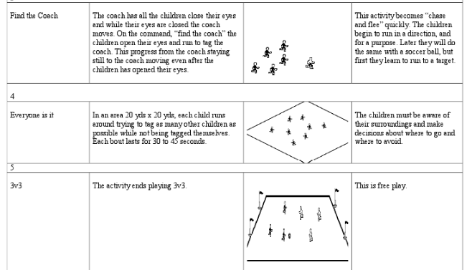
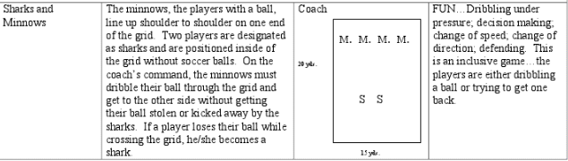
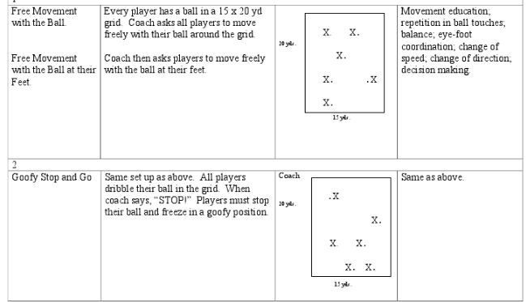
TRAINING SESSION EXAMPLES
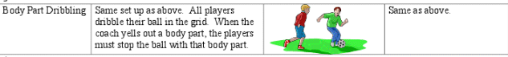
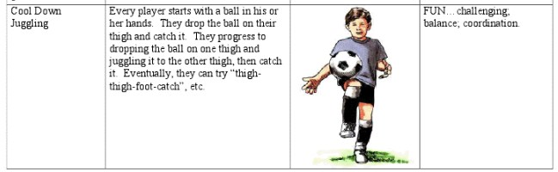

TRAINING SESSION EXAMPLES
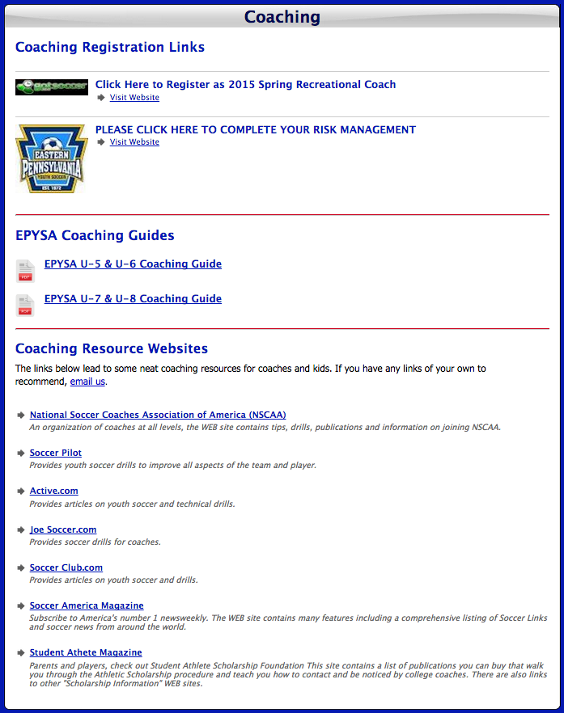
http://www.capsoccer.org/page/show/18726-coaching
COACHING RESOURCES:

