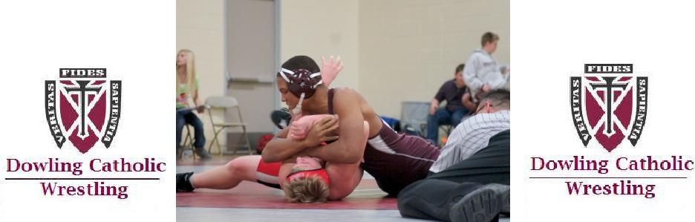

Registration
------------------------------------------------------------------------------------

An informational meeting will be held on Wednesday, October 19, 2016 at 5:30 pm at Dowling room 700.

REGISTRATION Name_________________________________________
Grade:____ Age____ Appx. weight______
School__________________________________
Parents Name(s)____________________________________________
Address______________________________________
City_________________________ Zip______________
Home phone____________________________________ Cell Phone_______________________________________
E-mail address 1 __________________________________

E-mail address 2____________________________________
Return with participation fee of $125 by Oct 30 to:
Dowling Catholic High School
Middle School Wrestling
1400 Buffalo Road
West Des Moines, IA 50265

Questions: Brant Parriott – Head Jr. High Wrestling Coach – bparriott@dowlingcatholic.org

Kevin Stanley – Head Varsity Wrestling
DOWLING CATHOLIC

MIDDLE SCHOOL

WRESTLING

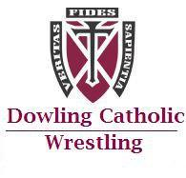

Join one of the Iowa’s premier high school wrestling program’s!

All 7th and 8th grade boys in the parochial school system and all experience levels are encouraged to participate.

2016

MIDDLE SCHOOL SCHEDULE
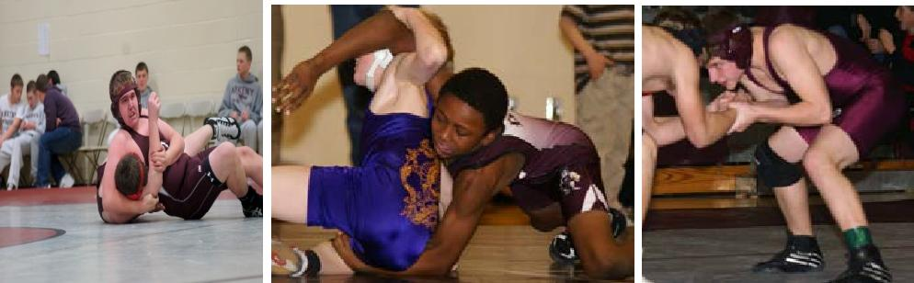

Season Dates: October 24 – Dec 19

Where: Practices will take place in the DCHS wrestling room 3 - 4 times per week. 8 wrestling meets will take place throughout the season as noted below. A calendar will be provided before the start of the season.

Thurs, Oct 27 |  | @ Dowling v SEP
Mon, Oct 31 | @ Stillwell
Thurs, Nov 3 |  | @ Waukee
Mon, Nov. 7 |  | @ Stillwell
Mon, Nov 21 | @ Dowling v DSM East
Mon, Nov 28 | @ Johnston
Mon, Dec 5 | @ Dowling v Ankeny
Tue, Dec. 6 |  | @ Waukee
Mon, Dec 19 |  | @ Marshalltown

Why join the Dowling Catholic Middle School Wrestling Program?
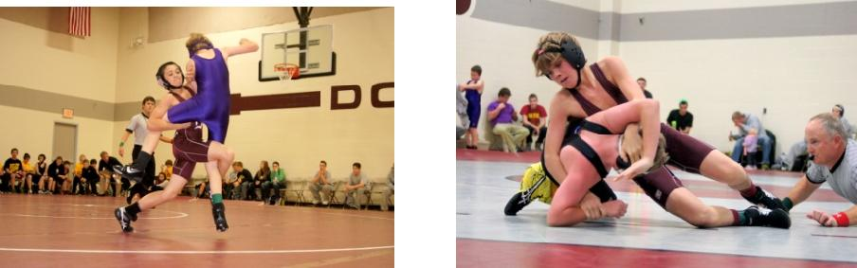
- It’s fun!! Wrestling is a challenging sport but through hard work and dedication everyone can achieve success. Making improvements and gaining success is extremely rewarding.

- Get to know the Dowling community, coaches, and wrestlers to better adjust to your future transition to Dowling.

- Improve strength and conditioning. No matter what your primary sport is, wrestling will help you get and stay in shape.

- Everyone can do it. Wrestlers compete against others their same size, age and ability. All body types can wrestle and be successful.

