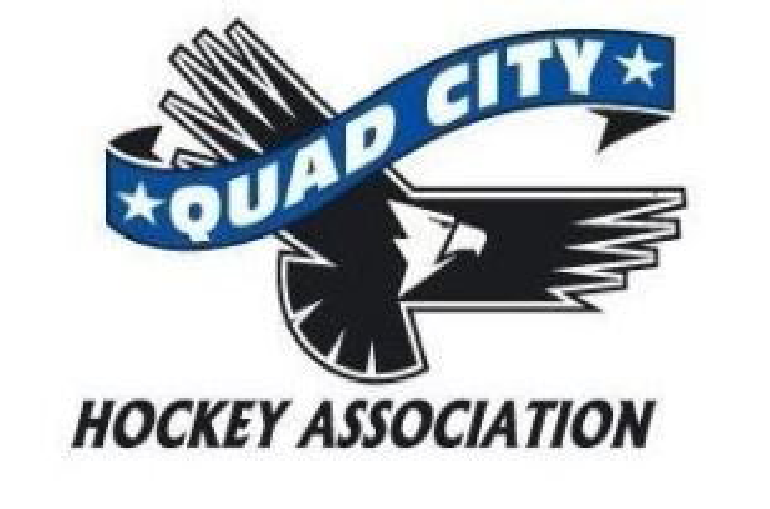
Agenda
Thursday, April 4, 2024
6:00 pm River’s Edge Conference Room

10 min | Call to Order: 6:00  Approved Absences – Kerry, Allen, Andrew, Melody  Approval of Minutes -
45 min | Director Reports  President – Todd Mahoney  - Board Code of Conduct Forms  - Get them filled out- John, Kerry, Andrew still missing theirs. New members will be done in June.  - DHSD Proposed Schedule 2024/25  - Andrew and Todd met with Dillon- He (Dillon) is working on the schedule, wants to talk through as a group regarding what this looks like moving forward. 6 hours on the ice for next season throughout the week. Dillon is asking the board to review over the next 30 days and come through with written ideas of what his expectations should consist of. Now that the 2nd sheet is in, the contract is up for renegotiation.  - Ice Update  - Met with the City, Ryan is sending bills. Our rate for this year, $247 plus $25 admin fee. Deal does show 1.5% increase each year until August 2027 for cost of ice.  - Vote for contract will be electronic  - Blues Coach  - As a board, it needs to be casted out for applicants.  - What does coaching structure look like(goalie coach, assistant coaching, etc)- As a board we need to decide who can/cannot be a coach with regards to parent/player relationship  Vice President – Andrew Quinn  - Not present  Past President- Melody Wright  - Not present  Treasurer – Megan Hoffman  - Todd Mahoney needs to be added to the QCHA checking account  - Motion: Add Todd as an authorized signer for the hockey association- Katie 2nd. Todd abstained.  - Need an audit performed- Will reach out to get a RFP for an outside audit by an outside company, Megan will work Andrew to get this going since it falls under the VP job role  Secretary – Vacant  Coaching – Zach Honert  - Coaches end of year party 4/16, will be at Bad Boyz. Coaches gifts will be given this year. Michelle has streamlined this process, will be part of registration going forward.  - Dates set for coaches registration, beginning of season coaches meeting 8/15. There will be in season workshops next season.  High School – John Gray  - End of year invoices for Blues going out soon. Budget is favorable  - No issues with parent payments  - Coaches position is priority  - 38 were rostered this year, use the numbers as a guide for next season  - Will be scheduling a meeting with incoming Bantam parents/players once we have a coach in place  Travel – Kerry Toporowski  - Not present  House – Phil Harms  - Summer hockey begins 7/9 until 8/14. Information will be going out in May.  - Save the Date email for Summer Hockey Registration & open registration June 1  DHSD – Dillon Fournier  One Goal – Allen Arndt  - Not present  - One Goal starts 4/29-5/15. Every Mon/Wed at 5:30- 24 players registered (22 LTP). Will be capped at 60.  - Try Hockey for Free on 4/20 (11:30-1:00)  At Large – Volunteerism –Heather Tysma  - Volunteer Policy- Looking to vote on this at the June meeting. This will be a whole association wide policy  - Alcohol Policy- Committee of Heather, Michelle and Megan- will send updated policy out to be voted at the May meeting  - 2nd sheet will be out 4/15-9/1  At Large – Asset Management –Libby Montenguise  - Welcome Back to Hockey Night- date to be determined  Pair with open skate and add “Intro to Hockey”  - Looking for new vendors for jerseys- has 3 quotes for new options  - Revamp of Manager’s Handbook  - Equipment (Locker Room) Sale - TBD  - Option to buy jersey and socks during the registration process (House League/Select)  At Large – Community Engagement and Storm Update– Kate Oswald  - QCHA/Storm Update regarding 50/50  At Large- Girls Team- Todd Ashby  - Skate with Lady Blues - 13 girls came to skate  Registrar Update - Michelle Arndt  - Projected HL numbers for 24-25: 225/226 player  - Total players 319 this season and 298 last season  - Try Hockey for Free 4/20 11:00am-12:30pm  - Girls Jamboree in DesMoines 4/6/24 - 3 girls from Quad Cities attending  - USA Hockey Membership opens 4/1/24 for the 24-25 season - Open now  - Board Member requirements must be completed by 7/31/24 - SafeSport, Background Check and USA number  - Spring Skills open - 33 already registered  - Coaches registration is open now. Added  - COVID guidelines still on registration - Remove completely
15 minutes | New Business: Motion for closed session at end of meeting
 | Adjournment: Libby 1st motion Phil 2nd motion - unanimous approval.

Next Meeting: Monday, May 6,, 2024, 6:00 p.m. River’s Edge Conference Room

Melody: Logo updated. Allow parents to order from SourceOne and SquadLocker. Up to $1,000 for a trademark. Ours is considered a common law trademark. Can send a cease an assist out if our logo is used. If sent we would need an attorney

John Dawson: Last home game April 5th. All final checks mailed to QCHA by next week.

