Kansas Boys State Meet 2006  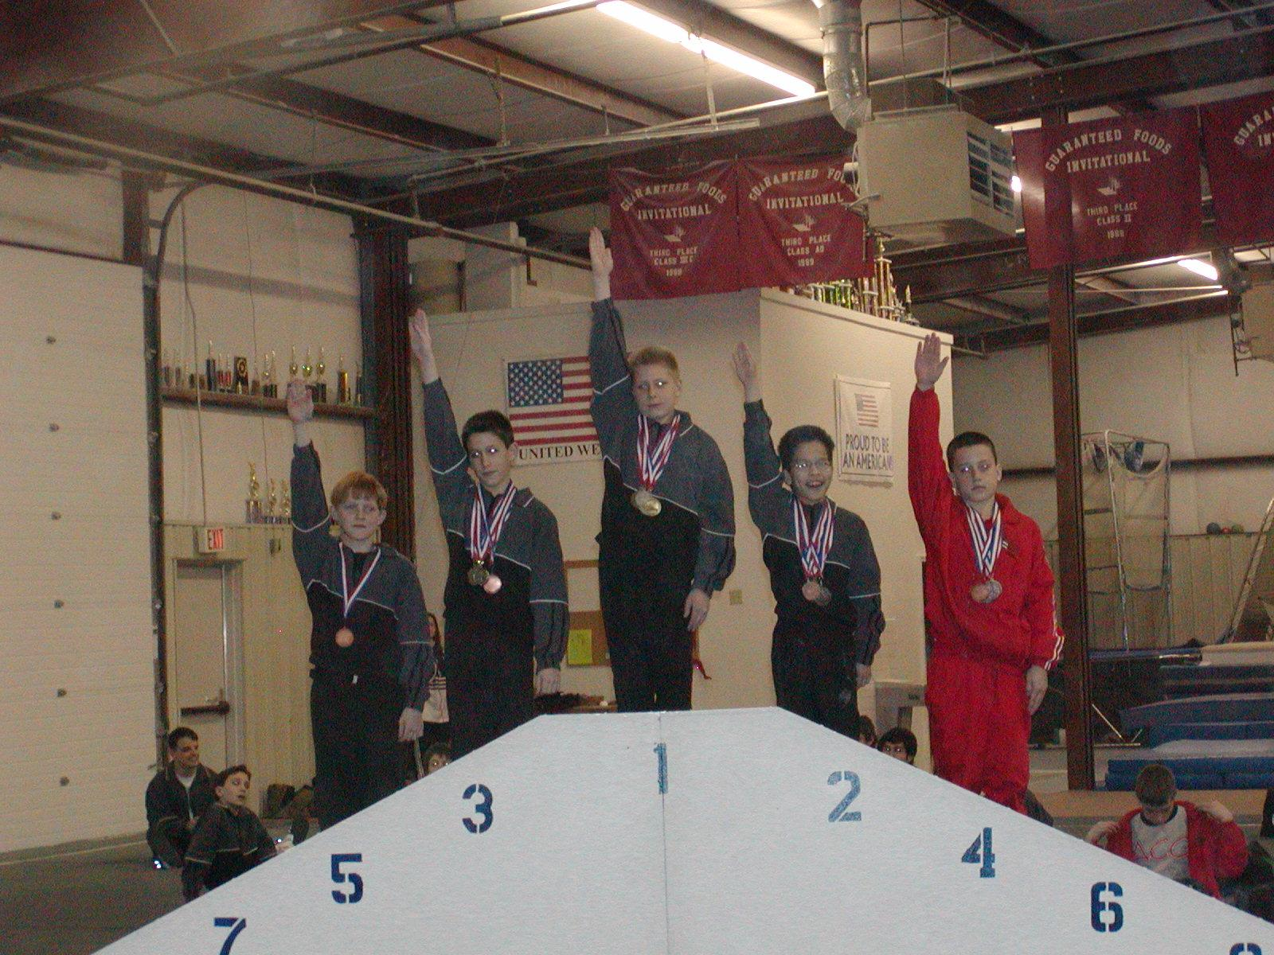 | Meet Results  Level 7 - 10-11  Session III

Place | Num | Name  Gym |  | Floor | Pommel | Rings | Vault | P Bars | H Bar | AA
1 | 504 | Zachary Tucker  Emerald City |  | 8.800  3 | 8.400  2 | 8.900  2 | 9.000  5 | 9.100  1 | 7.800  2 | 52.000  1
2 | 502 | Zachary Wendland  Emerald City |  | 9.300  1 | 8.600  1 | 8.800  3 | 9.100  4 | 8.900  2 | 7.000  3T | 51.700  2
3 | 505 | Alec Kopatich  Emerald City |  | 8.200  5 | 7.600  3 | 9.200  1 | 9.500  2 | 8.200  3 | 8.300  1 | 51.000  3
4 | 501 | Phillip Solis  Air Capital |  | 9.100  2 | 7.100  4 | 8.300  4 | 9.700  1 | 7.600  4T | 7.000  4T | 48.800  4
5 | 507 | Joseph Clark  Emerald City |  | 8.500  4 | 6.500  5 | 8.200  5 | 9.450  3 | 7.600  5T | 6.600  5 | 46.850  5

Kansas Boys State Meet 2006  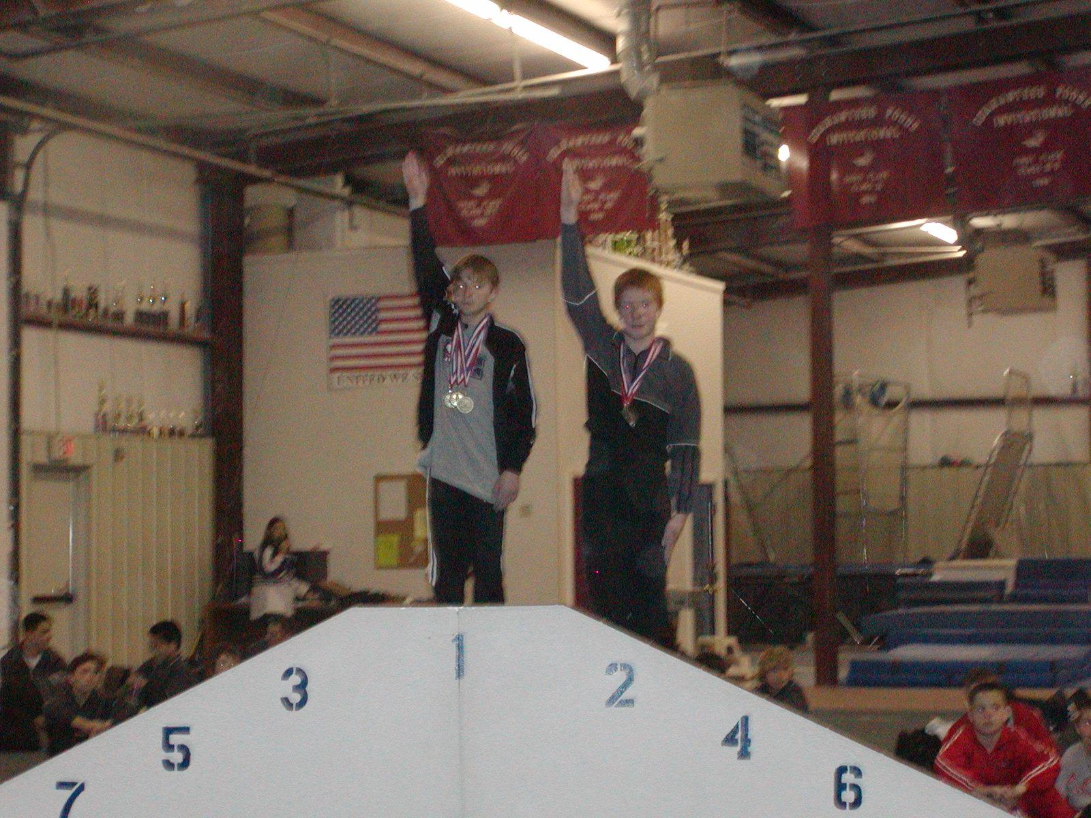 | Meet Results  Level 7 - 12+  Session III

Place | Num | Name  Gym |  | Floor | Pommel | Rings | Vault | P Bars | H Bar | AA
1 | 503 | Michael Casey  LGA |  | 8.700  1 | 7.000  2 | 7.400  2 | 9.400  1 | 8.000  1 | 7.500  1 | 48.000  1
2 | 506 | Daniel Fraser  Emerald City |  | 6.100  2 | 7.200  1 | 8.000  1 | 9.300  2 | 6.400  2 | 0.000  2 | 37.000  2

Boys State Meet 2006  McCracken's Gymnastics & Swim  15515 S. Keeler  Olathe, KS 66062  (913) 782-8555 (913) 782-7458 Fax  3/18/2006 | Team Results  Level 7 - All Age Divisions  Session III
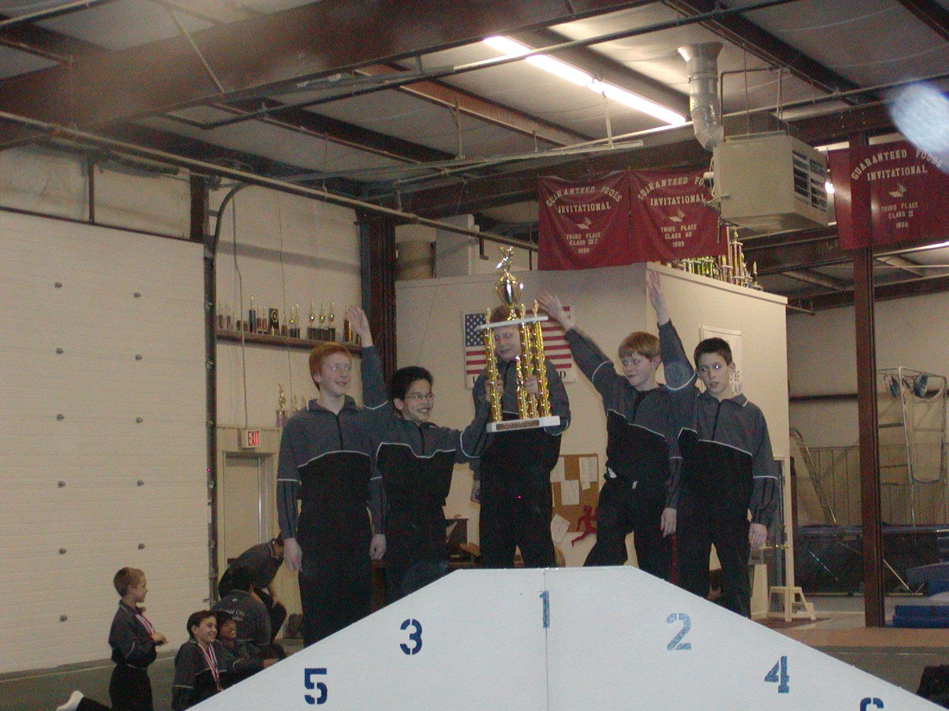
Place | Gym | Team | Score | Floor | Pommel | Rings | Vault | P Bars | H Bar
1 | Emerald City | * | 155.650 | 26.600  1 | 24.600  1 | 26.900  1 | 28.250  1 | 26.200  1 | 23.100  1

Kansas Boys State Meet 2006  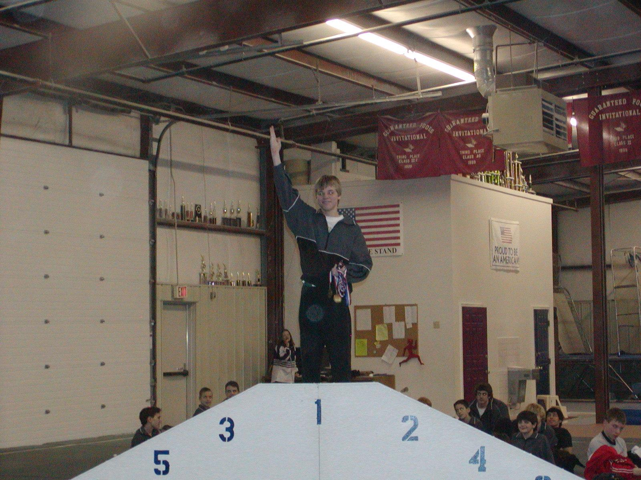 | Meet Results  Level 8 - 14-16  Session III

Place | Num | Name  Gym |  | Floor | Pommel | Rings | Vault | P Bars | H Bar | AA
1 | 601 | Trenton Privitt  Emerald City |  | 8.100  1 | 7.500  1 | 7.300  1 | 7.500  1 | 7.900  1 | 6.000  1 | 44.300  1
2 | 602 | Travis Privitt  Emerald City |  | __.___  2* | __.___  2* | __.___  2* | __.___  2* | __.___  2* | __.___  2* | 0.000  2*
3 | 603 | Stanley Strecker  Air Capital |  | __.___  3* | __.___  3* | __.___  3* | __.___  3* | __.___  3* | __.___  3* | 0.000  3*

