
ISWA OFFICE MAP & DIRECTIONS

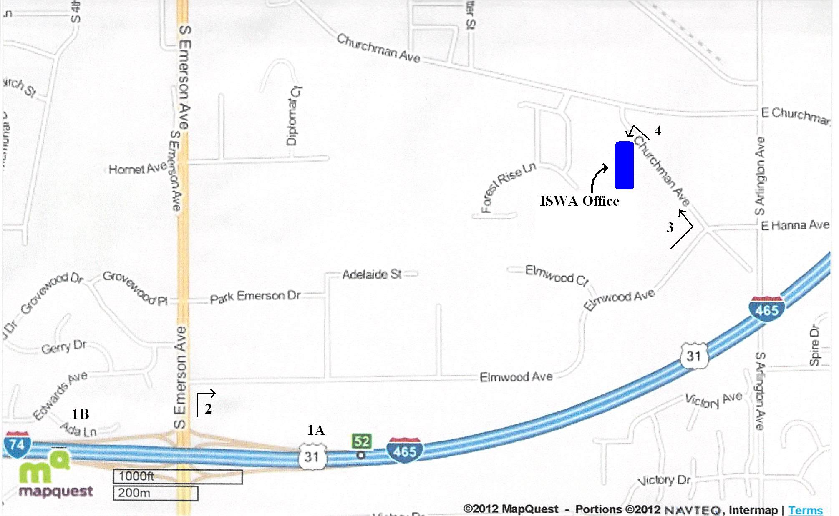

1A/B: If coming from the east/west on I-465, get off at Exit 52 and turn north onto Emerson Ave.

2: Turn right at the first light onto Elmwood Ave and go east on Elmwood to Churchman Avenue. Elmwood winds around the interstate. Churchman Avenue is the first street on the left before stop sign or at the end of “S” curves at Whirlpool sign.

3. Left onto Churchman Avenue to 5715. Turn left into blacktop driveway. There are 2 groups of tan buildings. Proceed through the open gate to the second group of of buildings on the right. The ISWA office is the 2nd office (Suite L). The name is on the door.

4. Note: Parking is limited. Please plan to carpool or have a parent drop you off it at all possible. If you must leave a vehicle at the office you will be allowed to park in designated areas only. Priority will be given to coaches.

