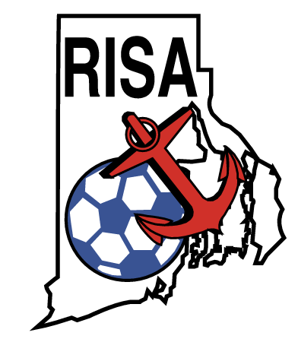
RHODE ISLAND SOCCER ASSOCIATION, INC.

Member of US Soccer Federation, Inc. and Federation Internationale de Football Association

2017 RHODE ISLAND SOCCER FESTIVAL TEAM REGISTRATION FORM

TEAM NAME:________________________________________

CAPTAIN’S FIRST NAME:____________________________________

CAPTAIN’S LAST NAME:_____________________________________

STREET ADDRESS:_________________________________________

CITY:___________________________STATE___________ZIPCODE___________

PHONE:_________________________CELL PHONE:_________________________

EMAIL ADDRESS:______________________________________________

I acknowledge that Soccer is a contact sport involving risk of serious injury, disability or death. Not all risks are foreseeable. In consideration of being allowed to participate. I agree to release, waive and covenant not to sue the United States Soccer Federation, the United States Amateur Soccer Association, the Rhode Island Soccer Association, Inc. in account of injury, death, or property damage alleged to be caused in whole or in part by affiliates’ actions or omissions.
I understand that the RISA Soccer Festival player registration fee includes payment of an insurance premium for medical health coverage, which combined with my primary medical insurance, will act as a secondary coverage for any injuries incurred from play on, July 23, 2016 only. In the event that I do not have primary health coverage, then this policy will act within its limitations of coverage and of deductibles as my primary coverage.

CAPAIN’S SIGNATURE______________________________________________

DATE:____________________

Mail team registration form, along with team roster and waiver of liability forms to:
Fee - $200 7 v 7 registration, $150 3 v 3 registration: Check payable to RISA

Rhode Island Soccer Association
% MFL USA Service Corp.
PO Box 7066
Cumberland, RI 02864

