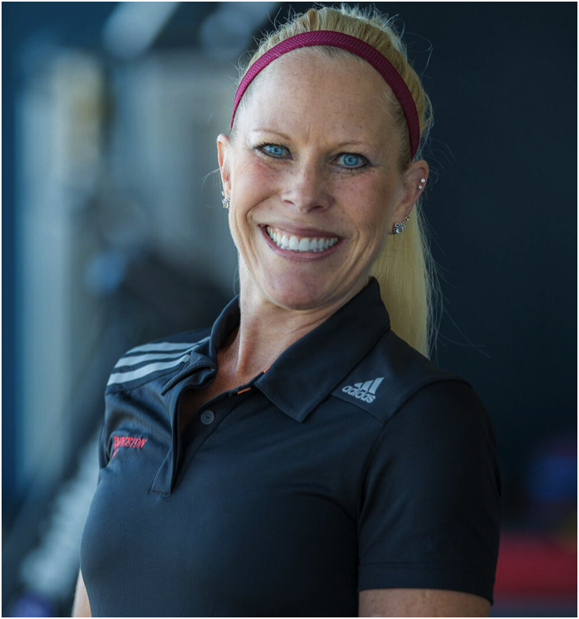
Princeton Club is proud to present Sports Performance Training for all athletes. This 6 week, high performance training camp will teach the athlete how to improve their game and over all athleticism; each training session will challenge the athlete to further develop skills needed to compete at the next level by focusing on key elements.
Program Key Elements:
*Athletic Power & Strength to increase Speed
*Improve Stamina
*Total Body Conditioning
*Acceleration, Agility, Control, & Balance
*Plyometric training to increase Explosive Power
*Nutrition for Performance
*Positive Mental Mind Set needed to compete & perform
*Education on Proper Warm-up technique & progression
*Injury Prevention exercises to create the Long Term Athlete
*Flexibility & Mobility with an emphasis on care for the shoulders, hips, knees and ankles.
*Weight Room Safety
Create the Total Athlete: this involves more than strength and speed. It is about developing character, confidence and skills for a standout team player. Program key elements better athleticism, with a large focus on care for the athlete’s growing and developing body, which is paramount in creating the Long Term Athlete.
June 12-July 21 Priscilla Peterson
Mondays & Fridays 11am-12PM Sports Performance Trainer
Wednesdays 7:45-8:45PM Princeton Club West
Cost: $180 8080 Watts Rd Madison
Register at the front desk priscilla@princetonclub.net

