2017 MATS FOOTBALL COMMUNICATION
via
Miramonte Boosters Club Website/ Football Pages
Sports Engine Account & Mobile App

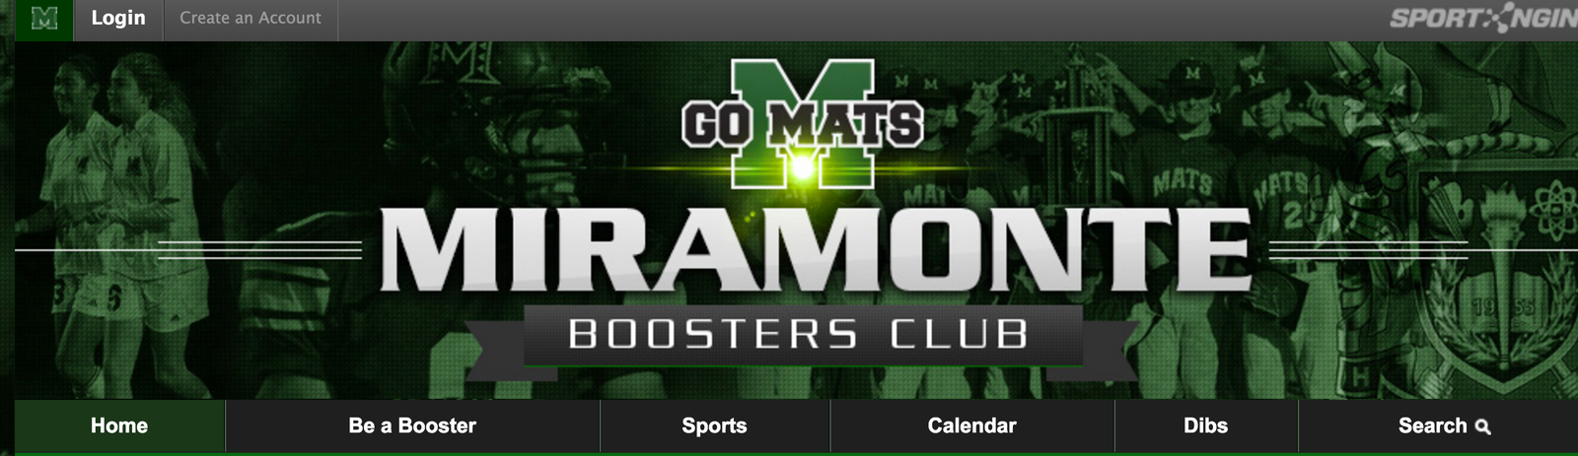
To ALL Football Players and Parents (Varsity, JV & Frosh): MATS Football is using the Boosters Club Website and the Sports Engine Mobile App for transmitting Team updates this year!

To receive future Mats Football Team emails or texts AND to view Mats Football docs complete the following steps:

“Join the Team”: Check your inbox for an email recently sent to you from (Mats Frosh Football - Miramonte Boosters Club).

1) “Accept Invite”(green button). This allows you to create your own Sports Engine Account (host of the Boosters/Football website).
* If you have a Sports Engine Account, “Log In”. Then go to Step 3.
* If you don’t have a Sports Engine Account, select “Create an Account”,
complete “Account Information”, and at bottom, click “Sign Up for your Sports Engine Account”.

2) On the Dashboard, click “Accept” (black button). Then Login. (see sample Dashboard below)

3) At “Select a Profile” screen: Click your name if account already set up OR Create a new profile.

4) Click “Become a Member” of the Frosh Football team (Top left hand corner of website)

5) On Dashboard (click Login box at top, left side of screen) go to “My Profile” and verify info.
Under the “Team Membership” section, the Mats Football team you have joined will now be listed.

Most Critical Steps:
6) Go to “Account Settings” (bottom of dashboard menu/ see sample below) to verify info or to change or add: Name, Password, email Address or Mobile Phone#.

7) To get texts, make sure your “Mobile Phone Number” is entered and check box described in #8.

**If a new phone entry, Click “Send Validation Code” button on right side. This will be sent to you via text.
Then, enter the Validation Code in field.

8) Review the “Notification Settings” section (within the Account Settings).
Check 2 boxes in the Miramonte Boosters Club section: “email” box AND “Text (your cell #)” box

You’re now all set for future Team texts, emails and can view the Mats Football docs

9) Lastly, set up the Sports Engine Mobile App (iOS and Android and Apple products)
Varsity Team ID: 227947….JV Team ID: 227948….Frosh Team ID: 227949

Questions? Contact your Frosh Team Parents

Sample: Dashboard menu (Boosters site)

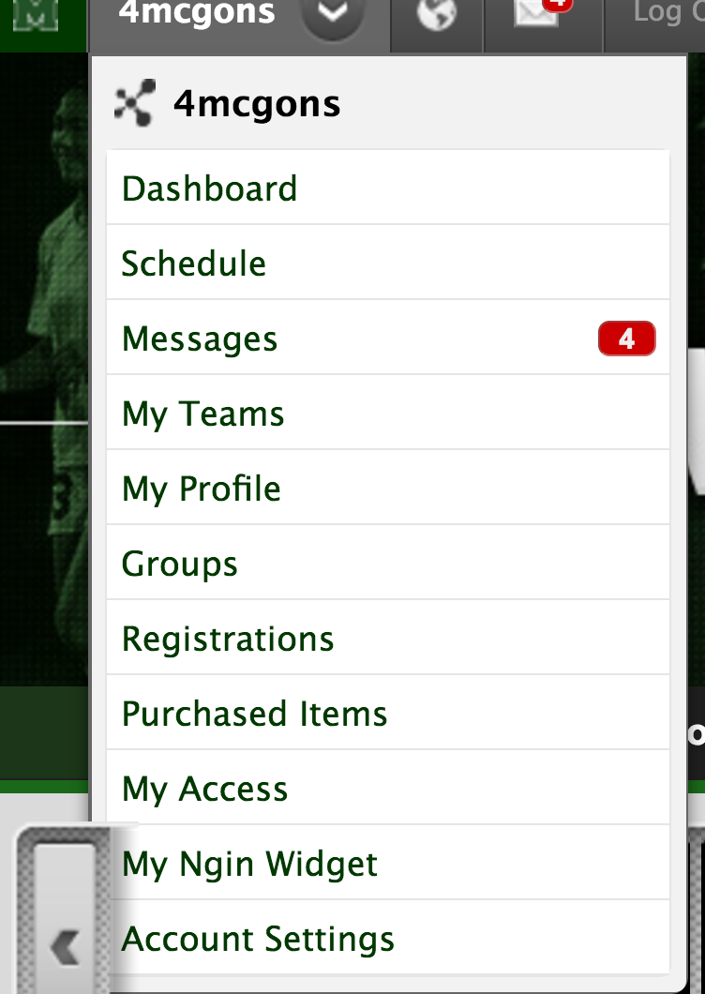

Sample: Account Settings & Notification Settings

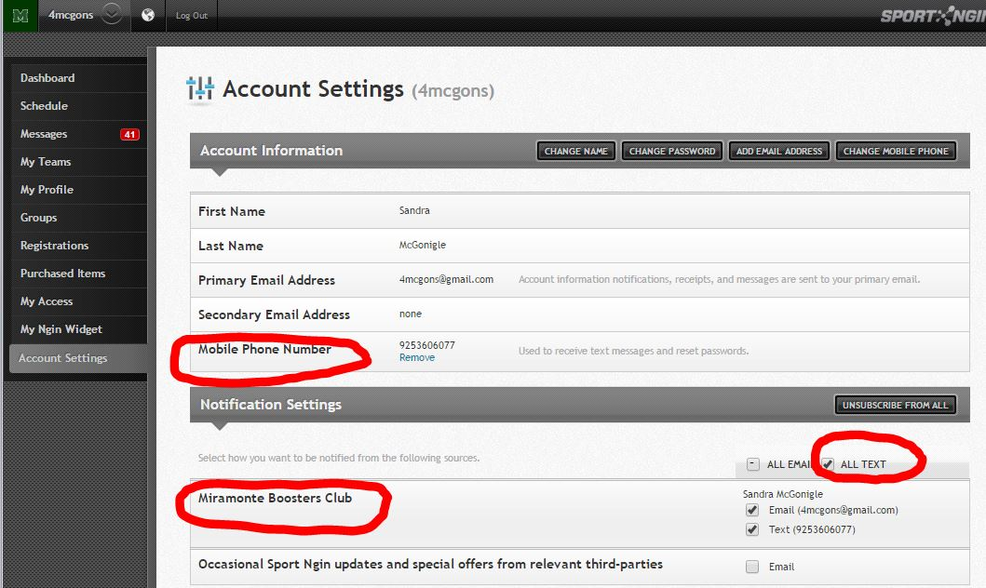

Sample: Varsity Football Webpage (Fall Sports)

NOTE: DOCUMENTS tab, highlighted in red, stores Football files in secure area.
Log in to your Sports Engine account to view files.

