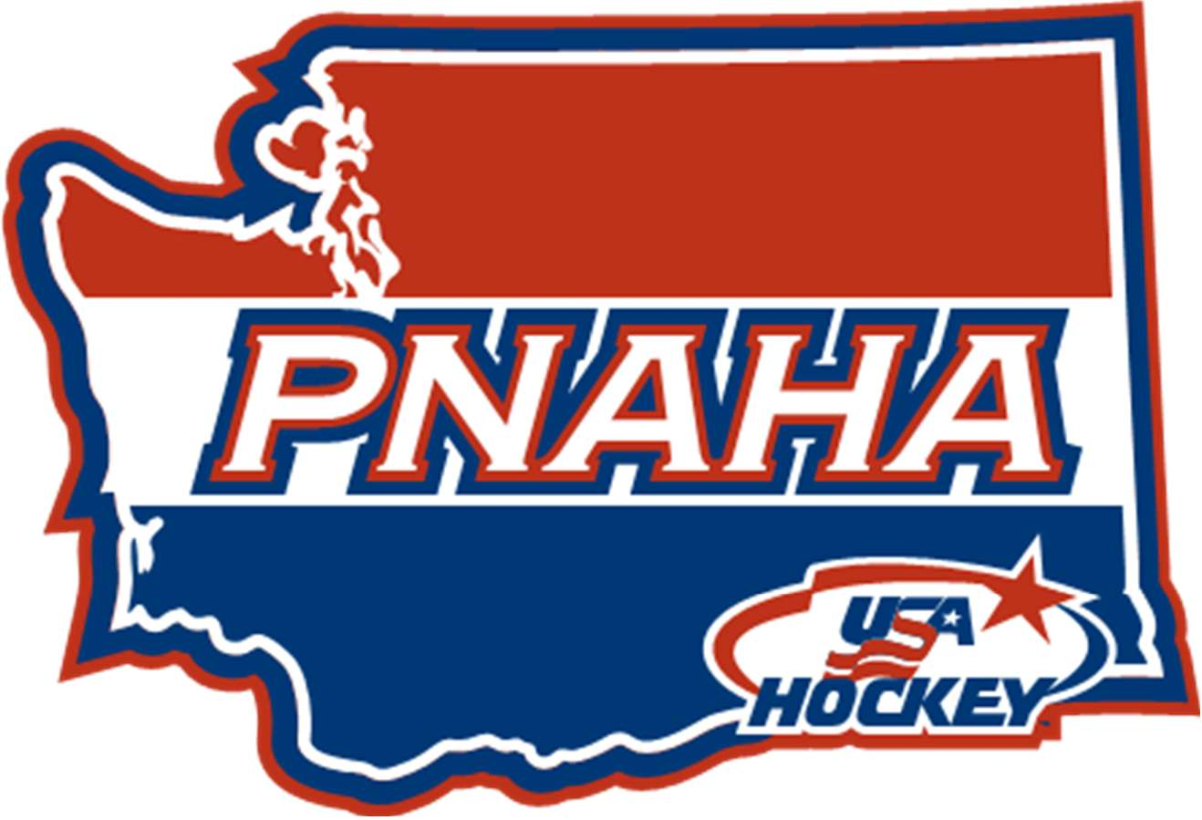PNAHA GENERAL WINTER MEETING
SATURDAY, JUNE 24, 2017 MINUTES

Coast wenatchee center hotel & Wenatchee convention center
201 North Wenatchee, Wenatchee, WA 98801

Dru Hammond, PNAHA President called the meeting to order at 9:05 a.m.
- Sign-In
- Sign-in sheets distributed and are an official record with these minutes. Voting delegate sign-in sheet completed with the following delegates present:
  - PNAHA President – Dru Hammond; 1st PNAHA Vice President – Robby Kaufman; 2nd PNAHA Vice President – Rob Azevedo; Secretary/Treasurer – Debbie Didzerekis
  - Member Organizations Present: EYH – Gary Gusinsky; IEAHA – Dave Nieuwenhuis; KVHA – Les Grauer; MLYHA – Ty Howard; SJHA – Ian Armstrong; SKAHA – Doug Kirton; SAYHA – Neil Runbeck; PSAHA – Chuck Zimmer; TCAHA – Kris Waltze; VYHA – Bob Knoerl; WAHA – Travis Fetzer; WCAHA – Ted Ritter; WSHC – Penny Delbarto; WWFHA – Colin Nurse and YAHA – Felicity Pittman
  - Member Organization not represented - None
- Introductions - Personal introductions made by the PNAHA Board of Directors and special guests, at total of 37 people were present for the meeting.
- Confirmation of Current Members – All members have provided required documents and meet criterial for members in good standing.
- Minutes of last meeting
- Minutes from January 7, 2017 Winter PNAHA meeting were presented to the board, Ty Howard (MLYHA) motion [to approve the minutes as presented], 2nd by Rob Azevedo (PNAHA 2nd VP), motion passed.
- Treasurer Report – Debbie Didzerekis
- Debbie Didzerekis (PNAHA Secretary/Treasurer) presented copies and reviewed the January 2017 – May 2017 Treasurer Report. Ending balance as of May 31, 2017 is $109,956.72. Robby Kaufman (PNAHA 1st VP) motion [to approve the treasurer report], 2nd Ian Armstrong (SJHA), motion passed.
- Associations were reminded that if any anytime they have questions or wish to see the PNAHA records they can do that, Debbie will show them the QuickBooks online, or she can send them a financial detailed report.
- Special Guests
- Donna Kaufman, Pacific District Director – Donna reviewed the USA Hockey Rule changes, for complete rule changes please review at www.usahockey.com.
- Steve Stevens, Pacific District Referee In Chief – Steve let us know that things are going well. There are some exciting changes coming for how referees register and recertify in order to help with referee retention.
- Steve Laing, Pacific District Director – Reviewed with everyone that for the upcoming Olympics the US is going back to using NCAA players and other non NHL players. There are a number of related issues to this that Steve reviewed with the group. The Olympic team will be named January 1, 2018 and will play their 1st game February 15. Steve briefly discussed women’s hockey and some of the issues that are going on with the program.
- Some items Steve reviewed:
- New USA Hockey Conflict of Interest waivers
- New Transgender policy
- Showcase moved to St. Louis, MO – Jr./Sr. High school tournament
- Girls Multidistrict camp went well, they brought in players as team leaders and used D1, D2 and D3 coaches for the program. They want to work to find ways to keep the girls at home instead of them having to leave home to play hockey
- Jamie Campbell, Concussion Protocol Implementation – Jamie reviewed with the group the Concussion protocol, now when you register with USA Hockey, you now confirm that you are aware that in hockey concussions can occur. It isn’t anything but an acknowledgement. There are various legislation regarding concussions in each state. The Pacific District has adopted the concussion protocol for all affiliates. The Pacific District does not expect or want this to create additional work for affiliates, they are planning to add an additional staff member to the Pacific District Board who will be responsible for player safety and do most of the work involved with the concussion protocol. For Washington State Jamie Huscroft is the concussion protocol champion who will be a resource for information. Rob Azevedo (PNAHA 2nd VP) motion [Accept and ratify the protocol for concussion management], 2nd by Gus Gusinsky (EYH), motion passed.
- Nomination’s for election – Call for nominations for PNAHA President, Dru Hammond nominated by Neil Runbeck (SAYHA), 2nd by Kris Waltz (TCAHA). A second call for nominations and a third call for nominations with no responses. Call for nominations for PNAHA 2nd Vice President, Brad Moon nominated by Travis Fetzer (WAHA), 2nd by Gus Gusinsky (EYH), Rob Azevedo nominated by Chuck Zimmer (PSAHA), 2nd by Kris Waltze. A second call for nominations and a third call for nominations with no responses. Nominations were closed.
Chuck Zimmer (PSAHA) moved for acclamation of PNAHA President, Dru Hammond, 2nd by Ted Ritter (WCAHA), motion passed.

BREAK 10:40 – 11:00

- Officer's Reports
- SUPERVISOR OF OFFICIALS – Ben Staehr
- The state tournaments went well, had a lot of good officials work the tournaments. Prepping for seminars for coming season. Working on a development plan for officials right now, some affiliates have mentoring programs and other types of development that they are doing on an affiliate levels. Ben will be going around the state more visiting affiliates to help them in any way he can. Right now he is hearing about storages, reasons are a lot of kids play hockey and he reminded everyone that when they are traveling if they give the local referee scheduler a call they can likely get you on games where ever they are. Ben reminded everyone he has supervisors one on the West side and one on the East side and they can help anyone with helping recruit and retain officials. Discussion around all associations working with local officials associations to help with retention/recruitment. Ben will work with Steve/Dan/Matt to each out to associations.
- Coaching Director – Rob Kaufman
- Player Development Camp – January 28-29, 2017 in Wenatchee at Town Toyota Center
- Camp overall went very well. A big Thank you to the team leaders, evaluators and associations. This year at camp the 15/16’s last ice time was done cross ice, which helped the evaluators, the cross ice allowed some players to standout and some of the goalies rose to the occasion. This was on the big ice and was a fun and exciting experience for both players and evaluators. We continue to receive great support at the 14/15 age groups, we are still lacking in the 16/17 age group, this year the players sent on to districts did okay but were not our top players.
- Rob asked the question to the group about do we continue to have 16/17 year olds at the development camp. The next camp is January 26, 27 & 28, 2018, it is essential that all associations let coaches know that they have to black out that weekend in order for players to participate. Players need to understand that they may not move on from Districts if selected to go but the experience and exposure they get just going to districts is a lot. It should be used as a measuring tool for growth and development.
- We need to work to make sure players understand and prepare for the next level. Discussion on what needs to be done to keep players playing at their home associations instead of going away at 15/16/17. Affiliates must promote Development camp to players and coaches and be in support of this program in order for it to be successful.
- Players moving forward from district camp on to national camp. Alex Bolshakov (15), Brendan Lee (15), Sam Myers (17) and Lucas Gallagher (17), no 16’s were selected. Here is the link to the list published by Pacific District. http://pacificdistricthockey.com/
- Thank you to Doug Kirton and Jamie Huscroft for attending the 14U Select Camp all week. The camp was a high intensity on and off ice workouts. The focused on nutrition, dryland and off ice planning. Players stayed in the dorms during the camp to get the whole experience, it was a great experience for the players.
- For coaches they must complete the Safesport and age group modules before stepping on the ice even for try outs. Modules are open already. A Level 4 Clinic is schedule already to be held in Bellevue September 22, 23, & 24, 2017. Rob is working on Level 1, 2 & 3 for August. Doug Kirton will be doing a clinic in Seattle Levels 1-3, there will also be additional Level 1-3 in Spokane and Tacoma late in the season.
** Break for lunch at 12:00 – due to some board members that need to leave the meeting early, we will move down to Old Business/New Business then return to the officer reports.
- GIRLS/WOMEN – Cindy Dayley
- Female Development Camp held January 28-29, 2017 in Everett, went well, we continue to work with USA Hockey and provide all female staff for the camp. Twenty-four (24) players moved on to the multi district camp from SJHA/WWFHA/Eastern WA. This was the first year the camp was able to field on those players ages 14-17 that would move on to next level. Previously younger and older females were invited to ensure enough numbers at the camp. Female hockey is growing in PNAHA and that is a great thing for our State.
- Two (2) of those 24 moved on to the national camp with 1 alternate. Selectees are at 15U Baily Kehl, at 18U Lokelani Antonio and 18U Alt – Allison Reeb. Congratulations to those players.
- Starting preparation for the 2018 camp to be held Jan 26, 27 & 28, 2018. Adding goalie sections to the camp, looking to add a special ice time for those selected to move on so they know what to expect as they move forward.
- Dru Hammond, noted that at the District Meeting, a shout out to Washington was given for the being proactive with the female camp and continuing to improve the camp.
- Discussion regarding issues with SJHA being denied entrance into PCAHA league when WWFHA was permitted to join the league. Debbie Didzerekis (PNAHA Secretary/Treasurer) motion [A taskforce of 4 reasonably uninterested individuals to address the female hockey issue with PCAHA league] 2nd Ian Armstrong (SJHA), motion passed. A call for the taskforce volunteers was made (Penny Delbarto (WSHC), Les Grauer (KVHA), Travis Fetzer (WAHA), and Doug Ross (SKAHA) will be the taskforce – Doug Ross will chair the taskforce.
- REGISTRAR/RISK MANAGER – Wendy Goldstein
- Wendy will be at the September meeting to meet with Registrars. All association registrars should attend. Please note the for 2017-2018 season only games played after September 1, 2017 will count toward the 20/10 rule for qualifying for state tournaments. For the 2017-18 Credential book they will only need to have official USA Hockey roster and game sheets (in newest to oldest order). No longer need consent to treat or code of conduct in the book.

- GOALIE DIRECTOR – Mike Landry
- Mike has visited several associations and held goalie labs and has seen some great things across the state. He still has some smaller associations to visit and is looking forward to working with them on goalie development.
- Mike has some suggestions toward the goalie development at State Development Camp and will be working with Rob and Dru on putting together a document to send out to associations on how to help goalie and identify those that should be going to development camp.
- LEAGUE COMMISSIONER – Tami Gurnard
  - 2017 League winner for 18U league is SKAHA
  - 2017 Tournament Results
    - State B hosted by WSHC – 14U Tacoma, 18U EYH
    - Tier II hosted by SAYHA – 14U , 16U Spokane, 18U SKAHA
    - 10U hosted by TCAHA – Gold – Moses Lake, Silver – SKAHA Lawrence, Bronze –SJHA Blue
    - 12U hosted by TCAHA – Gold – SJHA PW A, Silver – Tri Cities, Bronze –SJHA PW B
  - PNAHA league is a great deal and everyone should work to make sure your teams play in PNAHA. Neil Runbeck (SAYHA) stated Spokane is in support of playing PNAHA league this year and would like to see others do the same.
- safesport – Doug Ross
  - Revamping background check and what is posted, more information as it is completed.
  - Any Safesport reports that reference “sex” will automatically be handled by USA Hockey process automatically instead of local Safesport coordinators. All associations must automatically report this to local police department with any report of “sex” in it.
  - The quantity of locker room reports that are coming in clearly show that locker room monitors are not being done correctly. Everyone needs 2 monitor in the locker room not in the hall or sitting outside the locker room at all levels with exception of 8U because there are parents in the locker room with the 8U.
- adm director west side – Doug Kirton
  - Doug communicated to Joe Bennett the decision that was made regarding 10U half ice. Joe congratulates PNAHA on their vote to do half ice at 10U and out continued progress to lead the way.
- adm director east SIDE – Herman Cho
  - Spokane and Tri City continue to work and support ADM. Tri Cities has doubled house ice times with the use of ADM at all levels. Rep also increased ice time by 50% by using ADM and sharing ice.
- DISABLED HOCKEY DIRECTOR – Tami English (submitted before meeting)
- The Sno- King Thunderbird Sled Hockey team attended the USA Hockey Disabled Festival in San Jose this past April. We are pretty excited to report that we finished 2nd in the adult Liberty Division C group. Jamin Rader was our super star that won us 3 shootouts to take us into the Championship game. See attached picture.
- This program looks to expand to have a skills ice practice and a competition/travel team ice practice this season. We find opportunities to join the Surrey, BC sledge hockey program in clinics during the season, as well the Sno-King Thunderbird Sled Team will host an on-ice Try it Free evening on August 26th, followed by an on & off ice clinic on Sunday morning, August 27th . Josh Sweeney will lead both experiences.
- We continue to work with the Seattle Thunderbirds for an annual game opportunity on the Showare Center Ice. This has been a great opportunity to host a game with sled teams in Surrey and/or the Portland Winterhawks. The exhibition during the game in the evening is a great exposure for the Thunderbirds fans to see people with disabilities showcase their ‘ability’. We are grateful for the experience.
- The Winthrop Ice Rink received a USA Hockey Sled Grant to help serve a boy in the area that wanted to play hockey. They were able to get him out on the ice with some practice session during youth ice time. Connor and I talked about some ideas that could help bring awareness to the opportunity and help the program grow.
- I have not had an update from Bremerton, yet I heard they got a USA Hockey Sled Grant, as well. Last I heard there was a person in the area that had some energy behind getting a sled team kicked off. I will continue to try to reach those in the area about the program.
- There is a sled program at Frontier Ice (Post Falls, ID) in the off season that is growing. It serves those in the Spokane to Flathead Lake area of Montana. They have hosted a Pond Hockey games in September that some of our athletes have attended.
- The 2018 USA Hockey Disabled Festival will be held in Chicago, from April 12th – 15th.
- 1st Vice President – Robby Kaufman
- All has been going well and Robby wanted to thank those that elected him to the PNAHA 1st VP.
- Portland has a new person running their Jr. Hawks program and contacted Robby about why they are not playing in PNAHA. Robby and Donna gave them some background and education on that topic. So please know that Portland is looking to travel to WA for game so keep that in mind.
- 2nd Vice-President – Rob Azevedo
- Rob wanted to thank everyone for electing him to another term as VP. He also wanted to thank Spokane and Tri Cities for another well ran/hosted state tournament.
- Rob also attended the State Development camp and it was again and awesome opportunity and a lot of work went into the evaluation of the players.
- Reminder that everyone needs to be familiar with Safesport rules and be aware of alcohol and drug abuse issues and report it if you see it. We are tasked with keeping the players safe that we are in charge of and that is something we all need to take seriously.
- president – Dru Hammond
- Recently attended the USA Hockey Mid-Annual Congress meeting in June, the High School Showcase is now being ran through USA Hockey and will be held in St. Louse MO April 18-23. Need to ensure your afflicates are aware of this event and the tryouts.
- Block Grant allocation was sent back with Dru, check was for 20,550.63 (75% of our 17-18 grant and the remaining 25% of the 16-17 grant)
- Discussion about issues with insurance for directors and legal risk, more information to come on this subject from the Finance committee.
- Discussion on Transgender policy and base layer policies
- At the Presidents meeting a lot of discussion regarding parent complaints and when is enough enough? Discussion on group and Doug Kirton reminded everyone before you cut parent/player loose make sure you have documented the issues.
- Recently attended the Pacific District meeting in May. There may be district fee increases coming. Next Pacific District meeting will be October 21st in Portland, OR.
- Old Business
- Team Application – Joe Nichols 16U Independent Update – the team was denied membership to the league they were requesting so this request is denied.
- 10U CROSS ICE
  - Kris Waltze (TCAHA), motion [to remove 10U Cross Ice from the agenda], 2nd Ty Howard (MYLHA), motion failed.
  - Doug Kirton (SKAHA), motion [all PNAHA vs PNAHA associations play 10U half ice starting 17-18 season], 2nd Chuck Zimmer (PSAHA). Discussion about logistics for those associations without hard divider boards. SKAHA has 3 sets of boards they are willing to sell to the associations (MLYHA, SAYHA & TCAHA) in order to make this work. PSAHA agreed to bring their boards with them to the other associations as needed. Friendly Amendment [except when playing a PNAHA team in a non-PNAHA league or at a tournament that does not have all PNAHA teams.] Doug Kirton accepts friendly amendment, 2nd Chuck Zimmer (PSAHA) also accepts friendly amendment. Motion with friendly amendment passed (1 abstention).
Kris Waltze (TCAHA) motion [add the following language to PNAHA rules: 10U Players Playing Up-
Having 10U players play up at 12U is strongly discouraged but occasionally there are compelling reasons to do so. Each association, at their discretion, may allow up to two (2) 10U players per season to play up at the 12U division. Additional players playing up may be considered with an exception request to the state ADM director, who will only consider the request if it’s due to association needs. i.e. having to merge age divisions in order to have a functional program.] 2nd Debbie Didzerekis (PNAHA Secretary/Treasurer). Discussion regarding that PNAHA has 2 ADM directors, agreement among those present that East side ADM Coordinator would administer requests from West side associations and West Side ADM Coordinator would administer requests from the East side associations. Motion passed.
- NEW BUSINESS
- Election President/2nd Vice President – President was confirmed after nominations because there was only 1 nominee. Ballots were issues to all voting members present. 2nd Vice President elected Rob Azevedo. Ballots were counted and verified by Steve Laing and Jamie Campbell.
- 2017-2018 Try Hockey Free Dates – First Try Hockey Free event will be Saturday November 4, 2017 and the 2nd event will be Saturday March 3, 2018. All associations are encouraged to participate. We had 2 associations that were recognized for successfully completing the 2 and 2 Challenge as part of the 2016-2017 season, they were Wenatchee Amateur Hockey Association and Puget Sound Amateur Hockey Association. Congratulations to them on their success at growing the game.
- Tier I Team Review – Dru confirmed with all teams that are doing try outs who is fielding a 15U Tier I team. Kent is having tryouts this weekend and currently are the only team specifically fielding a 15u (2002) team.
- Rule 14 – Ian Armstrong (SJHA) motion [table expiration of Rule 14 until committee defines Tier I] 2nd Doug Kirton (SKAHA). Motion passed.
  - Dru has the list of competition/rules committee members and will send that out to everyone.
- FALL MEETING
- The PNAHA fall meeting will be held on Saturday, September 9, 2017 at the Coast Wenatchee Center Hotel & Wenatchee Convention Center in Wenatchee, located at 201 N. Wenatchee Avenue. Room reservations can be made by calling (509) 662-4411.
- ADJOURNMENT–Rob Azevedo (PNAHA 2nd VP) motion [to adjourn at 4:17 pm], 2nd by Les Grauner (KVHA), all in favor, meeting adjourned.

PNAHA Treasurer Report
As of December 31, 2016
Balance as of August 31, 2016 |  |  | $ 113,811.04
Income
 | Misc Income
 | Grant Funds | $19,703.75
 | Player Fees | $25,224.00
 | Total Income | $44,927.75
 |  |  | $ 158,738.79
Expenses
 | Meetings-Motels
 | Food | $ 3,291.72
 | Meeting Room/Hotel Rooms | $ 1,920.13
 | Misc Expenses | $ 61.62
 | Background Screening | $ 13.00
 | Bank Charges | $ 10.50
 | Cell/Telephone (Conference Line) | $ 301.79
 | Office/General Administrative Expenses | $ 550.37
 | Printing | $ 172.67
 | Storage | $ 495.00
 | Website (2yrs) | $ 1,000.00
 | PNAHA Travel | $ 1,427.22
 | PNAHA Development Camp
 | Ice Fees | $ 4,725.00
 | Total Expenses | $13,969.02
Balance as of December 31, 2016 |  |  | $ 144,769.77

