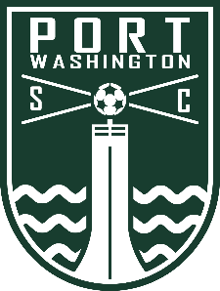

Port Washington Soccer Club Volunteer Fee Reimbursement Form
Port Washington Soccer Club Volunteer Policy: All families must complete 4 hours of volunteer time to be eligible for the $50 reimbursement.

FAMILY NAME:

PLAYER(S) NAME/TEAM:

ADDRESS:

EMAIL: PHONE:

I have fulfilled my hours as team manager/coach. Team name:

Date: Activity (include location): Hours:

Date: Activity (include location): Hours:

Date: Activity (include location): Hours:

Date: Activity (include location): Hours:

Date: Activity (include location): Hours:

Date: Activity (include location): Hours:

Total Hours: I verify that the above listed hours are accurate for the 2022-2023 season.

(Signature)_______________(Date)

Please hold form until all 4 hours are completed. All forms must be received by June 15, 2023, to be eligible for reimbursement. Allow up to 4 weeks as requests are processed monthly.

Turn form into your Recreational Coach or Select Team Manager who will then provide to the PWSC Treasurer (lynnetreasurerpwsc@gmail.com) OR mail to the Club Treasurer at PWSC, c/o Treasurer, PO Box 53, Port Washington, WI 53074.

