JAmes “Jimmy” Carson – IFA U17 Head Coach

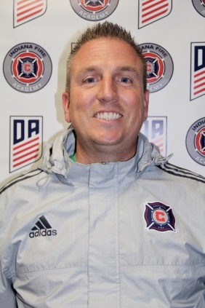

License: USSF “A” License

Education:

University of Indianapolis- Bachelor’s’ Science in Elementary Education, 2003
University of Indianapolis- Master in Administration, 2007
Coaching Experience:

Indiana Fire Jrs. ECNL (2 years)

- Head Coach 2002 & 2004 Girls

- Head Coach U14 & 15 Girls

Indiana Olympic Development Program

- Assistant Director (2 years)

- Age Group Coordinator 1998, 1999, 2000 Boys & 2001, 2002 Girls

As Indiana Olympic Develop Coach:

2012 ODP Region II Champions

2012 ODP National Championship- Runner Up

Helped Guide 26 players to Regional Pool Honors & 6 National Pool Players

US Youth Soccer- ODP Region 2 Staff Coach

- Assistant Coach, 2002 Girls & 2003 Girls

Dynamo FC

- Girls Technical Director (5 years of director experience)

- Head Coach (14 years of club coaching experience- boys, girls, men’s’, & women’s’ teams)

North Central High School

-Women’s Head Coach (3 years of head coaching experience)

As Women’s Head Coach at North Central High School:

Record: 46-16-4

1 State Runner-up Title, 1 Semi-State Championship, 3 Sectional Titles, &

1 Marion County Championship

1 Marion County Coaches of Girls Sports Association- Championship Coach Award

-Women’s Assistant Coach (3 years of head coaching experience)

Indiana State Select Women’s Team Head Coach (2 years of coaching experience)

Indiana Youth Soccer Coaching Education Program- Staff Member (3 years of coaching experience)

Playing Experience:
University of Indianapolis (4 years of playing experience)
Indiana State Select Team (6 years of playing experience)
Dynamo Katner F.C. ‘80 (10 years of playing experience)
Indiana Olympic Development Team (4 years of playing experience)
Lawrence North High School (Varsity- 4 years of playing experience)

