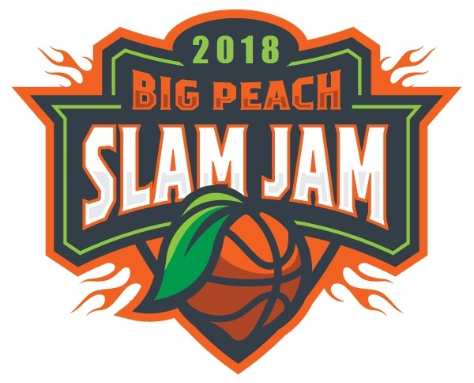
2018 BlazeSports America Big Peach Slam Jam
Wheelchair Basketball Tournament
REGISTER NOW!
BlazeSports America is hosting the 2nd Annual Big Peach Slam Jam wheelchair basketball tournament - open to both NWBA Varsity and Prep teams from across the country.We hope you will join us in making this one of the best tournaments of the 2017-2018 season.
When: January 27-28, 2018
Where: LakePoint Sporting Community facility
Cost: $300
***Please list in the notes section if you are registering a Varsity or Prep team***
Contact Todd Liscomb for more information
Email: tliscomb@blazesports.org
Office: 404-270-2028
Cell: 404-242-4057

