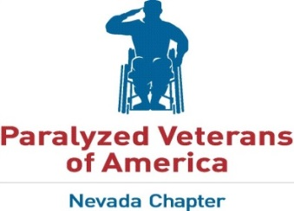
2017-2018 Las Vegas YUCCAS Tournament Schedule

Team Name__________________________________________________________________________

Team Contact____________________________ Telephone No. _______________________________

Address______________________________________________________________________________

City__________________________________________ State_________ Zip______________________

E-Mail_______________________________________________________________________________

Tournament Dates Division No. of Teams Max Entry Deadline

January 6th – 7th 2018 DI 12 December 22nd, 2017 $___________
January 20th – 21st 2018 II/III 12 January 5th 2018 $ ___________
February 17th – 18th 2018 II/III 12 January 26th 2018 $___________
March 10th – 11th 2018 DI 12 February 23rd 2018 $ ___________
March 17th – 18th 2018 II 6 March 2nd 2018 $ ___________

Total Amount Due: $___________
Entry fee for Division II/III tournaments - $400.00 per team
Entry fee for Championship Division - $500.00 per team

Note: All fees must be paid in United States Dollars only.

Please make checks payable to: Las Vegas Adaptive Sports Club
Please mail checks to: ATT: Nathan Carruth
799 Milstead Ct.
Las Vegas, NV 89110

If you have any questions, please contact, Nathan Carruth at (702) 994-6809 or nathan.carruth@yahoo.com
or Jonathan Foster (702) 306-7613, jfoster@lasvegasnevada.gov
