Eldorado  Youth Wrestling Registration  Monday October 9, 2017  Hello wrestling families,  The 2017-2018 wrestling season is quickly approaching and it is time to get registered for another great season. Eldorado wrestling is renowned for having a great wrestling program which produces excellent student athletes and we look forward to carrying on that tradition. This will be our fourth season participating in NMWAY. The league has grown to over 30 teams from New Mexico and the surrounding areas which will provide our wrestlers with the highest quality mat time at all levels. Our season registration meeting will be held on Monday October 9th at 11 am located at Eldorado high school in the gym lobby. This season our registration fee will be $190 per wrestler and $180 per wrestler for two or more siblings which will include a sublimated singlet, dri fit shirt and fight shorts, as well as NUWAY insurance card and NMWAY membership fee. We will also be offering traveling and fundraising opportunities for those wrestlers who would like to compete at the national level. Our practices will be held from 6-8 pm Monday- Thursday beginning on November 1st. All of our coaches have wrestling experience, are certified through NUWAY and have a current background check. We will have a 1:5 coach to wrestler ratio in accordance with NMWAY regulations to provide our athletes with the highest quality coaching possible. I look forward to seeing all of our returning wrestlers and welcoming all of our new wrestlers to the team. Please feel free to contact me with any questions. |  |  | 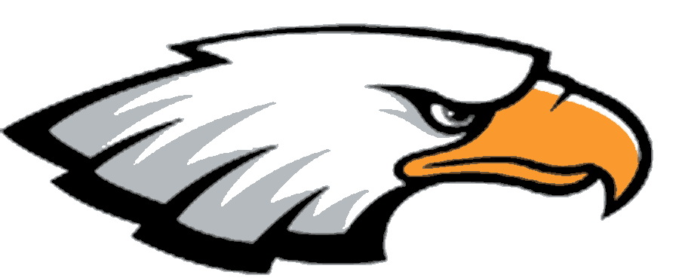  Important Dates  ** Registration Monday October 9th at 11 am  ** Practice begins November 1st, 6-8 pm  **Mandatory Parents meeting November 1st beginning of practice  Contact Info  Ernie Byers  Head Coach  (505)315-1762  coacherniebyers@yahoo.com  Website: nmwaywrestling.com  Like us on Facebook at facebook.com/eldoradowrestling

