USA Wrestling
2017-2018 FY National Coaches Education Program (NCEP)
Requirements for All Certification Levels
Copper (launched 9/1/2017) – For coaching kids at ages Bantam, Intermediate, and Novice.
Available online or in-person (in-person where states provide the course)
Online link TBD
(Must be a current coach member of USA Wrestling to take any course.)
Bronze (launched 1/1/2015) – For coaching ages Schoolboy and up.
Available online or in-person (in-person where states provide the course)
Online link https://www.usawmembership.com/PurchaseItem.jsp?purchaseItemId=901
(Must be a current coach member of USA Wrestling to take any course.)
Silver – Advanced certification (optional)
Requirements for Silver:
- 8 task credits through the 3D online coaching program.
Cost is $115 minus a 10% discount for USA Wrestling members. The link to the online course is available at: http://3dinstitute.com/product/3dimensional-coaching-certification/
Select "Add to Cart"
Select "View Cart"
Add the USA Wrestling 10% Discount Code - USAW2015 in the "Apply Coupon" Section and Click "Apply Coupon."
Complete the course and provide USA Wrestling NCEP Manager, Mike Clayton, an image of your certificate of completion (including your USA Wrestling Member ID Number) via email to get credits for the course at mclayton@usawrestling.org.
- Co-teach a bronze class: NCEP Manager will help you work with your state association on this. (Required evaluation form from your state office must be completed for certification credit.)
- Attend a Silver Level Coaching College: These occur each fall (typically in Oct) and each summer at the World or Olympic Trials. Contact the NCEP Manager for dates and info. Cost is @ $500 plus room/board.
- Silver Technical Certification: (Either in person with a National Office Staff Member at one of our camps or through video submission – most all are via video)
A. Prepare a complete written practice plan
B. Submit the plan to the NCEP Manager for review
C. Once approved, run a practice and video tape the entire practice
D. Submit the video and attached evaluation form to the NCEP Manager.
E. NCEP Manager reviews and provides feedback.
- CPR/AED Certification (must be current at time of certification)
- SafeSport Certification through the USOC @ http://safesport.org/take-the-training/

Gold – Advanced certification (optional)
Requirements for Gold:
- Certifications at all previous levels (Copper through Silver)
- 12 Task Credits
  - 2 credits: Read and summarize the book “Ego is the Enemy” and one other book (book two may be a book you’ve already completed). Explain how you will use what you learned from this book in your coaching and personal life.
  - 2 credits: Invest a minimum of four months mentoring an upcoming younger coach. Keep a journal of conversations with this coach, ways you’ve helped them, ways you’ve grown, issues you faced. Provide a full summary of how your efforts helped to successfully guide this young coach based on what you’ve learned through your NCEP journey. The mentee must also provide a written summary to USA Wrestling’s NCEP Manager on how you helped them throughout the mentorship process.
  - 2 credits: Community service – Use your team or club to perform a local community service project. Submit the following info for credit: 1. Why did you pick this project? 2. What did you do? 3. What did the team learn? 4. What did you (and assistants) learn? 5. How did your efforts help this charity or organization? 6. How did your efforts improve visibility for the sport of wrestling (and for your program) in your community?
  - 6 credits (1 credit each for):
    - Hosting a USA Wrestling Tournament (submit an initial written plan on how you will run this event before it starts and submit a written summary of lessons learned after the event)
    - Draft and submit a Macro periodization plan for a full season
    - Draft and submit a Meso periodization plan for a 45 day window of season
    - Draft and submit a Micro periodization plan for a 7 day window of season
    - Volunteer coach at a full week of either the Big Brother/Future Freestyle Camp (annually in March the week after NCAA D1’s) or at the 2024 camp (annually the week of July 4th)
    - One miscellaneous task – upon approval of NCEP Manager – for 1 task credit
- Coach Apprentice Program (CAP) International Trip. Includes: daily travel log, trip summary, group project, assistance to national team during the trip. Cost is @ $4,000.
- Teach a session at a Silver College (arrange this task with the NCEP Manager – we will work to ensure we book your teaching at a date/location that works for both you and the NCEP program). Costs include your discounted clinic fee, travel, room, and board.
- CPR/AED Certification (must be current at time of certification)
- SafeSport Certification through the USOC @ http://safesport.org/take-the-training/ (free course)

For questions/concerns, please contact NCEP Manager, Mike Clayton.
All the best,
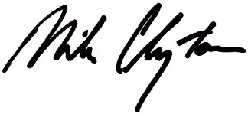
Mike Clayton
Manager, National Coaches Education Program (NCEP)
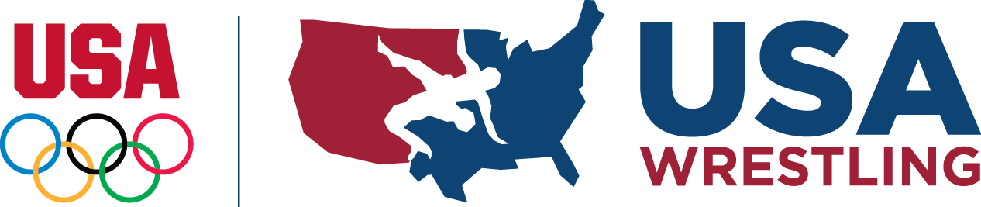
USA Wrestling
6155 Lehman Dr., Colorado Springs, CO 80918
Mike Direct: 719.265.3631
Cell: 862.754.2743
Twitter: @ClaytonUSAW
Mike's site at Session 6 Wrestling
USA Wrestling Educational Resources
"On the opposite side of fear is a love of learning. Fear is fertilizer to future growth.
Embrace it and quit wasting time mulling around in your comfort zone."
-Brett Bartholomew, TeamEXOS

