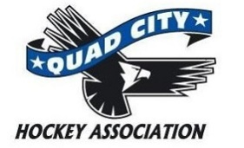
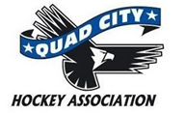
Photo Release Form

The Quad City Hockey Association (QCHA) has my permission to use my or my child’s photograph taken during any of the House League practices/events to promote the association and our House League. I understand that the images may be used in print publications, online publications, presentations, websites, and social media. I also understand that no royalty, fee or other compensation shall become payable to me by reason of such use. I release the QCHA from any and all liability that may arise in connection with such use.
Name of Child: _____________________________________
Name of Child: _____________________________________
Name of Child: _____________________________________
I am the parent or legal guardian of the child(ren) named above and have the legal authority to execute this consent and release.
Signature of Parent/Guardian: ________________________________________ Date: ______________
Printed Name: _____________________________________________________
Relationship to Child(ren): ____________________________________________

