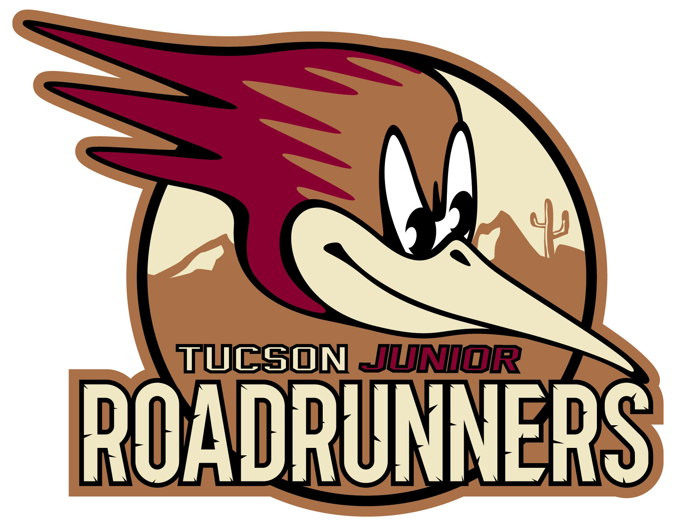

Wildcat Youth Hockey Association
(Junior Roadrunners)
Policy and Procedure Manual

The Wildcat Youth Hockey Association (WYHA) reserves the right to, at any time, review and amend any and all policies and procedures contained within this manual.
Not all Wildcat Youth Hockey Association policies and procedures may be contained in this manual.
In the event clarification regarding a policy or procedure is required, the WYHA members should always contact management for interpretation and/or assistance on any policy or procedure whether contained in this manual or not. In the event of a dispute regarding the interpretation and/or wording of any of the stated policies and procedures contained herein, the WYHA shall review and render a decision based on the best interest of the organization.

Mission Statement
Our mission is to provide a positive environment where players can enjoy and learn about the game of hockey by teaching sportsmanship, hockey skills and proper fundamentals. We strive to bring out the very best from every skater and help them reach the peak of their potential and beyond.
We are guided by the values of sportsmanship, honesty, respect for the individual and integrity of the game. All players, coaches and teams are registered with Arizona Amateur Hockey Association (AAHA) and USA Hockey.

General
- WYHA policies must adhere to the following guidelines:
  - Simplified English will be used.
  - Each policy should address only one issue.
  - The policy must clearly define the parties or persons affected.
  - Policies should not include details on how to administer policies.
  - Personal opinions or editorializing do not belong in policies.
- On annual basis, the WYHA Board of Directors will review the existing policies of the organization.
- Any member in good standing may request the creation or change of the WYHA policies. The requestor will submit their request in writing to the Association. WYHA will:
  - Acknowledge the receipt of the request.
  - Notify the requestor of the outcome of their request following action by the board.
- The organization shall provide equal membership/employment/service opportunities to all eligible persons without regard to race, religion, color, national origin, citizenship, age, gender, sexual preference, marital status, parental status, veteran status, handicap, membership in any labor organization, or political affiliation.

Governing Structure
- WYHA Operating Procedures
  - The day-to-day business operations and together with the concerns of the WYHA Youth League shall be handled by the WYHA Board members.
  - The WYHA shall designate a Coaching Director of Youth Hockey. The Coaching Director of Youth Hockey shall be responsible for the management of all hockey programs.
  - The position(s) of Assistant Coach(es) will assist and report directly to the Coaching Director of Youth Hockey.
- Committee Chairs
  - The President and/or the Coaching Director of Youth Hockey may, at his discretion and subject to WYHA Board, create committees to assist in the facilitation of various duties. Each committee shall have a committee chair.
  - Any person wishing to serve on a committee should notify the chair of the committee on which they wish to serve. Certain committees lend themselves to either restricted or open membership. Circumstances permitting, members may serve on the committee.
- Membership
  - Each registered participant in WYHA program shall be considered a member. Membership status is extended to each parent or legal guardian of any minor member. A member is in good standing if that member is current on all WYHA, AAHA and USA Hockey fee requirements and is not the subject of current or ongoing disciplinary decisions which affect that member’s status.
  - By participating in WYHA program sponsored events, each member agrees to abide by all rules and policies that govern WYHA and to at all times conduct themselves at WYHA affiliated events in a manner which reflects positively on WYHA. Membership can be revoked at any time if the member does not abide by the policies, procedures and rules and regulations of WYHA.

- Registration
  - All registrants must complete all forms or provide any documentation required by WYHA, AAHA and USA Hockey to participate in any WYHA activity. Activities include but not limited to tryouts, evaluations, practices, games, clinics and power skating classes.
  - Per AAHA regulations, all registrants must be in good financial standing with all AAHA organizations before being eligible for WYHA membership.
  - All proper payments must be received by WYHA prior to participation in any activities including tryouts, evaluations, practices and games.
  - The Coaching Director of Youth Hockey will determine the number of teams and divisions each year.
- Injury and Refund Policy
  - A refund or credit may be granted for an injury that requires a player to miss at least 50% of the season. Documentation will be required to verify the injury.
  - A refund or credit may be granted in the event a player’s parents employment requires that the parent permanently move which results in the player missing at least 50% of the season. Documentation will be required to verify the job relocation.
  - Refunds and credits are not granted for suspensions or expulsions from the league/program.
  - Refunds and credits are not granted for injuries caused by a player fighting or doing any other prohibited activity on or off the ice.
  - Refunds and credits are not granted for not showing up to games.
  - The Coaching Director of Youth Hockey will then review the request and determine what, if any amount of fees is to be reimbursed to the player. A decision shall be made in writing within 14 days of the request.

Coach and Manager Policies
- Coaching Education Requirements
  - All coaches must be certified at the level of the team they are coaching as required by USA Hockey.
  - All coaches are expected to participate in the continuing education program required by USA Hockey.
  - All coaches must be screened under the AAHA screening and background check policy prior to any activity with the team.
  - All coaches must complete the USA Hockey Safe Sport program.
- Coach and Team Manager Removal
  - All Coaches and Team Managers will conduct themselves in a manner consistent with the spirit of the Mission Statement. ANy inappropriate behavior will result in disciplinary action. This may include removal of the individual from their position.

- Coaches Responsibilities
  - Coaches are expected to know the playing rules of the game.
  - Coaches should recruit a Team Manager to help with the team administration Upon selection, coaches shall submit the manager’s name for final approval from the Coaching Director of Youth Hockey.
  - At least one coach or manager must be in the locker room and/or hallway at all times for each practice or game. A coach or manager shall be the last person to leave the locker room.
  - The only persons allowed on the ice are rostered players and the certified coaches of the team. Guest coaches are permitted as long as they have proper certification and registration to USA Hockey.
  - Coaches shall maintain team discipline and take reasonable measures for violations of team rules. Coaches shall teach and condone only clean hokey.
  - Coaches shall be responsible for keeping all skaters off the ice during times scheduled for resurfacing the ice. No one should go on the ice before the resurfacing doors close.
  - Coaches are responsible for reporting any injuries that occur on or off the ice immediately to the WYHA representatives in order to facilitate appropriate first aid care. Coaches must also complete, with the WYHA representatives, the facility accident report.
- Off-Ice Behavior
  - Players are subject to disciplinary action if their off-ice actions are deemed unacceptable. Generally, players are expected to conduct themselves in accordance with the written Policies, Rules, Rink Rules and Codes of Conduct contained herein or in USA Hockey rules. Any player found to be in violation of this policy will be subject to immediate disciplinary action, including possible immediate suspension or expulsion from the team and the Arena.
- Member Codes of Conduct
  - Coaches:
    - Treat everyone fairly within the context of their activity, regardless of gender, place of origin, color, sexual orientation, religion, political belief or economic status.
    - Direct comments or criticism at the performance rather than the athlete.
    - Refrain from public criticism of fellow coaches, officials and volunteers
    - Refrain from the use of profane, insulting, harassing or otherwise offensive language in the conduct of his duties.
    - Treat opponents and officials with due respect both in victory and defeat and encourage athletes to act accordingly.
    - Actively encourage athletes to uphold the rules of their sport and the spirit of such rules.
    - Respect athlete’s dignity; verbal or physical behaviors that constitute harassment or abuse are unacceptable.
    - Never verbally or physically abuse a player of official.
    - Never advocate or condone the use of drugs of other banned performance enhancing substances.
    - Never provide under age athletes with alcohol and never encourage its use.
    - Be a positive role model to our players.
    - Care more about the child than winning the game. Remember, players are involved in the sport for fun.
    - Be alert to the physical safety of the players.
    - Be generous with your praise when it is deserved.
    - Teach good sportsmanship, respect parents, opponents and officials.
    - Familiarize yourself with the rules, techniques and strategies of the game.
    - Recognize your influence on players, be honest and consistent.
    - Teach basic values of teamwork.
    - Emphasize the development of the fundamental skills of the game.
    - Adjust to personal needs and problems of players.
    - Maintain an open line of communication with the parents. Explain the goals and objectives of the team.
    - Give all players the opportunity to improve their skills, gain confidence and develop self-esteem.
    - Organize practices that are fun and challenging for your players.
    - Be concerned with the overall development of your players Stress good health habits and clean living.
  - Players:
    - Play for fun.
    - Respect you coach, your teammates and opponents.
    - Do not argue an official’s decision.
    - Play by the rules.
    - Work hard to improve your skills.
    - Be a team player. Get along with your teammates.
    - Try your hardest to win but be a good sport.
    - Learn teamwork, sportsmanship and discipline.
    - Be on time for practices and games and be prepared with the required equipment.
  - Parents:
    - Realize the importance of practice to develop the necessary skills of the game. Be positive and encouraging to your child. Screaming at coaches, officials or your child is never a positive look.
    - Be understanding and supportive of the coaches and officials.
    - Teach your child that honest effort, good sportsmanship and teamwork are most important.
    - Encourage your child to play by the rules.
    - Set a good example for your child.
    - Remember that children play sports for their enjoyment,not yours.
    - Appreciate good plays for your child’s teammates as well as opponents.
    - Supervise your children at all WYHA events. Parents are financially responsible for any property damage done to the facility or property of another member.
    - Choose an appropriate time, place and manner to discuss with your coaching staff or the WYHA Youth Hockey Coaching Director any concerns or other issues.
  - Spectators:
    - Spectators must conduct themselves with courtesy and respect to others participating or observing WYHA events.
    - Spectators must remain behind the glass areas of the rink and not knock, pound or hang on the glass.
    - Spectators must avoid any contact with the player’s bench, the coaches, the official timekeepers’ area and the penalty box area unless specifically instructed by an official or the coaching staff.
  - Dressing Rooms:
    - Rules for dressing rooms are posted outside the locker rooms. Parents must ensure that they and the players are aware of these rules.
    - Team coaches are to supervise use of dressing rooms before and after games and practices. If a coach cannot be present, it is that coach’s responsibility to arrange for a suitable adult replacement. Any adult who is a locker room monitor must be screened through the AAHA screening process prior to becoming an adult locker room monitor. Information on the screening process can be found at the AAHA website at: http://www.azamateurhockey.org/
    - Teams may secure their assigned locker rooms approximately one hour prior to their scheduled ice time.
    - Players and coaches must always treat the dressing rooms with respect for the property of the rink and of other players. Any damages done to any dressing room will result in disciplinary action. This action may include suspension from the dressing room for the entire team. Each team and parents are financially responsible for damages to any dressing room caused by its players.
    - Due to possible theft and other issues, WYHA highly encourages all teams to leave all valuables in their cars or take them with the to the player’s bench area. Dressing room keys could also be available from either Guest Services or a Building Supervisor.
    - Trashing of other players’ belongings, stealing, throwing trash and tape and shooting of pucks or balls are not acceptable in either the dressing room or the arena and will lead to disciplinary action including loss of dressing room privileges.

Sexual and Physical Abuse Policy
The safety of Wildcat Youth Hockey Association’s participants is of paramount importance. This includes not only on-ice safety, but also off-ice safety in any part of its programs. The WYHA follows and adheres to USA Hockey’s Safe Sport program.

The Wildcat Youth Hockey Association maintains a ZERO TOLERANCE policy for abuse and misconduct including physical, psychological, or sexual abuse of any child participant, adult, coach, volunteer or parent. Any violation of this policy shall result in immediate removal from the WYHA, Board of Directors, or any position with the WYHA and shall be reported to the proper authorities.
USA Hockey Safe Sport is a program that includes, and is focused on, the organization’s off-ice safety efforts.
The USA Hockey Safe Sport Handbook addresses:
- Policies prohibiting the following:
  - Sexual Abuse and Misconduct
  - Physical Abuse and Misconduct
  - Emotional Abuse and Misconduct
  - Bullying, Threats and Harassment
  - Hazing
- Other policies included adres areas where misconduct can occur and are intended to reduce the risk of potential abuse, including:
  - Locker Room Policy
  - Electronic Communications Policy
  - Travel Policy
  - Billeting Policy
- Education and Awareness Training
- Screening and Background Check Program
- Reporting of Concerns of Abuse
- Responding to Abuse and Other Misconduct
- Monitoring and Supervision of the Program
A WYHA Hockey member or parent of any member who violates any of the Safe Sport policies or fails to consent to, and pass a screening and background check in compliance with the Screening and Background Check Program, may be denied eligibility within any WYHA and/or USA Hockey program and is subject to appropriate disciplinary action including, but not limited to, suspension, permanent suspension, and/or referral to law enforcement authorities.
For the complete USA HOckey Safe Sport Handbook, visit: http://www.usahockey.com/safesport

