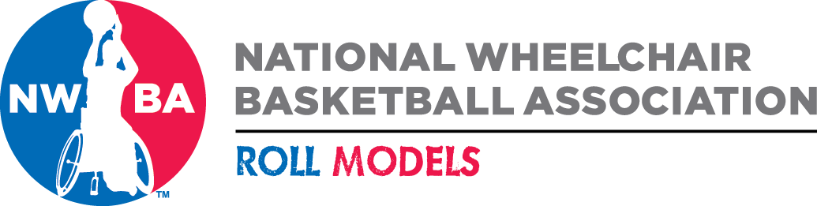

NWBA Athlete of the Month Nomination Form

Circle
Division: College Men College Women Junior Varsity Prep

Adult Division I Adult Division II Adult Division III Women’s

Athlete Name: ____ Month: _____________

Team:

Hometown: Residence:

Year in School:

Player Statistics for October:

Single Game Stats:

Tournament Stats:

Season Stats:

Any records set, if so, please detail:

Nomination Description:

Nomination Submitted By:

Name:

Affiliation:

Please send two photos of nominated athlete.

Submit Nominations to NWBA by Monday, October 30th at 12:00 p.m. MT.

Send to: Kimberly Kasper, NWBA, via email: kimkasper@nwba.com

