- Log on to OMBGA.net with your account used to register your travel player
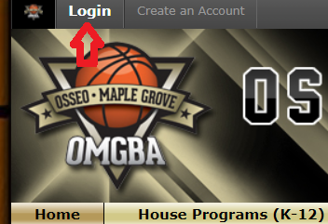

- Next, click on the Dibs tab
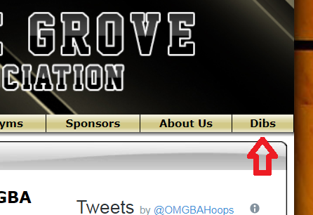

- Click on the current season “Volunteer” session
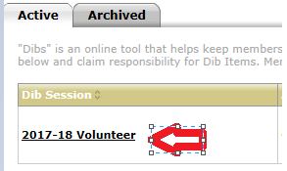
- Select “Status” Unclaimed and Click “Filter Dib Items”
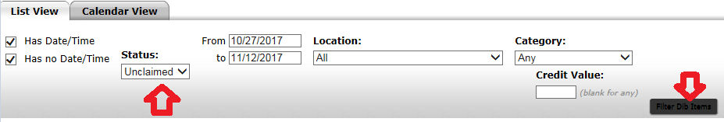

- Select the shift you want to volunteer for
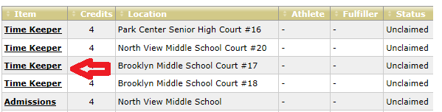

- Click “Claim this Dib Item”
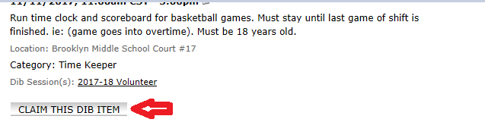
- Complete the requested information then Click “Claim Dib Item”
