What’s New?
November 2017
President’s Message
Innovation, strategic thinking, and effective collaboration, are key skills in successful leaders.
- CIRA Ontario wants to honour leaders like this. If you know a leader, please recommend them to us so we can honour them at our April conference. Please send nominations for the following awards:
  - Honourary Award
  - Doyle-Harkness Award
  - Professional Award
  - For more information about these awards, please visit our website at: http://www.ciraontario.com/awards
- Intramural Award for your school? If you run a great intramural program be sure to nominate your school by April 15. For more information go to: http://www.ciraontario.com/awards
- As a leader please let us know if you are able to lead a session at our upcoming April conference. I you wish to lead or want to suggest a leader please let us know at ciraontario@gmail.com

Card Resources
ONLY $10.00 + tax and shipping
http://www.ciraontario.com/cards
GAME EXAMPLES NEXT PAGE!
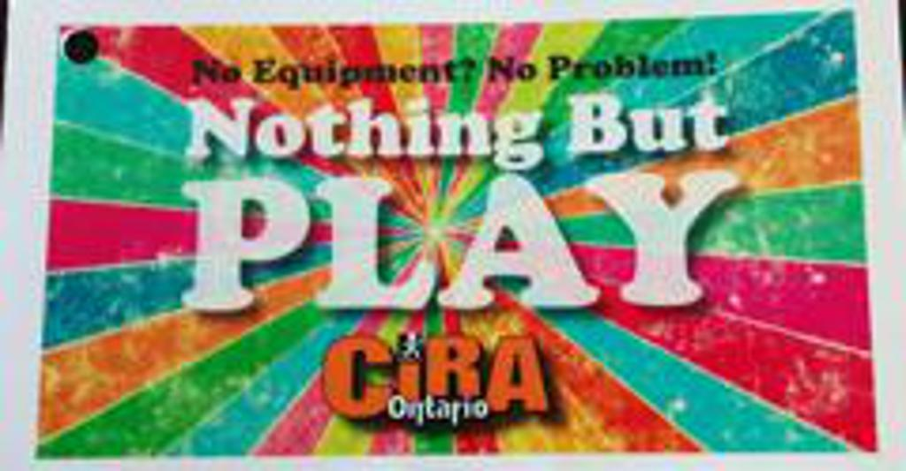

Hoop it Up Resource Cards- Game Sample
Moving Baskets
Equipment: Two inner tubes or hula hoops, beach balls, gator balls
Create two teams of four to five players. Their challenge is to carry the inner tube above their head and move around the playing area. The rest of the players try and throw a beach ball or foam ball through the tube. When someone does score a basket, they switch with a player carrying the hoop. The new shot maker joins the other players scoring baskets. The people supporting the tubes must keep both hands on the tubes at all times.

Nothing But PLAY Cards- Game Sample
Pizza Party
Players sit in a circle. The leader assigns one of three pizza toppings to each player. For example: pepperoni, mushrooms, and cheese. One player is selected to stand in the middle. The centre player calls out a pizza topping and all those players must switch spots without getting their spot stolen by the player in the middle. The last player to find a spot is the new caller in the middle and they call out a new topping. If the player in the middle calls out “pizza party”, then everyone must switch spots.

Health and Fitness Games/Activities
Visit the following link for a list of Fitness and Health Games and Activities:
http://assets.ngin.com/attachments/document/0054/7369/forum-organization-and-ideas-fitness-health.pdf

OASPHE and CIRA Ontario Conference, 2018

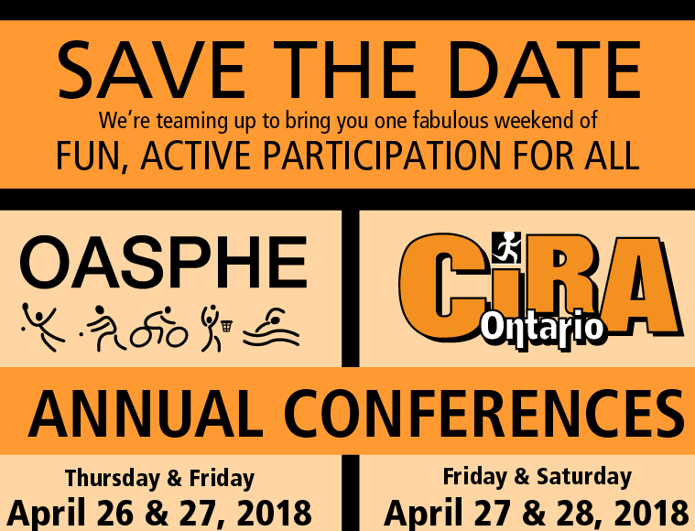

Register at:
http://www.ciraontario.com/conference

