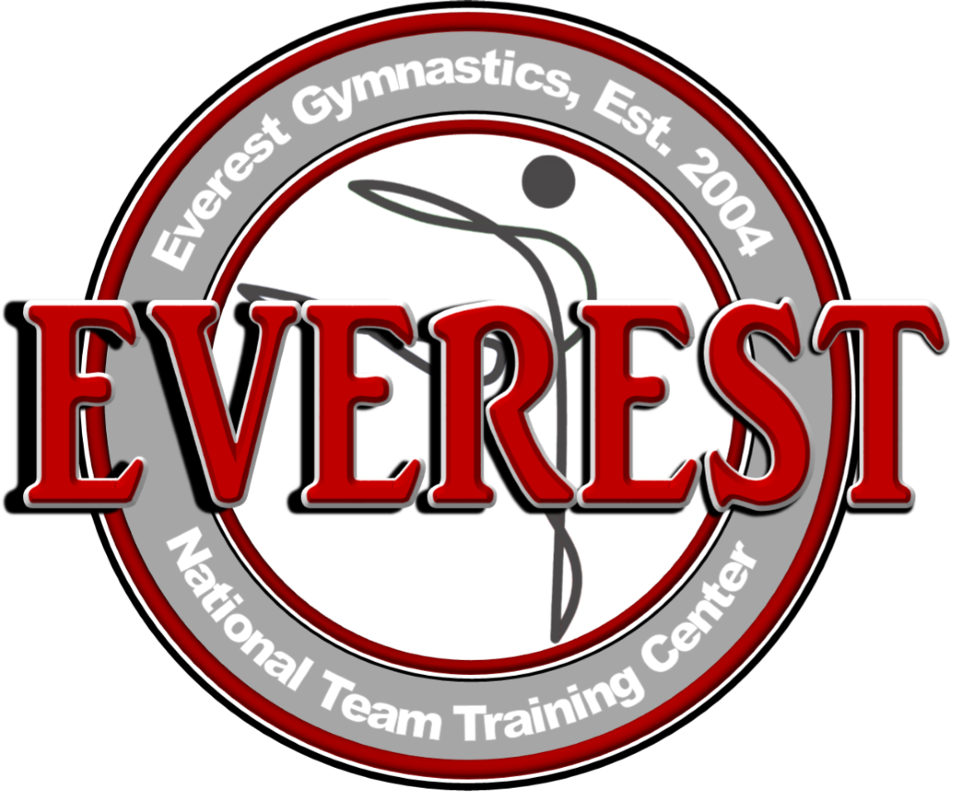

MEDIA ADVISORY
November 8, 2017

Huntersville Gymnast to Sign National Letter of Intent
Meredith Robinson committing to NCSU and a full athletic scholarship

WHAT: Everest Gymnastics is proud to announce that Meredith Robinson will sign a National Letter of Intent (NLI), committing to North Carolina State University (NCSU). The NLI commits Robinson to attend NCSU and act as a formal acceptance of her full athletic scholarship.
Robinson, from Huntersville, NC, started gymnastics when she was three years old and has been training with Everest since 2009, when her family came to Huntersville from Charleston, S.C.
“We are so proud of Meredith and her decision to accept the full athletic scholarship with NCSU,” said Qi Han, owner and head coach at Everest Gymnastics. “She has worked so hard for this and we know there is success ahead of her.”
Robinson, whose favorite gymnastics event is the uneven bars, plans to study biology or psychology to pursue a career in the medical field, while representing NC State’s women’s gymnastics team.
“My biggest goal this year will be achieved once I sign for my scholarship with NC State. I can’t believe it’s finally happening,” said Robinson. “Han and Chen are my second family and have always supported and encouraged me to do my best. This would not have been possible without them.”
Join Everest Gymnastics, fellow gymnasts, and her family in celebrating Robinson’s accomplishment at a National Signing Day presentation.
WHEN: November 8, 2017, 2:30 p.m.
WHERE: Everest Gymnastics, 103 Parr Dr., Huntersville, NC 28078
PHOTO OPS:
- Meredith Robinson signing her National Letter of Intent with North Carolina State University
- Everest Gymnastics owners and head coaches, Qi Han and Yiwen Chen.

CONTACT: Anna Roesler, 919-703-7771, anna@mckeemanpr.com

