Freedom Custom Socks

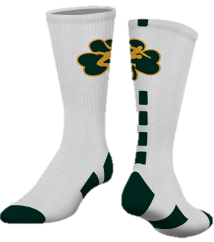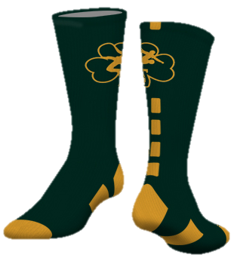
Men's Sizes | White/Green Pair | Green/Gold Pair
Youth: Sizes 5 and under
Small: Sizes 6-7
Medium: Sizes 8-10
Large: Size 11-13
Xlarge: 14+
Women's Sizes
Youth: Shoe sizes 6 and under
Small: Shoe sizes 7-9
Medium: Shoe sizes 10-12
Large: Shoe sizes 13+
Total

Each pair of socks is $12.00 Checks can be written out to Freedom Wrestling Club and handed to Mr. Lancaster. This sock order form is due Nov.27. It takes 2-3 weeks to get the order in. Thank you!

Name _______________________________________________

Phone Number ________________________________________

